Quick start guide to Kubeflow

목차

**1. Install MicroK8s 2**

**2. Install Juju 5**

**3. Deploying Kubeflow 6**

**4. Configuration 11**

**5. Accessing the Dashboard 12**

**6. Katib Operators 14**

**7. Install docker and container 18**

**8. Install miniconda 30**

**9. Install kfp and dsl-compile 44**

**10. Generating pipeline images 49**

**11. Deploying pipeline 69**

# **1. Install MicroK8s**

**traindb@traindb-VirtualBox:~/Desktop$ sudo snap install microk8s --classic --channel=1.21/stable**

|  |
| --- |
| [sudo] password for traindb:  microk8s (1.21/stable) v1.21.12 from Canonical✓ installed |

**traindb@traindb-VirtualBox:~/Desktop$** **sudo usermod -a -G microk8s $USER**

**traindb@traindb-VirtualBox:~/Desktop$** **newgrp microk8s**

**traindb@traindb-VirtualBox:~/Desktop$ mkdir ~/.kube**

**traindb@traindb-VirtualBox:~/Desktop$ sudo chown -f -R $USER ~/.kube**

**traindb@traindb-VirtualBox:~/Desktop$ microk8s enable dns storage ingress metallb:10.64.140.43-10.64.140.49 istio dashboard registry knative // gpu kubeflow**

|  |
| --- |
| Enabling DNS  Applying manifest  serviceaccount/coredns created  configmap/coredns created  deployment.apps/coredns created  service/kube-dns created  clusterrole.rbac.authorization.k8s.io/coredns created  clusterrolebinding.rbac.authorization.k8s.io/coredns created  Restarting kubelet  DNS is enabled  Enabling default storage class  deployment.apps/hostpath-provisioner created  storageclass.storage.k8s.io/microk8s-hostpath created  serviceaccount/microk8s-hostpath created  clusterrole.rbac.authorization.k8s.io/microk8s-hostpath created  clusterrolebinding.rbac.authorization.k8s.io/microk8s-hostpath created  Storage will be available soon  Enabling Ingress  ingressclass.networking.k8s.io/public created  namespace/ingress created  serviceaccount/nginx-ingress-microk8s-serviceaccount created  clusterrole.rbac.authorization.k8s.io/nginx-ingress-microk8s-clusterrole created  role.rbac.authorization.k8s.io/nginx-ingress-microk8s-role created  clusterrolebinding.rbac.authorization.k8s.io/nginx-ingress-microk8s created  rolebinding.rbac.authorization.k8s.io/nginx-ingress-microk8s created  configmap/nginx-load-balancer-microk8s-conf created  configmap/nginx-ingress-tcp-microk8s-conf created  configmap/nginx-ingress-udp-microk8s-conf created  daemonset.apps/nginx-ingress-microk8s-controller created  Ingress is enabled  Enabling MetalLB  Applying Metallb manifest  namespace/metallb-system created  secret/memberlist created  Warning: policy/v1beta1 PodSecurityPolicy is deprecated in v1.21+, unavailable in v1.25+  podsecuritypolicy.policy/controller created  podsecuritypolicy.policy/speaker created  serviceaccount/controller created  serviceaccount/speaker created  clusterrole.rbac.authorization.k8s.io/metallb-system:controller created  clusterrole.rbac.authorization.k8s.io/metallb-system:speaker created  role.rbac.authorization.k8s.io/config-watcher created  role.rbac.authorization.k8s.io/pod-lister created  clusterrolebinding.rbac.authorization.k8s.io/metallb-system:controller created  clusterrolebinding.rbac.authorization.k8s.io/metallb-system:speaker created  rolebinding.rbac.authorization.k8s.io/config-watcher created  rolebinding.rbac.authorization.k8s.io/pod-lister created  daemonset.apps/speaker created  deployment.apps/controller created  configmap/config created  MetalLB is enabled |

**traindb@traindb-VirtualBox:~/Desktop$ microk8s status --wait-ready**

|  |
| --- |
| microk8s is running  high-availability: no  datastore master nodes: 127.0.0.1:19001  datastore standby nodes: none  addons:  enabled:  dns # CoreDNS  ha-cluster # Configure high availability on the current node  disabled:  ambassador # Ambassador API Gateway and Ingress  cilium # SDN, fast with full network policy  dashboard # The Kubernetes dashboard  fluentd # Elasticsearch-Fluentd-Kibana logging and monitoring  gpu # Automatic enablement of Nvidia CUDA  helm # Helm 2 - the package manager for Kubernetes  helm3 # Helm 3 - Kubernetes package manager  host-access # Allow Pods connecting to Host services smoothly  ingress # Ingress controller for external access  istio # Core Istio service mesh services  jaeger # Kubernetes Jaeger operator with its simple config  keda # Kubernetes-based Event Driven Autoscaling  knative # The Knative framework on Kubernetes.  kubeflow # Kubeflow for easy ML deployments  linkerd # Linkerd is a service mesh for Kubernetes and other frameworks  metallb # Loadbalancer for your Kubernetes cluster  metrics-server # K8s Metrics Server for API access to service metrics  multus # Multus CNI enables attaching multiple network interfaces to pods  openebs # OpenEBS is the open-source storage solution for Kubernetes  openfaas # openfaas serverless framework  portainer # Portainer UI for your Kubernetes cluster  prometheus # Prometheus operator for monitoring and logging  rbac # Role-Based Access Control for authorisation  registry # Private image registry exposed on localhost:32000  storage # Storage class; allocates storage from host directory  traefik # traefik Ingress controller for external access |

# **2. Install Juju**

**traindb@traindb-VirtualBox:~/Desktop$** **sudo snap install juju --classic**

|  |
| --- |
| juju 2.9.29 from Canonical✓ installed |

**traindb@traindb-VirtualBox:~/Desktop$** **juju bootstrap microk8s**

|  |
| --- |
| Since Juju 2 is being run for the first time, it has downloaded the latest public cloud information.  Creating Juju controller "microk8s-localhost" on microk8s/localhost  Bootstrap to Kubernetes cluster identified as microk8s/localhost  Fetching Juju Dashboard 0.8.1  Creating k8s resources for controller "controller-microk8s-localhost"  Starting controller pod  Bootstrap agent now started  Contacting Juju controller at 10.152.183.121 to verify accessibility...  Bootstrap complete, controller "microk8s-localhost" is now available in namespace "controller-microk8s-localhost"  Now you can run  juju add-model <model-name>  to create a new model to deploy k8s workloads. |

# **3. Deploying Kubeflow**

**traindb@traindb-VirtualBox:~/Desktop$** **juju add-model kubeflow**

|  |
| --- |
| Added 'kubeflow' model on microk8s/localhost with credential 'microk8s' for user 'admin' |

**traindb@traindb-VirtualBox:~/Desktop$** **juju deploy kubeflow-lite --trust**

|  |
| --- |
| Located bundle "kubeflow-lite" in charm-hub, revision 60  Located charm "admission-webhook" in charm-hub, channel stable  Located charm "argo-controller" in charm-hub, channel stable  Located charm "dex-auth" in charm-hub, channel 2.28/stable  Located charm "envoy" in charm-hub, channel stable  Located charm "istio-gateway" in charm-hub, channel 1.5/stable  Located charm "istio-pilot" in charm-hub, channel 1.5/stable  Located charm "jupyter-controller" in charm-hub, channel stable  Located charm "jupyter-ui" in charm-hub, channel stable  Located charm "kfp-api" in charm-hub, channel stable  Located charm "charmed-osm-mariadb-k8s" in charm-hub, channel stable  Located charm "kfp-persistence" in charm-hub, channel stable  Located charm "kfp-profile-controller" in charm-hub, channel stable  Located charm "kfp-schedwf" in charm-hub, channel stable  Located charm "kfp-ui" in charm-hub, channel stable  Located charm "kfp-viewer" in charm-hub, channel stable  Located charm "kfp-viz" in charm-hub, channel stable  Located charm "kubeflow-dashboard" in charm-hub, channel stable  Located charm "kubeflow-profiles" in charm-hub, channel stable  Located charm "kubeflow-roles" in charm-hub, channel stable  Located charm "kubeflow-volumes" in charm-hub, channel stable  Located charm "metacontroller-operator" in charm-hub, channel stable  Located charm "minio" in charm-hub, channel stable  Located charm "mlmd" in charm-hub, channel stable  Located charm "oidc-gatekeeper" in charm-hub, channel stable  Located charm "seldon-core" in charm-hub, channel stable  Located charm "training-operator" in charm-hub, channel stable  Executing changes:  - upload charm admission-webhook from charm-hub from channel latest/stable with architecture=amd64  - deploy application admission-webhook from charm-hub with 1 unit with latest/stable  added resource oci-image  - set annotations for admission-webhook  - upload charm argo-controller from charm-hub from channel latest/stable with architecture=amd64  - deploy application argo-controller from charm-hub with 1 unit with latest/stable  added resource oci-image  - set annotations for argo-controller  - upload charm dex-auth from charm-hub from channel 2.28/stable with architecture=amd64  - deploy application dex-auth from charm-hub with 1 unit with 2.28/stable  added resource oci-image  - set annotations for dex-auth  - upload charm envoy from charm-hub from channel latest/stable with architecture=amd64  - deploy application envoy from charm-hub with 1 unit with latest/stable  added resource oci-image  - set annotations for envoy  - upload charm istio-gateway from charm-hub from channel 1.5/stable with architecture=amd64  - deploy application istio-ingressgateway from charm-hub with 1 unit with 1.5/stable using istio-gateway  added resource oci-image  - set annotations for istio-ingressgateway  - upload charm istio-pilot from charm-hub from channel 1.5/stable with architecture=amd64  - deploy application istio-pilot from charm-hub with 1 unit with 1.5/stable  added resource oci-image  - set annotations for istio-pilot  - upload charm jupyter-controller from charm-hub from channel latest/stable with architecture=amd64  - deploy application jupyter-controller from charm-hub with 1 unit with latest/stable  added resource oci-image  - set annotations for jupyter-controller  - upload charm jupyter-ui from charm-hub from channel latest/stable with architecture=amd64  - deploy application jupyter-ui from charm-hub with 1 unit with latest/stable  added resource oci-image  - set annotations for jupyter-ui  - upload charm kfp-api from charm-hub from channel latest/stable with architecture=amd64  - deploy application kfp-api from charm-hub with 1 unit with latest/stable  added resource oci-image  - set annotations for kfp-api  - upload charm charmed-osm-mariadb-k8s from charm-hub from channel latest/stable with architecture=amd64  - deploy application kfp-db from charm-hub with 1 unit with latest/stable using charmed-osm-mariadb-k8s  - set annotations for kfp-db  - upload charm kfp-persistence from charm-hub from channel latest/stable with architecture=amd64  - deploy application kfp-persistence from charm-hub with 1 unit with latest/stable  added resource oci-image  - set annotations for kfp-persistence  - upload charm kfp-profile-controller from charm-hub from channel latest/stable with architecture=amd64  - deploy application kfp-profile-controller from charm-hub with 1 unit with latest/stable  added resource oci-image  - set annotations for kfp-profile-controller  - upload charm kfp-schedwf from charm-hub from channel latest/stable with architecture=amd64  - deploy application kfp-schedwf from charm-hub with 1 unit with latest/stable  added resource oci-image  - set annotations for kfp-schedwf  - upload charm kfp-ui from charm-hub from channel latest/stable with architecture=amd64  - deploy application kfp-ui from charm-hub with 1 unit with latest/stable  added resource oci-image  - set annotations for kfp-ui  - upload charm kfp-viewer from charm-hub from channel latest/stable with architecture=amd64  - deploy application kfp-viewer from charm-hub with 1 unit with latest/stable  added resource oci-image  - set annotations for kfp-viewer  - upload charm kfp-viz from charm-hub from channel latest/stable with architecture=amd64  - deploy application kfp-viz from charm-hub with 1 unit with latest/stable  added resource oci-image  - set annotations for kfp-viz  - upload charm kubeflow-dashboard from charm-hub from channel latest/stable with architecture=amd64  - deploy application kubeflow-dashboard from charm-hub with 1 unit with latest/stable  added resource oci-image  - set annotations for kubeflow-dashboard  - upload charm kubeflow-profiles from charm-hub from channel latest/stable with architecture=amd64  - deploy application kubeflow-profiles from charm-hub with 1 unit with latest/stable  added resource kfam-image  added resource profile-image  - set annotations for kubeflow-profiles  - upload charm kubeflow-roles from charm-hub from channel latest/stable with architecture=amd64  - deploy application kubeflow-roles from charm-hub with 1 unit with latest/stable  - set annotations for kubeflow-roles  - upload charm kubeflow-volumes from charm-hub from channel latest/stable with architecture=amd64  - deploy application kubeflow-volumes from charm-hub with 1 unit with latest/stable  added resource oci-image  - set annotations for kubeflow-volumes  - upload charm metacontroller-operator from charm-hub from channel latest/stable with architecture=amd64  - deploy application metacontroller-operator from charm-hub with 1 unit with latest/stable  - set annotations for metacontroller-operator  - upload charm minio from charm-hub from channel latest/stable with architecture=amd64  - deploy application minio from charm-hub with 1 unit with latest/stable  added resource oci-image  - set annotations for minio  - upload charm mlmd from charm-hub from channel latest/stable with architecture=amd64  - deploy application mlmd from charm-hub with 1 unit with latest/stable  added resource oci-image  - set annotations for mlmd  - upload charm oidc-gatekeeper from charm-hub from channel latest/stable with architecture=amd64  - deploy application oidc-gatekeeper from charm-hub with 1 unit with latest/stable  added resource oci-image  - set annotations for oidc-gatekeeper  - upload charm seldon-core from charm-hub from channel latest/stable with architecture=amd64  - deploy application seldon-controller-manager from charm-hub with 1 unit with latest/stable using seldon-core  added resource oci-image  - set annotations for seldon-controller-manager  - upload charm training-operator from charm-hub from channel latest/stable with architecture=amd64  - deploy application training-operator from charm-hub with 1 unit with latest/stable  added resource training-operator-image  - set annotations for training-operator  - add relation argo-controller - minio  - add relation dex-auth:oidc-client - oidc-gatekeeper:oidc-client  - add relation istio-pilot:ingress - dex-auth:ingress  - add relation istio-pilot:ingress - jupyter-ui:ingress  - add relation istio-pilot:ingress - kfp-ui:ingress  - add relation istio-pilot:ingress - kubeflow-dashboard:ingress  - add relation istio-pilot:ingress - kubeflow-volumes:ingress  - add relation istio-pilot:ingress - oidc-gatekeeper:ingress  - add relation istio-pilot:ingress-auth - oidc-gatekeeper:ingress-auth  - add relation istio-pilot:istio-pilot - istio-ingressgateway:istio-pilot  - add relation kfp-api - kfp-db  - add relation kfp-api:kfp-api - kfp-persistence:kfp-api  - add relation kfp-api:kfp-api - kfp-ui:kfp-api  - add relation kfp-api:kfp-viz - kfp-viz:kfp-viz  - add relation kfp-api:object-storage - minio:object-storage  - add relation kfp-profile-controller:object-storage - minio:object-storage  - add relation kfp-ui:object-storage - minio:object-storage  - add relation kubeflow-profiles - kubeflow-dashboard  - add relation mlmd:grpc - envoy:grpc  Deploy of bundle completed. |

**traindb@traindb-VirtualBox:~/Desktop$** **watch -c juju status --color**

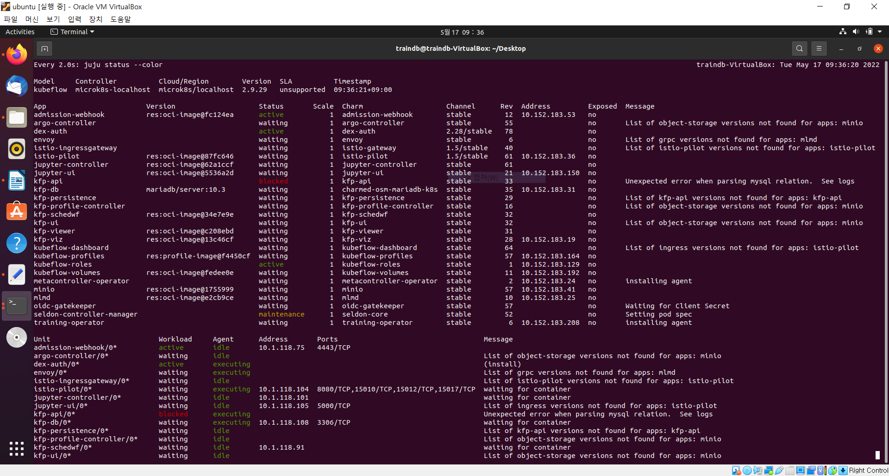

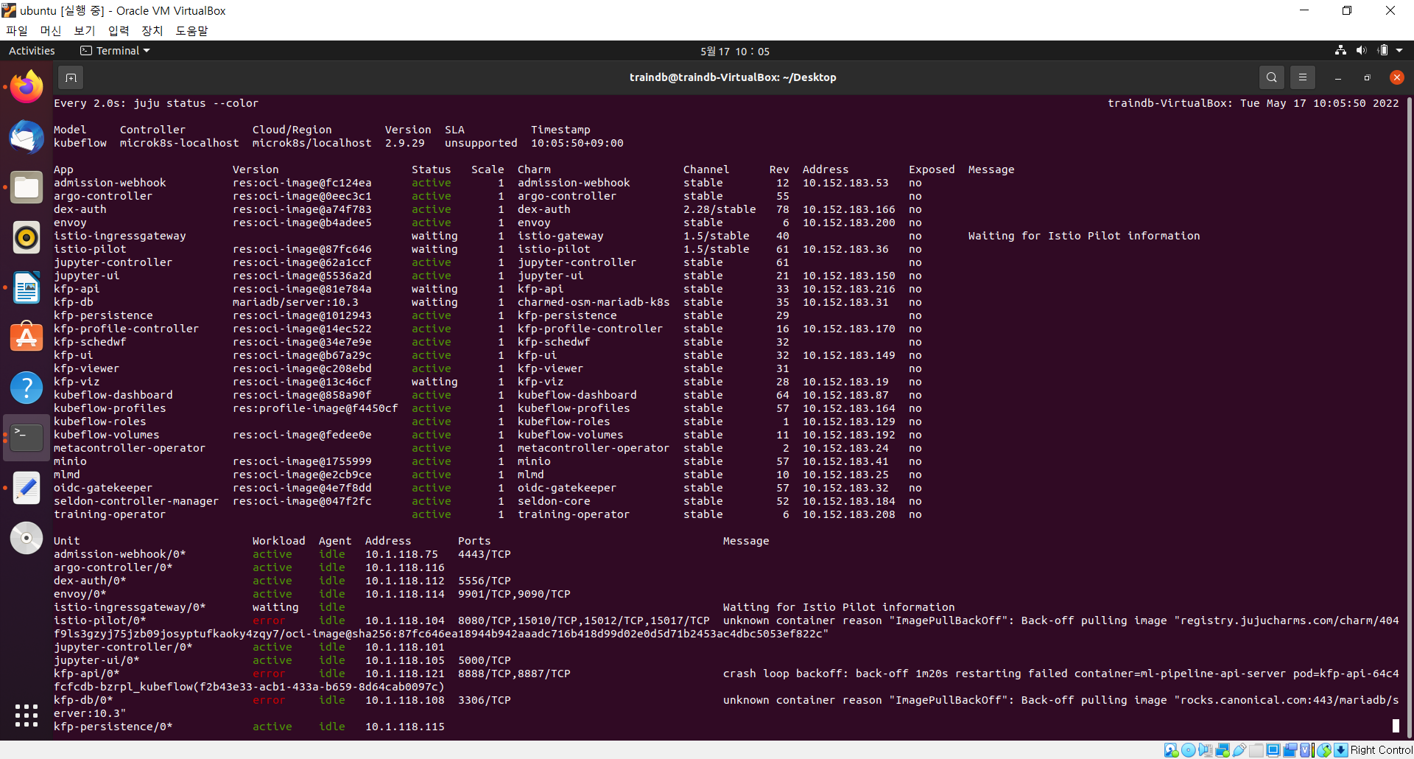

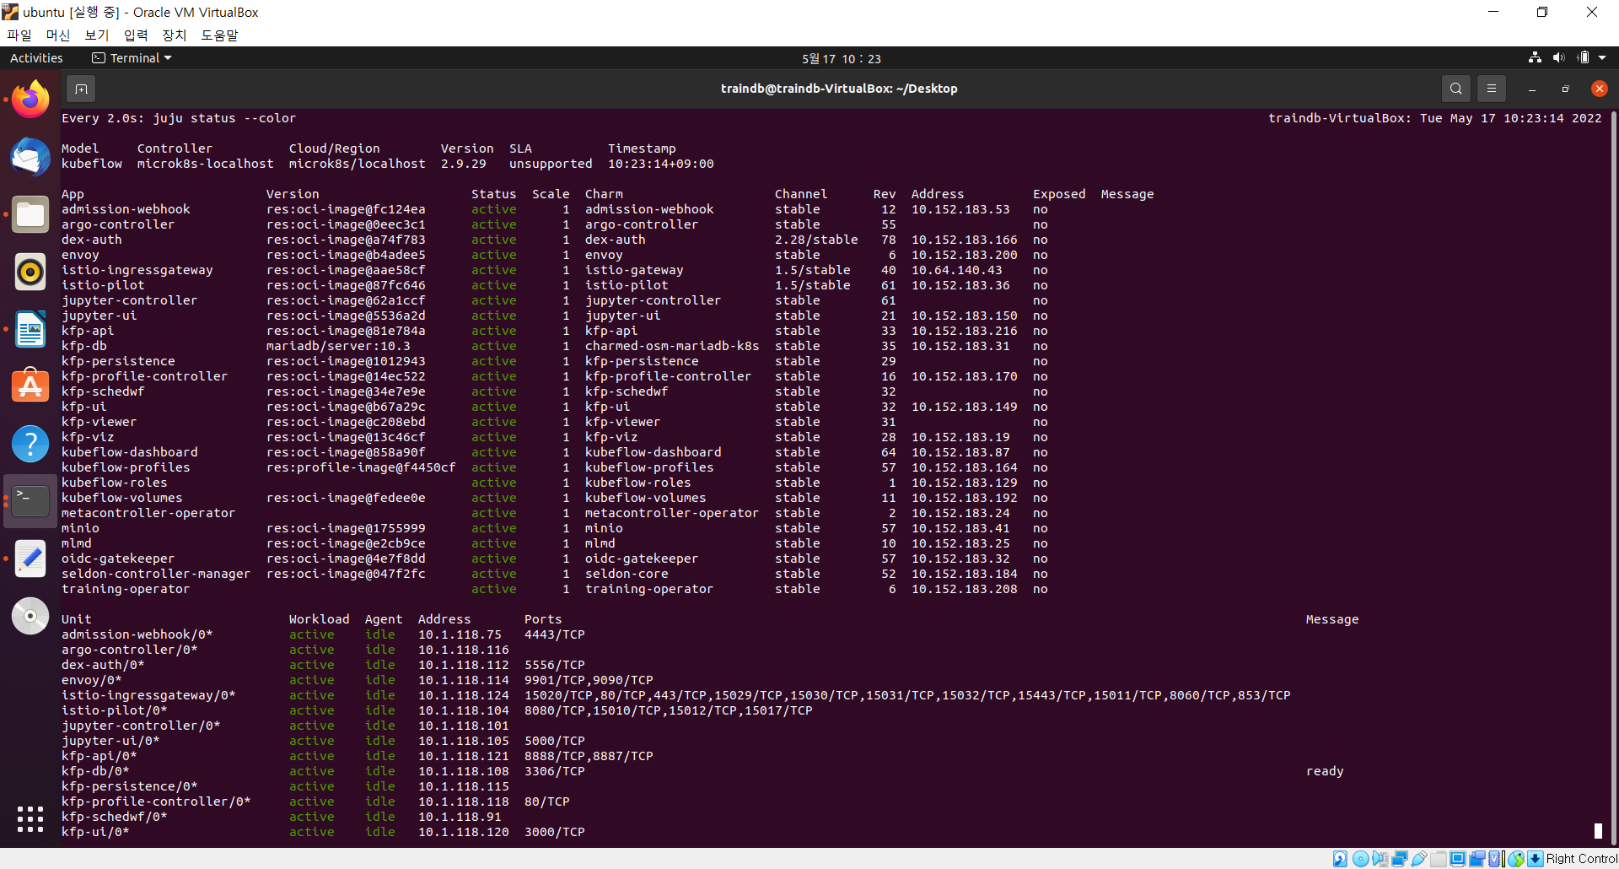

# **4. Configuration**

**traindb@traindb-VirtualBox:~/Desktop$** **juju config dex-auth public-url=http://10.64.140.43.nip.io**

**traindb@traindb-VirtualBox:~/Desktop$** **juju config oidc-gatekeeper public-url=http://10.64.140.43.nip.io**

**traindb@traindb-VirtualBox:~/Desktop$** **juju config dex-auth static-username=traindb**

**traindb@traindb-VirtualBox:~/Desktop$** **juju config dex-auth static-password=traindb**

# **5. Accessing the Dashboard**

[**http://10.64.140.43.nip.io**](http://10.64.140.43.nip.io)

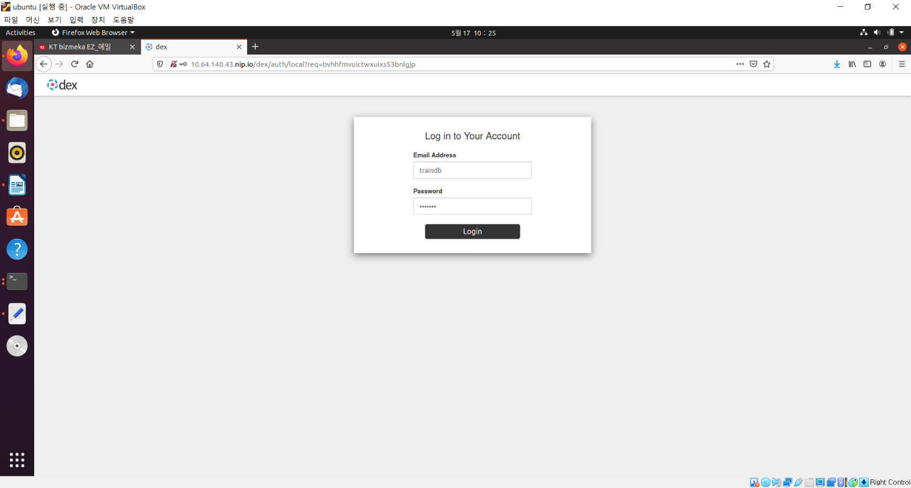

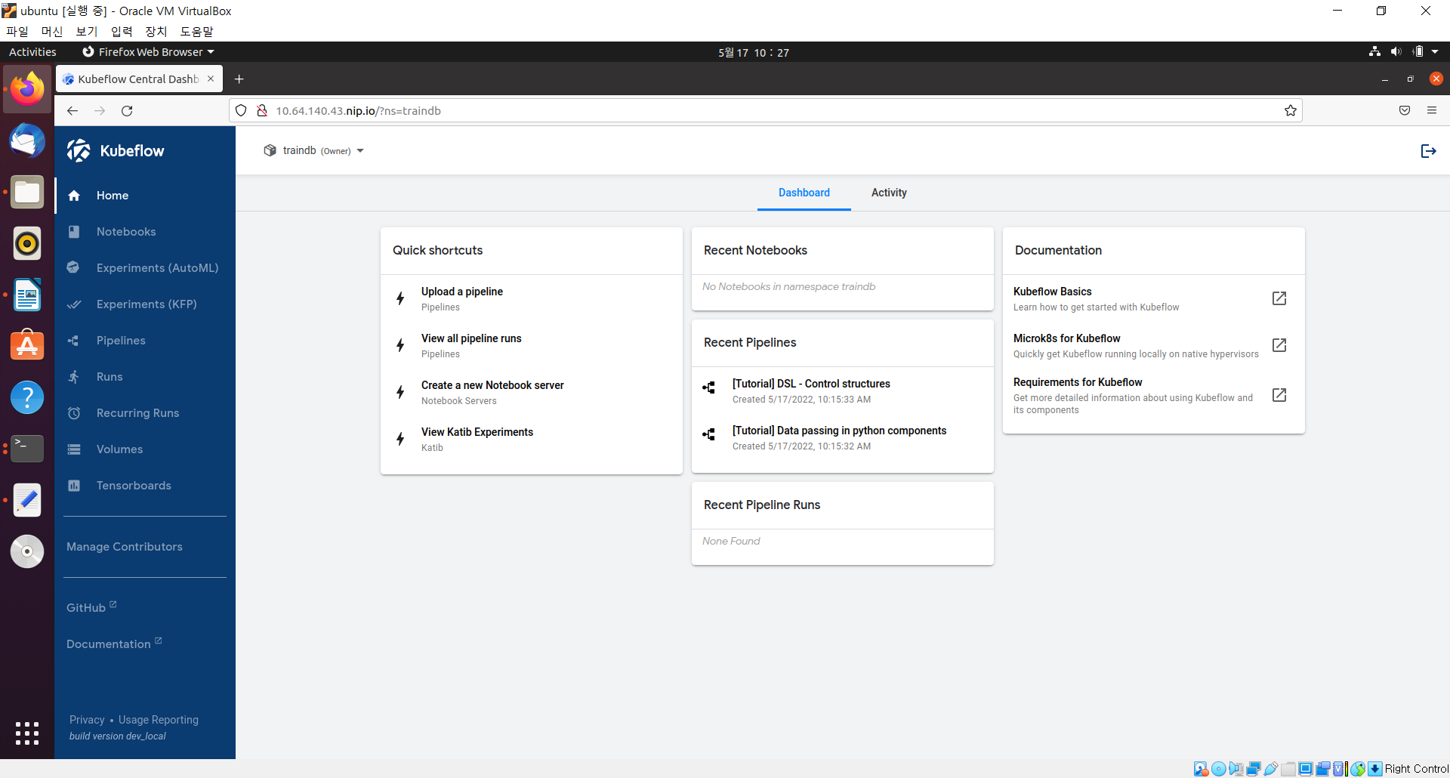

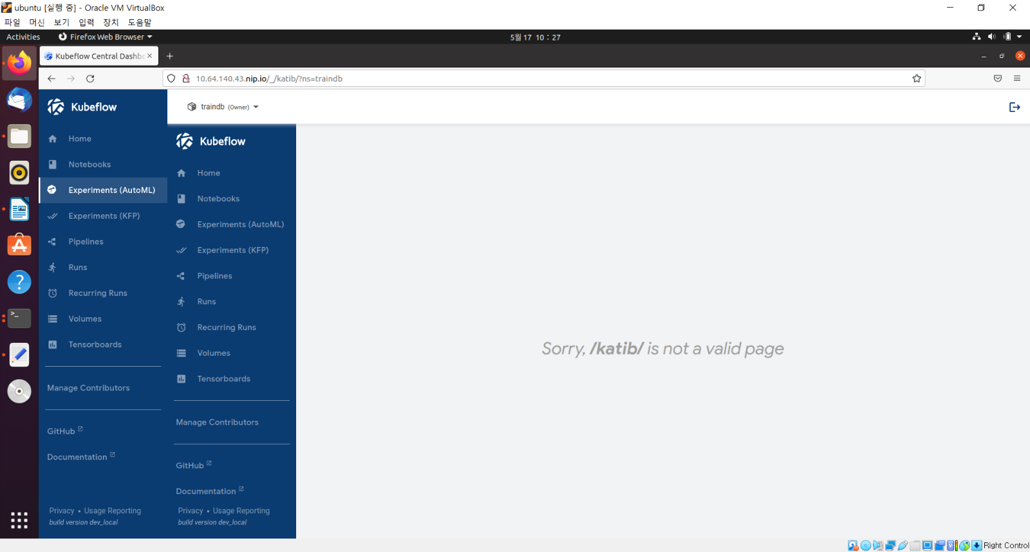

# **6. Katib Operators**



**traindb@traindb-VirtualBox:~/Desktop$** **juju deploy katib**

|  |
| --- |
| Located bundle "katib" in charm-hub, revision 10  Located charm "katib-controller" in charm-hub, channel stable  Located charm "mariadb-k8s" in charm-store, channel stable  Located charm "katib-db-manager" in charm-hub, channel stable  Located charm "katib-ui" in charm-hub, channel stable  Executing changes:  - upload charm katib-controller from charm-hub from channel stable with architecture=amd64  - deploy application katib-controller from charm-hub with 1 unit with stable  added resource oci-image  - set annotations for katib-controller  - upload charm mariadb-k8s from charm-store with architecture=amd64  - deploy application katib-db from charm-store with 1 unit using mariadb-k8s  - set annotations for katib-db  - upload charm katib-db-manager from charm-hub from channel stable with architecture=amd64  - deploy application katib-db-manager from charm-hub with 1 unit with stable  added resource oci-image  - set annotations for katib-db-manager  - upload charm katib-ui from charm-hub from channel stable with architecture=amd64  - deploy application katib-ui from charm-hub with 1 unit with stable  added resource oci-image  - set annotations for katib-ui  - add relation katib-db-manager - katib-db  Deploy of bundle completed. |

**traindb@traindb-VirtualBox:~/Desktop$** **watch -c juju status –color**

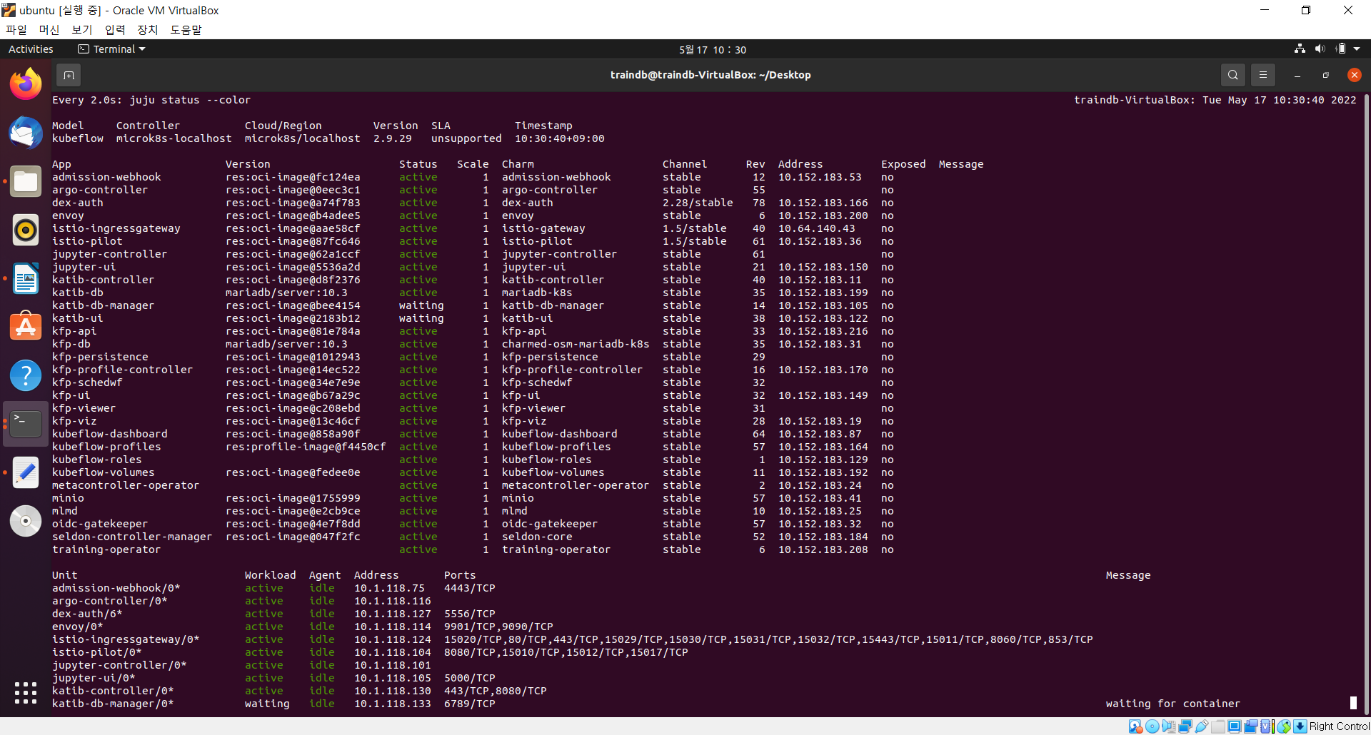

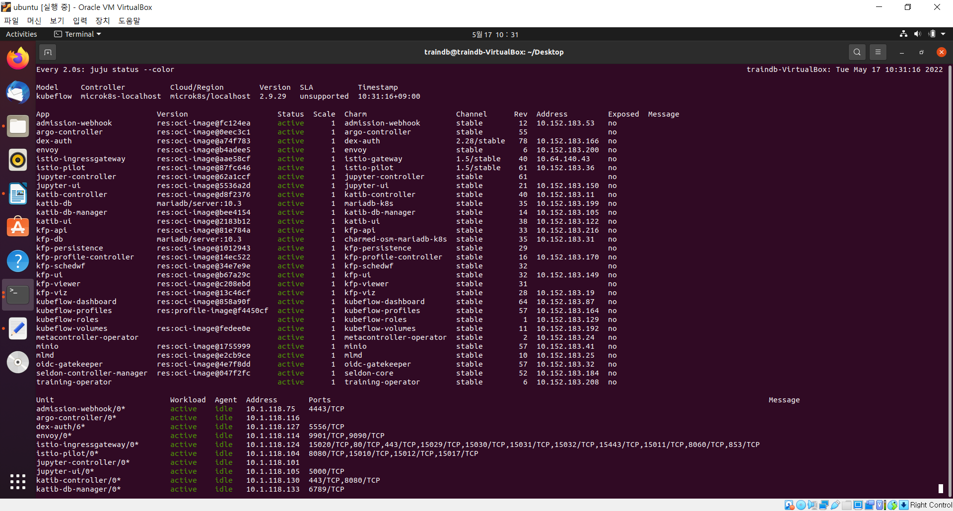

**traindb@traindb-VirtualBox:~/Desktop$** **juju relate istio-pilot katib-ui**

**traindb@traindb-VirtualBox:~/Desktop$ juju deploy tensorboards-web-app**

|  |
| --- |
| Located charm "tensorboards-web-app" in charm-hub, revision 3  Deploying "tensorboards-web-app" from charm-hub charm "tensorboards-web-app", revision 3 in channel stable on focal |

**traindb@traindb-VirtualBox:~/Desktop$** **watch -c juju status --color**

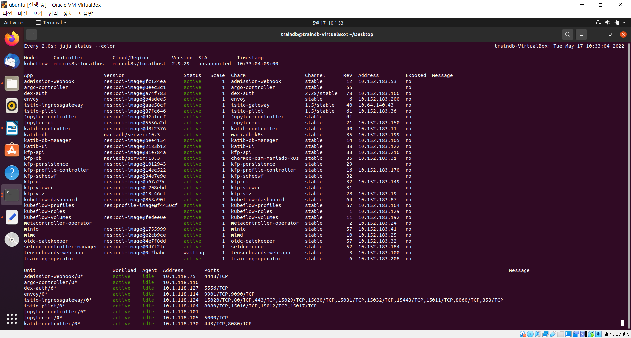

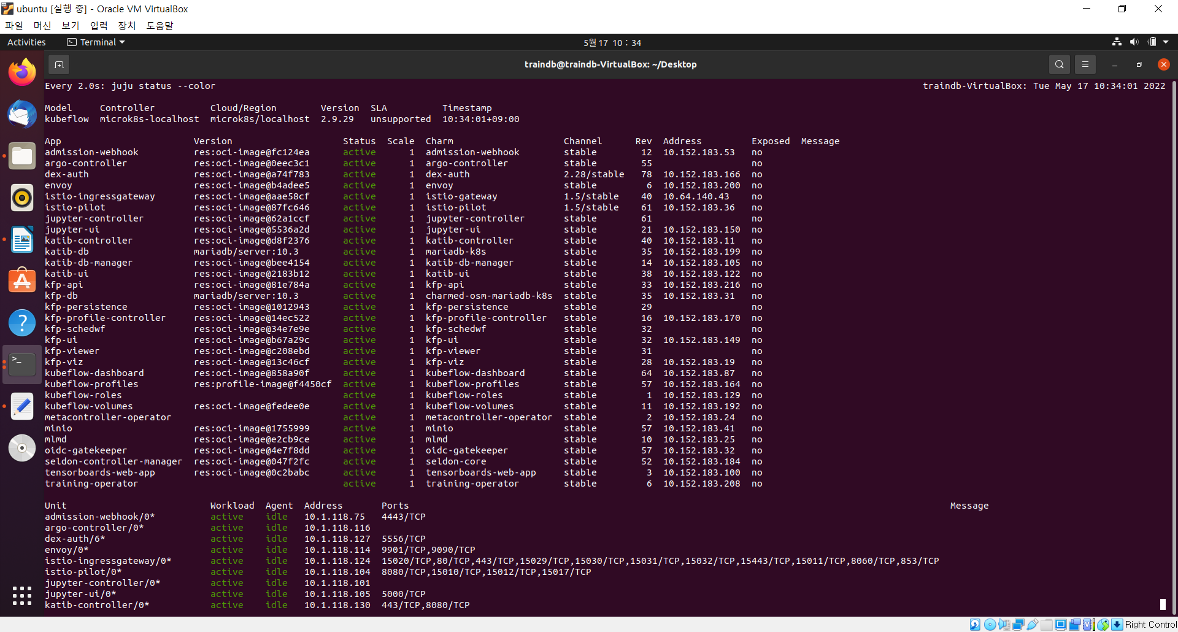

**traindb@traindb-VirtualBox:~/Desktop$** **juju relate istio-pilot tensorboards-web-app**

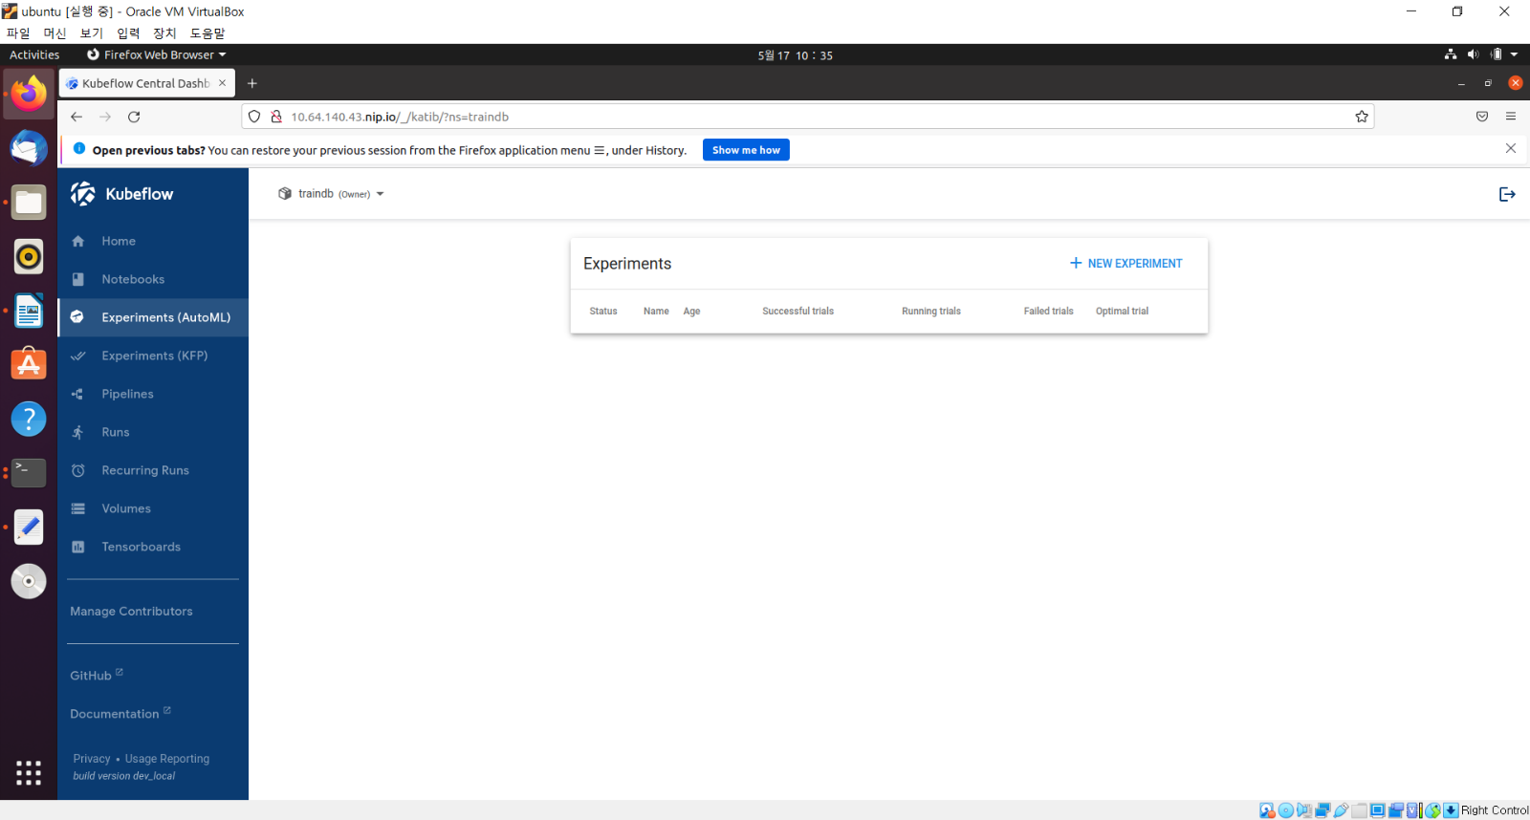

# **7. Install docker and container**

**traindb@traindb-VirtualBox:~/Desktop$** **sudo apt remove docker docker-engine docker.io containerd**

|  |
| --- |
| [sudo] password for traindb:  Reading package lists... Done  Building dependency tree  Reading state information... Done  E: Unable to locate package docker-engine |

**traindb@traindb-VirtualBox:~/Desktop$** **sudo apt update**

|  |
| --- |
| Get:1 http://security.ubuntu.com/ubuntu focal-security InRelease [114 kB]  Hit:2 http://kr.archive.ubuntu.com/ubuntu focal InRelease  Get:3 http://kr.archive.ubuntu.com/ubuntu focal-updates InRelease [114 kB]  Get:4 http://kr.archive.ubuntu.com/ubuntu focal-backports InRelease [108 kB]  Fetched 336 kB in 3s (131 kB/s)  Reading package lists... Done  Building dependency tree  Reading state information... Done  182 packages can be upgraded. Run 'apt list --upgradable' to see them. |

**traindb@traindb-VirtualBox:~/Desktop$** **sudo apt install -y apt-transport-https ca-certificates curl gnupg lsb-release**

|  |
| --- |
| Reading package lists... Done  Building dependency tree  Reading state information... Done  lsb-release is already the newest version (11.1.0ubuntu2).  lsb-release set to manually installed.  ca-certificates is already the newest version (20210119~20.04.2).  ca-certificates set to manually installed.  The following additional packages will be installed:  dirmngr gnupg-l10n gnupg-utils gpg gpg-agent gpg-wks-client gpg-wks-server gpgconf gpgsm gpgv  Suggested packages:  tor parcimonie xloadimage scdaemon  The following NEW packages will be installed:  apt-transport-https curl  The following packages will be upgraded:  dirmngr gnupg gnupg-l10n gnupg-utils gpg gpg-agent gpg-wks-client gpg-wks-server gpgconf gpgsm  gpgv  11 upgraded, 2 newly installed, 0 to remove and 171 not upgraded.  Need to get 2,729 kB of archives.  After this operation, 573 kB of additional disk space will be used.  Get:1 http://kr.archive.ubuntu.com/ubuntu focal-updates/main amd64 gpg-wks-client amd64 2.2.19-3ubuntu2.1 [97.6 kB]  Get:2 http://kr.archive.ubuntu.com/ubuntu focal-updates/main amd64 dirmngr amd64 2.2.19-3ubuntu2.1 [329 kB]  Get:3 http://kr.archive.ubuntu.com/ubuntu focal-updates/main amd64 gnupg-utils amd64 2.2.19-3ubuntu2.1 [480 kB]  Get:4 http://kr.archive.ubuntu.com/ubuntu focal-updates/main amd64 gpg-wks-server amd64 2.2.19-3ubuntu2.1 [90.3 kB]  Get:5 http://kr.archive.ubuntu.com/ubuntu focal-updates/main amd64 gpg-agent amd64 2.2.19-3ubuntu2.1 [232 kB]  Get:6 http://kr.archive.ubuntu.com/ubuntu focal-updates/main amd64 gpg amd64 2.2.19-3ubuntu2.1 [483 kB]  Get:7 http://kr.archive.ubuntu.com/ubuntu focal-updates/main amd64 gpgconf amd64 2.2.19-3ubuntu2.1 [124 kB]  Get:8 http://kr.archive.ubuntu.com/ubuntu focal-updates/main amd64 gnupg-l10n all 2.2.19-3ubuntu2.1 [51.7 kB]  Get:9 http://kr.archive.ubuntu.com/ubuntu focal-updates/main amd64 gnupg all 2.2.19-3ubuntu2.1 [259 kB]  Get:10 http://kr.archive.ubuntu.com/ubuntu focal-updates/main amd64 gpgsm amd64 2.2.19-3ubuntu2.1 [217 kB]  Get:11 http://kr.archive.ubuntu.com/ubuntu focal-updates/main amd64 gpgv amd64 2.2.19-3ubuntu2.1 [199 kB]  Get:12 http://kr.archive.ubuntu.com/ubuntu focal-updates/universe amd64 apt-transport-https all 2.0.6 [4,680 B]  Get:13 http://kr.archive.ubuntu.com/ubuntu focal-updates/main amd64 curl amd64 7.68.0-1ubuntu2.11 [162 kB]  Fetched 2,729 kB in 13s (218 kB/s)  (Reading database ... 187081 files and directories currently installed.)  Preparing to unpack .../00-gpg-wks-client_2.2.19-3ubuntu2.1_amd64.deb ...  Unpacking gpg-wks-client (2.2.19-3ubuntu2.1) over (2.2.19-3ubuntu2) ...  Preparing to unpack .../01-dirmngr_2.2.19-3ubuntu2.1_amd64.deb ...  Unpacking dirmngr (2.2.19-3ubuntu2.1) over (2.2.19-3ubuntu2) ...  Preparing to unpack .../02-gnupg-utils_2.2.19-3ubuntu2.1_amd64.deb ...  Unpacking gnupg-utils (2.2.19-3ubuntu2.1) over (2.2.19-3ubuntu2) ...  Preparing to unpack .../03-gpg-wks-server_2.2.19-3ubuntu2.1_amd64.deb ...  Unpacking gpg-wks-server (2.2.19-3ubuntu2.1) over (2.2.19-3ubuntu2) ...  Preparing to unpack .../04-gpg-agent_2.2.19-3ubuntu2.1_amd64.deb ...  Unpacking gpg-agent (2.2.19-3ubuntu2.1) over (2.2.19-3ubuntu2) ...  Preparing to unpack .../05-gpg_2.2.19-3ubuntu2.1_amd64.deb ...  Unpacking gpg (2.2.19-3ubuntu2.1) over (2.2.19-3ubuntu2) ...  Preparing to unpack .../06-gpgconf_2.2.19-3ubuntu2.1_amd64.deb ...  Unpacking gpgconf (2.2.19-3ubuntu2.1) over (2.2.19-3ubuntu2) ...  Preparing to unpack .../07-gnupg-l10n_2.2.19-3ubuntu2.1_all.deb ...  Unpacking gnupg-l10n (2.2.19-3ubuntu2.1) over (2.2.19-3ubuntu2) ...  Preparing to unpack .../08-gnupg_2.2.19-3ubuntu2.1_all.deb ...  Unpacking gnupg (2.2.19-3ubuntu2.1) over (2.2.19-3ubuntu2) ...  Preparing to unpack .../09-gpgsm_2.2.19-3ubuntu2.1_amd64.deb ...  Unpacking gpgsm (2.2.19-3ubuntu2.1) over (2.2.19-3ubuntu2) ...  Preparing to unpack .../10-gpgv_2.2.19-3ubuntu2.1_amd64.deb ...  Unpacking gpgv (2.2.19-3ubuntu2.1) over (2.2.19-3ubuntu2) ...  Setting up gpgv (2.2.19-3ubuntu2.1) ...  Selecting previously unselected package apt-transport-https.  (Reading database ... 187081 files and directories currently installed.)  Preparing to unpack .../apt-transport-https_2.0.6_all.deb ...  Unpacking apt-transport-https (2.0.6) ...  Selecting previously unselected package curl.  Preparing to unpack .../curl_7.68.0-1ubuntu2.11_amd64.deb ...  Unpacking curl (7.68.0-1ubuntu2.11) ...  Setting up apt-transport-https (2.0.6) ...  Setting up gnupg-l10n (2.2.19-3ubuntu2.1) ...  Setting up gpgconf (2.2.19-3ubuntu2.1) ...  Setting up curl (7.68.0-1ubuntu2.11) ...  Setting up gpg (2.2.19-3ubuntu2.1) ...  Setting up gnupg-utils (2.2.19-3ubuntu2.1) ...  Setting up gpg-agent (2.2.19-3ubuntu2.1) ...  Setting up gpgsm (2.2.19-3ubuntu2.1) ...  Setting up dirmngr (2.2.19-3ubuntu2.1) ...  Setting up gpg-wks-server (2.2.19-3ubuntu2.1) ...  Setting up gpg-wks-client (2.2.19-3ubuntu2.1) ...  Setting up gnupg (2.2.19-3ubuntu2.1) ...  Processing triggers for man-db (2.9.1-1) ...  Processing triggers for install-info (6.7.0.dfsg.2-5) ... |

**traindb@traindb-VirtualBox:~/Desktop$** **sudo curl -fsSL https://download.docker.com/linux/ubuntu/gpg | sudo gpg --dearmor -o /usr/share/keyrings/docker-archive-keyring.gpg**

**traindb@traindb-VirtualBox:~/Desktop$** **sudo echo "deb [arch=amd64 signed-by=/usr/share/keyrings/docker-archive-keyring.gpg] https://download.docker.com/linux/ubuntu $(lsb_release -cs) stable" | sudo tee /etc/apt/sources.list.d/docker.list > /dev/null**

**traindb@traindb-VirtualBox:~/Desktop$** **sudo apt update**

|  |
| --- |
| Hit:1 http://kr.archive.ubuntu.com/ubuntu focal InRelease  Get:2 http://security.ubuntu.com/ubuntu focal-security InRelease [114 kB]  Get:3 http://kr.archive.ubuntu.com/ubuntu focal-updates InRelease [114 kB]  Get:4 https://download.docker.com/linux/ubuntu focal InRelease [57.7 kB]  Get:5 https://download.docker.com/linux/ubuntu focal/stable amd64 Packages [16.7 kB]  Get:6 http://kr.archive.ubuntu.com/ubuntu focal-backports InRelease [108 kB]  Fetched 410 kB in 2s (238 kB/s)  Reading package lists... Done  Building dependency tree  Reading state information... Done  171 packages can be upgraded. Run 'apt list --upgradable' to see them. |

**traindb@traindb-VirtualBox:~/Desktop$** **sudo apt install docker-ce containerd.io**

|  |
| --- |
| Reading package lists... Done  Building dependency tree  Reading state information... Done  The following additional packages will be installed:  docker-ce-cli docker-ce-rootless-extras docker-scan-plugin git git-man liberror-perl pigz  slirp4netns  Suggested packages:  aufs-tools cgroupfs-mount | cgroup-lite git-daemon-run | git-daemon-sysvinit git-doc git-el  git-email git-gui gitk gitweb git-cvs git-mediawiki git-svn  The following NEW packages will be installed:  containerd.io docker-ce docker-ce-cli docker-ce-rootless-extras docker-scan-plugin git git-man  liberror-perl pigz slirp4netns  0 upgraded, 10 newly installed, 0 to remove and 171 not upgraded.  Need to get 107 MB of archives.  After this operation, 460 MB of additional disk space will be used.  Do you want to continue? [Y/n] y  Get:1 https://download.docker.com/linux/ubuntu focal/stable amd64 containerd.io amd64 1.6.4-1 [28.1 MB]  Get:2 http://kr.archive.ubuntu.com/ubuntu focal/universe amd64 pigz amd64 2.4-1 [57.4 kB]  Get:3 http://kr.archive.ubuntu.com/ubuntu focal/main amd64 liberror-perl all 0.17029-1 [26.5 kB]  Get:4 http://kr.archive.ubuntu.com/ubuntu focal-updates/main amd64 git-man all 1:2.25.1-1ubuntu3.4 [885 kB]  Get:5 https://download.docker.com/linux/ubuntu focal/stable amd64 docker-ce-cli amd64 5:20.10.16~3-0~ubuntu-focal [40.6 MB]  Get:6 http://kr.archive.ubuntu.com/ubuntu focal-updates/main amd64 git amd64 1:2.25.1-1ubuntu3.4 [4,560 kB]  Get:7 https://download.docker.com/linux/ubuntu focal/stable amd64 docker-ce amd64 5:20.10.16~3-0~ubuntu-focal [21.0 MB]  Get:8 https://download.docker.com/linux/ubuntu focal/stable amd64 docker-ce-rootless-extras amd64 5:20.10.16~3-0~ubuntu-focal [8,168 kB]  Get:9 https://download.docker.com/linux/ubuntu focal/stable amd64 docker-scan-plugin amd64 0.17.0~ubuntu-focal [3,521 kB]  Get:10 http://kr.archive.ubuntu.com/ubuntu focal/universe amd64 slirp4netns amd64 0.4.3-1 [74.3 kB]  Fetched 107 MB in 19s (5,723 kB/s)  Selecting previously unselected package pigz.  (Reading database ... 187092 files and directories currently installed.)  Preparing to unpack .../0-pigz_2.4-1_amd64.deb ...  Unpacking pigz (2.4-1) ...  Selecting previously unselected package containerd.io.  Preparing to unpack .../1-containerd.io_1.6.4-1_amd64.deb ...  Unpacking containerd.io (1.6.4-1) ...  Selecting previously unselected package docker-ce-cli.  Preparing to unpack .../2-docker-ce-cli_5%3a20.10.16~3-0~ubuntu-focal_amd64.deb ...  Unpacking docker-ce-cli (5:20.10.16~3-0~ubuntu-focal) ...  Selecting previously unselected package docker-ce.  Preparing to unpack .../3-docker-ce_5%3a20.10.16~3-0~ubuntu-focal_amd64.deb ...  Unpacking docker-ce (5:20.10.16~3-0~ubuntu-focal) ...  Selecting previously unselected package docker-ce-rootless-extras.  Preparing to unpack .../4-docker-ce-rootless-extras_5%3a20.10.16~3-0~ubuntu-focal_amd64.deb ...  Unpacking docker-ce-rootless-extras (5:20.10.16~3-0~ubuntu-focal) ...  Selecting previously unselected package docker-scan-plugin.  Preparing to unpack .../5-docker-scan-plugin_0.17.0~ubuntu-focal_amd64.deb ...  Unpacking docker-scan-plugin (0.17.0~ubuntu-focal) ...  Selecting previously unselected package liberror-perl.  Preparing to unpack .../6-liberror-perl_0.17029-1_all.deb ...  Unpacking liberror-perl (0.17029-1) ...  Selecting previously unselected package git-man.  Preparing to unpack .../7-git-man_1%3a2.25.1-1ubuntu3.4_all.deb ...  Unpacking git-man (1:2.25.1-1ubuntu3.4) ...  Selecting previously unselected package git.  Preparing to unpack .../8-git_1%3a2.25.1-1ubuntu3.4_amd64.deb ...  Unpacking git (1:2.25.1-1ubuntu3.4) ...  Selecting previously unselected package slirp4netns.  Preparing to unpack .../9-slirp4netns_0.4.3-1_amd64.deb ...  Unpacking slirp4netns (0.4.3-1) ...  Setting up slirp4netns (0.4.3-1) ...  Setting up docker-scan-plugin (0.17.0~ubuntu-focal) ...  Setting up liberror-perl (0.17029-1) ...  Setting up containerd.io (1.6.4-1) ...  Created symlink /etc/systemd/system/multi-user.target.wants/containerd.service → /lib/systemd/syste  m/containerd.service.  Setting up docker-ce-cli (5:20.10.16~3-0~ubuntu-focal) ...  Setting up pigz (2.4-1) ...  Setting up git-man (1:2.25.1-1ubuntu3.4) ...  Setting up docker-ce-rootless-extras (5:20.10.16~3-0~ubuntu-focal) ...  Setting up docker-ce (5:20.10.16~3-0~ubuntu-focal) ...  Created symlink /etc/systemd/system/multi-user.target.wants/docker.service → /lib/systemd/system/do  cker.service.  Created symlink /etc/systemd/system/sockets.target.wants/docker.socket → /lib/systemd/system/docker  .socket.  Setting up git (1:2.25.1-1ubuntu3.4) ...  Processing triggers for man-db (2.9.1-1) ...  Processing triggers for systemd (245.4-4ubuntu3.15) ... |

**traindb@traindb-VirtualBox:~/Desktop$** **cat <<EOF | sudo tee /etc/modules-load.d/containerd.conf**

|  |
| --- |
| **> overlay**  **> br_netfilter**  **> EOF**  overlay  br_netfilter |

**traindb@traindb-VirtualBox:~/Desktop$ cat <<EOF | sudo tee /etc/sysctl.d/99-kubernetes-cri.conf**

|  |
| --- |
| **> net.bridge.bridge-nf-call-iptables = 1**  **> net.ipv4.ip_forward = 1**  **> net.bridge.bridge-nf-call-ip6tables = 1**  **> EOF**  net.bridge.bridge-nf-call-iptables = 1  net.ipv4.ip_forward = 1  net.bridge.bridge-nf-call-ip6tables = 1 |

**traindb@traindb-VirtualBox:~/Desktop$** **sudo mkdir -p /etc/containerd**

**traindb@traindb-VirtualBox:~/Desktop$** **containerd config default | sudo tee /etc/containerd/config.toml**

|  |
| --- |
| disabled_plugins = []  imports = []  oom_score = 0  plugin_dir = ""  required_plugins = []  root = "/var/lib/containerd"  state = "/run/containerd"  temp = ""  version = 2  [cgroup]  path = ""  [debug]  address = ""  format = ""  gid = 0  level = ""  uid = 0  [grpc]  address = "/run/containerd/containerd.sock"  gid = 0  max_recv_message_size = 16777216  max_send_message_size = 16777216  tcp_address = ""  tcp_tls_ca = ""  tcp_tls_cert = ""  tcp_tls_key = ""  uid = 0  [metrics]  address = ""  grpc_histogram = false  [plugins]  [plugins."io.containerd.gc.v1.scheduler"]  deletion_threshold = 0  mutation_threshold = 100  pause_threshold = 0.02  schedule_delay = "0s"  startup_delay = "100ms"  [plugins."io.containerd.grpc.v1.cri"]  device_ownership_from_security_context = false  disable_apparmor = false  disable_cgroup = false  disable_hugetlb_controller = true  disable_proc_mount = false  disable_tcp_service = true  enable_selinux = false  enable_tls_streaming = false  enable_unprivileged_icmp = false  enable_unprivileged_ports = false  ignore_image_defined_volumes = false  max_concurrent_downloads = 3  max_container_log_line_size = 16384  netns_mounts_under_state_dir = false  restrict_oom_score_adj = false  sandbox_image = "k8s.gcr.io/pause:3.6"  selinux_category_range = 1024  stats_collect_period = 10  stream_idle_timeout = "4h0m0s"  stream_server_address = "127.0.0.1"  stream_server_port = "0"  systemd_cgroup = false  tolerate_missing_hugetlb_controller = true  unset_seccomp_profile = ""  [plugins."io.containerd.grpc.v1.cri".cni]  bin_dir = "/opt/cni/bin"  conf_dir = "/etc/cni/net.d"  conf_template = ""  ip_pref = ""  max_conf_num = 1  [plugins."io.containerd.grpc.v1.cri".containerd]  default_runtime_name = "runc"  disable_snapshot_annotations = true  discard_unpacked_layers = false  ignore_rdt_not_enabled_errors = false  no_pivot = false  snapshotter = "overlayfs"  [plugins."io.containerd.grpc.v1.cri".containerd.default_runtime]  base_runtime_spec = ""  cni_conf_dir = ""  cni_max_conf_num = 0  container_annotations = []  pod_annotations = []  privileged_without_host_devices = false  runtime_engine = ""  runtime_path = ""  runtime_root = ""  runtime_type = ""  [plugins."io.containerd.grpc.v1.cri".containerd.default_runtime.options]  [plugins."io.containerd.grpc.v1.cri".containerd.runtimes]  [plugins."io.containerd.grpc.v1.cri".containerd.runtimes.runc]  base_runtime_spec = ""  cni_conf_dir = ""  cni_max_conf_num = 0  container_annotations = []  pod_annotations = []  privileged_without_host_devices = false  runtime_engine = ""  runtime_path = ""  runtime_root = ""  runtime_type = "io.containerd.runc.v2"  [plugins."io.containerd.grpc.v1.cri".containerd.runtimes.runc.options]  BinaryName = ""  CriuImagePath = ""  CriuPath = ""  CriuWorkPath = ""  IoGid = 0  IoUid = 0  NoNewKeyring = false  NoPivotRoot = false  Root = ""  ShimCgroup = ""  SystemdCgroup = false  [plugins."io.containerd.grpc.v1.cri".containerd.untrusted_workload_runtime]  base_runtime_spec = ""  cni_conf_dir = ""  cni_max_conf_num = 0  container_annotations = []  pod_annotations = []  privileged_without_host_devices = false  runtime_engine = ""  runtime_path = ""  runtime_root = ""  runtime_type = ""  [plugins."io.containerd.grpc.v1.cri".containerd.untrusted_workload_runtime.options]  [plugins."io.containerd.grpc.v1.cri".image_decryption]  key_model = "node"  [plugins."io.containerd.grpc.v1.cri".registry]  config_path = ""  [plugins."io.containerd.grpc.v1.cri".registry.auths]  [plugins."io.containerd.grpc.v1.cri".registry.configs]  [plugins."io.containerd.grpc.v1.cri".registry.headers]  [plugins."io.containerd.grpc.v1.cri".registry.mirrors]  [plugins."io.containerd.grpc.v1.cri".x509_key_pair_streaming]  tls_cert_file = ""  tls_key_file = ""  [plugins."io.containerd.internal.v1.opt"]  path = "/opt/containerd"  [plugins."io.containerd.internal.v1.restart"]  interval = "10s"  [plugins."io.containerd.internal.v1.tracing"]  sampling_ratio = 1.0  service_name = "containerd"  [plugins."io.containerd.metadata.v1.bolt"]  content_sharing_policy = "shared"  [plugins."io.containerd.monitor.v1.cgroups"]  no_prometheus = false  [plugins."io.containerd.runtime.v1.linux"]  no_shim = false  runtime = "runc"  runtime_root = ""  shim = "containerd-shim"  shim_debug = false  [plugins."io.containerd.runtime.v2.task"]  platforms = ["linux/amd64"]  sched_core = false  [plugins."io.containerd.service.v1.diff-service"]  default = ["walking"]  [plugins."io.containerd.service.v1.tasks-service"]  rdt_config_file = ""  [plugins."io.containerd.snapshotter.v1.aufs"]  root_path = ""  [plugins."io.containerd.snapshotter.v1.btrfs"]  root_path = ""  [plugins."io.containerd.snapshotter.v1.devmapper"]  async_remove = false  base_image_size = ""  discard_blocks = false  fs_options = ""  fs_type = ""  pool_name = ""  root_path = ""  [plugins."io.containerd.snapshotter.v1.native"]  root_path = ""  [plugins."io.containerd.snapshotter.v1.overlayfs"]  root_path = ""  upperdir_label = false  [plugins."io.containerd.snapshotter.v1.zfs"]  root_path = ""  [plugins."io.containerd.tracing.processor.v1.otlp"]  endpoint = ""  insecure = false  protocol = ""  [proxy_plugins]  [stream_processors]  [stream_processors."io.containerd.ocicrypt.decoder.v1.tar"]  accepts = ["application/vnd.oci.image.layer.v1.tar+encrypted"]  args = ["--decryption-keys-path", "/etc/containerd/ocicrypt/keys"]  env = ["OCICRYPT_KEYPROVIDER_CONFIG=/etc/containerd/ocicrypt/ocicrypt_keyprovider.conf"]  path = "ctd-decoder"  returns = "application/vnd.oci.image.layer.v1.tar"  [stream_processors."io.containerd.ocicrypt.decoder.v1.tar.gzip"]  accepts = ["application/vnd.oci.image.layer.v1.tar+gzip+encrypted"]  args = ["--decryption-keys-path", "/etc/containerd/ocicrypt/keys"]  env = ["OCICRYPT_KEYPROVIDER_CONFIG=/etc/containerd/ocicrypt/ocicrypt_keyprovider.conf"]  path = "ctd-decoder"  returns = "application/vnd.oci.image.layer.v1.tar+gzip"  [timeouts]  "io.containerd.timeout.bolt.open" = "0s"  "io.containerd.timeout.shim.cleanup" = "5s"  "io.containerd.timeout.shim.load" = "5s"  "io.containerd.timeout.shim.shutdown" = "3s"  "io.containerd.timeout.task.state" = "2s"  [ttrpc]  address = ""  gid = 0  uid = 0 |

**traindb@traindb-VirtualBox:~/Desktop$** **sudo systemctl restart containerd**

**traindb@traindb-VirtualBox:~/Desktop$** **sudo vi /etc/containerd/config.toml**

|  |
| --- |
| - [plugins."io.containerd.grpc.v1.cri".containerd.runtimes.runc]  - ...  - [plugins."io.containerd.grpc.v1.cri".containerd.runtimes.runc.options]  - SystemdCgroup = **true** 변경  **traindb@traindb-VirtualBox:~/Desktop$** **sudo systemctl restart containerd**  **traindb@traindb-VirtualBox:~/Desktop$ sudo vi /etc/docker/daemon.json**  {  "exec-opts": ["native.cgroupdriver=systemd"],  "log-driver": "json-file",  "log-opts": {  "max-size": "100m"  },  "storage-driver": "overlay2"  } |

**traindb@traindb-VirtualBox:~/Desktop$** **sudo mkdir -p /etc/systemd/system/docker.service.d**

**traindb@traindb-VirtualBox:~/Desktop$ sudo systemctl daemon-reload**

**traindb@traindb-VirtualBox:~/Desktop$** **sudo systemctl restart docker**

**traindb@traindb-VirtualBox:~/Desktop$** **docker images**

|  |
| --- |
| Got permission denied while trying to connect to the Docker daemon socket at unix:///var/run/docker.sock: Get "http://%2Fvar%2Frun%2Fdocker.sock/v1.24/images/json": dial unix /var/run/docker.sock: connect: permission denied |

**traindb@traindb-VirtualBox:~/Desktop$** **sudo docker images**

|  |
| --- |
| REPOSITORY TAG IMAGE ID CREATED SIZE |

sudo usermod -aG docker $USER

sudo su $USER

# **8. Install miniconda**

**traindb@traindb-VirtualBox:~/Desktop$** **apt-get update**

|  |
| --- |
| Reading package lists... Done  E: List directory /var/lib/apt/lists/partial is missing. - Acquire (2: No such file or directory)  W: Problem unlinking the file /var/cache/apt/srcpkgcache.bin - RemoveCaches (13: Permission denied) |

**traindb@traindb-VirtualBox:~/Desktop$** **sudo apt-get update**

|  |
| --- |
| Get:1 https://download.docker.com/linux/ubuntu focal InRelease [57.7 kB]  Get:2 https://download.docker.com/linux/ubuntu focal/stable amd64 Packages [16.7 kB]  Get:3 http://kr.archive.ubuntu.com/ubuntu focal InRelease [265 kB]  Get:4 http://security.ubuntu.com/ubuntu focal-security InRelease [114 kB]  Get:5 http://kr.archive.ubuntu.com/ubuntu focal-updates InRelease [114 kB]  Get:6 http://security.ubuntu.com/ubuntu focal-security/main i386 Packages [432 kB]  Get:7 http://kr.archive.ubuntu.com/ubuntu focal-backports InRelease [108 kB]  Get:8 http://kr.archive.ubuntu.com/ubuntu focal/main i386 Packages [718 kB]  Get:9 http://security.ubuntu.com/ubuntu focal-security/main amd64 Packages [1,451 kB]  Get:10 http://kr.archive.ubuntu.com/ubuntu focal/main amd64 Packages [970 kB]  Get:11 http://kr.archive.ubuntu.com/ubuntu focal/main Translation-en [506 kB]  Get:12 http://kr.archive.ubuntu.com/ubuntu focal/main amd64 DEP-11 Metadata [494 kB]  Get:13 http://security.ubuntu.com/ubuntu focal-security/main Translation-en [249 kB]  Get:14 http://security.ubuntu.com/ubuntu focal-security/main amd64 DEP-11 Metadata [40.7 kB]  Get:15 http://security.ubuntu.com/ubuntu focal-security/main DEP-11 48x48 Icons [18.3 kB]  Get:16 http://security.ubuntu.com/ubuntu focal-security/main DEP-11 64x64 Icons [35.5 kB]  Get:17 http://kr.archive.ubuntu.com/ubuntu focal/main DEP-11 48x48 Icons [98.4 kB]  Get:18 http://security.ubuntu.com/ubuntu focal-security/main DEP-11 64x64@2 Icons [29 B]  Get:19 http://security.ubuntu.com/ubuntu focal-security/main amd64 c-n-f Metadata [10.1 kB]  Get:20 http://security.ubuntu.com/ubuntu focal-security/restricted i386 Packages [22.0 kB]  Get:21 http://security.ubuntu.com/ubuntu focal-security/restricted amd64 Packages [911 kB]  Get:22 http://kr.archive.ubuntu.com/ubuntu focal/main DEP-11 64x64 Icons [163 kB]  Get:23 http://kr.archive.ubuntu.com/ubuntu focal/main DEP-11 64x64@2 Icons [15.8 kB]  Get:24 http://kr.archive.ubuntu.com/ubuntu focal/main amd64 c-n-f Metadata [29.5 kB]  Get:25 http://kr.archive.ubuntu.com/ubuntu focal/restricted amd64 Packages [22.0 kB]  Get:26 http://kr.archive.ubuntu.com/ubuntu focal/restricted i386 Packages [8,112 B]  Get:27 http://kr.archive.ubuntu.com/ubuntu focal/restricted Translation-en [6,212 B]  Get:28 http://kr.archive.ubuntu.com/ubuntu focal/restricted amd64 c-n-f Metadata [392 B]  Get:29 http://kr.archive.ubuntu.com/ubuntu focal/universe i386 Packages [4,642 kB]  Get:30 http://security.ubuntu.com/ubuntu focal-security/restricted Translation-en [130 kB]  Get:31 http://security.ubuntu.com/ubuntu focal-security/restricted amd64 c-n-f Metadata [532 B]  Get:32 http://security.ubuntu.com/ubuntu focal-security/universe i386 Packages [550 kB]  Get:33 http://security.ubuntu.com/ubuntu focal-security/universe amd64 Packages [702 kB]  Get:34 http://security.ubuntu.com/ubuntu focal-security/universe Translation-en [125 kB]  Get:35 http://security.ubuntu.com/ubuntu focal-security/universe amd64 DEP-11 Metadata [66.3 kB]  Get:36 http://security.ubuntu.com/ubuntu focal-security/universe DEP-11 48x48 Icons [33.1 kB]  Get:37 http://security.ubuntu.com/ubuntu focal-security/universe DEP-11 64x64 Icons [71.6 kB]  Get:38 http://security.ubuntu.com/ubuntu focal-security/universe DEP-11 64x64@2 Icons [29 B]  Get:39 http://security.ubuntu.com/ubuntu focal-security/universe amd64 c-n-f Metadata [14.4 kB]  Get:40 http://security.ubuntu.com/ubuntu focal-security/multiverse amd64 Packages [20.7 kB]  Get:41 http://security.ubuntu.com/ubuntu focal-security/multiverse i386 Packages [7,180 B]  Get:42 http://security.ubuntu.com/ubuntu focal-security/multiverse Translation-en [5,196 B]  Get:43 http://security.ubuntu.com/ubuntu focal-security/multiverse amd64 DEP-11 Metadata [2,464 B]  Get:44 http://security.ubuntu.com/ubuntu focal-security/multiverse DEP-11 48x48 Icons [29 B]  Get:45 http://security.ubuntu.com/ubuntu focal-security/multiverse DEP-11 64x64 Icons [2,638 B]  Get:46 http://security.ubuntu.com/ubuntu focal-security/multiverse DEP-11 64x64@2 Icons [29 B]  Get:47 http://security.ubuntu.com/ubuntu focal-security/multiverse amd64 c-n-f Metadata [500 B]  Get:48 http://kr.archive.ubuntu.com/ubuntu focal/universe amd64 Packages [8,628 kB]  Get:49 http://kr.archive.ubuntu.com/ubuntu focal/universe Translation-en [5,124 kB]  Get:50 http://kr.archive.ubuntu.com/ubuntu focal/universe amd64 DEP-11 Metadata [3,603 kB]  Get:51 http://kr.archive.ubuntu.com/ubuntu focal/universe DEP-11 48x48 Icons [3,016 kB]  Get:52 http://kr.archive.ubuntu.com/ubuntu focal/universe DEP-11 64x64 Icons [7,794 kB]  Get:53 http://kr.archive.ubuntu.com/ubuntu focal/universe DEP-11 64x64@2 Icons [44.3 kB]  Get:54 http://kr.archive.ubuntu.com/ubuntu focal/universe amd64 c-n-f Metadata [265 kB]  Get:55 http://kr.archive.ubuntu.com/ubuntu focal/multiverse amd64 Packages [144 kB]  Get:56 http://kr.archive.ubuntu.com/ubuntu focal/multiverse i386 Packages [74.7 kB]  Get:57 http://kr.archive.ubuntu.com/ubuntu focal/multiverse Translation-en [104 kB]  Get:58 http://kr.archive.ubuntu.com/ubuntu focal/multiverse amd64 DEP-11 Metadata [48.4 kB]  Get:59 http://kr.archive.ubuntu.com/ubuntu focal/multiverse DEP-11 48x48 Icons [23.1 kB]  Get:60 http://kr.archive.ubuntu.com/ubuntu focal/multiverse DEP-11 64x64 Icons [192 kB]  Get:61 http://kr.archive.ubuntu.com/ubuntu focal/multiverse DEP-11 64x64@2 Icons [214 B]  Get:62 http://kr.archive.ubuntu.com/ubuntu focal/multiverse amd64 c-n-f Metadata [9,136 B]  Get:63 http://kr.archive.ubuntu.com/ubuntu focal-updates/main i386 Packages [650 kB]  Get:64 http://kr.archive.ubuntu.com/ubuntu focal-updates/main amd64 Packages [1,790 kB]  Get:65 http://kr.archive.ubuntu.com/ubuntu focal-updates/main Translation-en [330 kB]  Get:66 http://kr.archive.ubuntu.com/ubuntu focal-updates/main amd64 DEP-11 Metadata [278 kB]  Get:67 http://kr.archive.ubuntu.com/ubuntu focal-updates/main DEP-11 48x48 Icons [60.8 kB]  Get:68 http://kr.archive.ubuntu.com/ubuntu focal-updates/main DEP-11 64x64 Icons [98.3 kB]  Get:69 http://kr.archive.ubuntu.com/ubuntu focal-updates/main DEP-11 64x64@2 Icons [29 B]  Get:70 http://kr.archive.ubuntu.com/ubuntu focal-updates/main amd64 c-n-f Metadata [15.1 kB]  Get:71 http://kr.archive.ubuntu.com/ubuntu focal-updates/restricted i386 Packages [24.3 kB]  Get:72 http://kr.archive.ubuntu.com/ubuntu focal-updates/restricted amd64 Packages [975 kB]  Get:73 http://kr.archive.ubuntu.com/ubuntu focal-updates/restricted Translation-en [139 kB]  Get:74 http://kr.archive.ubuntu.com/ubuntu focal-updates/restricted amd64 c-n-f Metadata [528 B]  Get:75 http://kr.archive.ubuntu.com/ubuntu focal-updates/universe amd64 Packages [920 kB]  Get:76 http://kr.archive.ubuntu.com/ubuntu focal-updates/universe i386 Packages [679 kB]  Get:77 http://kr.archive.ubuntu.com/ubuntu focal-updates/universe Translation-en [206 kB]  Get:78 http://kr.archive.ubuntu.com/ubuntu focal-updates/universe amd64 DEP-11 Metadata [390 kB]  Get:79 http://kr.archive.ubuntu.com/ubuntu focal-updates/universe DEP-11 48x48 Icons [257 kB]  Get:80 http://kr.archive.ubuntu.com/ubuntu focal-updates/universe DEP-11 64x64 Icons [458 kB]  Get:81 http://kr.archive.ubuntu.com/ubuntu focal-updates/universe DEP-11 64x64@2 Icons [29 B]  Get:82 http://kr.archive.ubuntu.com/ubuntu focal-updates/universe amd64 c-n-f Metadata [20.6 kB]  Get:83 http://kr.archive.ubuntu.com/ubuntu focal-updates/multiverse amd64 Packages [24.4 kB]  Get:84 http://kr.archive.ubuntu.com/ubuntu focal-updates/multiverse i386 Packages [8,432 B]  Get:85 http://kr.archive.ubuntu.com/ubuntu focal-updates/multiverse Translation-en [7,336 B]  Get:86 http://kr.archive.ubuntu.com/ubuntu focal-updates/multiverse amd64 DEP-11 Metadata [944 B]  Get:87 http://kr.archive.ubuntu.com/ubuntu focal-updates/multiverse DEP-11 48x48 Icons [1,867 B]  Get:88 http://kr.archive.ubuntu.com/ubuntu focal-updates/multiverse DEP-11 64x64 Icons [2,497 B]  Get:89 http://kr.archive.ubuntu.com/ubuntu focal-updates/multiverse DEP-11 64x64@2 Icons [29 B]  Get:90 http://kr.archive.ubuntu.com/ubuntu focal-updates/multiverse amd64 c-n-f Metadata [592 B]  Get:91 http://kr.archive.ubuntu.com/ubuntu focal-backports/main i386 Packages [34.8 kB]  Get:92 http://kr.archive.ubuntu.com/ubuntu focal-backports/main amd64 Packages [42.2 kB]  Get:93 http://kr.archive.ubuntu.com/ubuntu focal-backports/main Translation-en [10.1 kB]  Get:94 http://kr.archive.ubuntu.com/ubuntu focal-backports/main amd64 DEP-11 Metadata [9,588 B]  Get:95 http://kr.archive.ubuntu.com/ubuntu focal-backports/main DEP-11 48x48 Icons [6,961 B]  Get:96 http://kr.archive.ubuntu.com/ubuntu focal-backports/main DEP-11 64x64 Icons [10.5 kB]  Get:97 http://kr.archive.ubuntu.com/ubuntu focal-backports/main DEP-11 64x64@2 Icons [29 B]  Get:98 http://kr.archive.ubuntu.com/ubuntu focal-backports/main amd64 c-n-f Metadata [864 B]  Get:99 http://kr.archive.ubuntu.com/ubuntu focal-backports/restricted amd64 c-n-f Metadata [116 B]  Get:100 http://kr.archive.ubuntu.com/ubuntu focal-backports/universe amd64 Packages [22.7 kB]  Get:101 http://kr.archive.ubuntu.com/ubuntu focal-backports/universe i386 Packages [12.8 kB]  Get:102 http://kr.archive.ubuntu.com/ubuntu focal-backports/universe Translation-en [15.5 kB]  Get:103 http://kr.archive.ubuntu.com/ubuntu focal-backports/universe amd64 DEP-11 Metadata [30.8 kB]  Get:104 http://kr.archive.ubuntu.com/ubuntu focal-backports/universe DEP-11 48x48 Icons [13.2 kB]  Get:105 http://kr.archive.ubuntu.com/ubuntu focal-backports/universe DEP-11 64x64 Icons [22.6 kB]  Get:106 http://kr.archive.ubuntu.com/ubuntu focal-backports/universe DEP-11 64x64@2 Icons [29 B]  Get:107 http://kr.archive.ubuntu.com/ubuntu focal-backports/universe amd64 c-n-f Metadata [804 B]  Get:108 http://kr.archive.ubuntu.com/ubuntu focal-backports/multiverse amd64 c-n-f Metadata [116 B]  Fetched 49.9 MB in 2min 22s (351 kB/s)  Reading package lists... Done |

**traindb@traindb-VirtualBox:~/Desktop$** **sudo apt-get install -y wget bzip2**

|  |
| --- |
| Reading package lists... Done  Building dependency tree  Reading state information... Done  bzip2 is already the newest version (1.0.8-2).  bzip2 set to manually installed.  The following packages will be upgraded:  wget  1 upgraded, 0 newly installed, 0 to remove and 170 not upgraded.  Need to get 348 kB of archives.  After this operation, 4,096 B disk space will be freed.  Get:1 http://kr.archive.ubuntu.com/ubuntu focal-updates/main amd64 wget amd64 1.20.3-1ubuntu2 [348 kB]  Fetched 348 kB in 3s (136 kB/s)  (Reading database ... 188277 files and directories currently installed.)  Preparing to unpack .../wget_1.20.3-1ubuntu2_amd64.deb ...  Unpacking wget (1.20.3-1ubuntu2) over (1.20.3-1ubuntu1) ...  Setting up wget (1.20.3-1ubuntu2) ...  Processing triggers for install-info (6.7.0.dfsg.2-5) ...  Processing triggers for man-db (2.9.1-1) ... |

**traindb@traindb-VirtualBox:~/Desktop$** **wget https://repo.continuum.io/miniconda/Miniconda3-latest-Linux-x86_64.sh**

|  |
| --- |
| --2022-05-17 12:09:20-- https://repo.continuum.io/miniconda/Miniconda3-latest-Linux-x86_64.sh  Resolving repo.continuum.io (repo.continuum.io)... 104.18.201.79, 104.18.200.79, 2606:4700::6812:c94f, ...  Connecting to repo.continuum.io (repo.continuum.io)|104.18.201.79|:443... connected.  HTTP request sent, awaiting response... 301 Moved Permanently  Location: https://repo.anaconda.com/miniconda/Miniconda3-latest-Linux-x86_64.sh [following]  --2022-05-17 12:09:20-- https://repo.anaconda.com/miniconda/Miniconda3-latest-Linux-x86_64.sh  Resolving repo.anaconda.com (repo.anaconda.com)... 104.16.130.3, 104.16.131.3, 2606:4700::6810:8303, ...  Connecting to repo.anaconda.com (repo.anaconda.com)|104.16.130.3|:443... connected.  HTTP request sent, awaiting response... 200 OK  Length: 76607678 (73M) [application/x-sh]  Saving to: ‘Miniconda3-latest-Linux-x86_64.sh’  Miniconda3-latest-Linux- 100%[===============================>] 73.06M 11.2MB/s in 6.6s  2022-05-17 12:09:27 (11.1 MB/s) - ‘Miniconda3-latest-Linux-x86_64.sh’ saved [76607678/76607678] |

**traindb@traindb-VirtualBox:~/Desktop$** **bash Miniconda3-latest-Linux-x86_64.sh**

|  |
| --- |
| Welcome to Miniconda3 py39_4.12.0  In order to continue the installation process, please review the license  agreement.  Please, press ENTER to continue  >>>  ======================================  End User License Agreement - Miniconda  ======================================  Copyright 2015-2022, Anaconda, Inc.  All rights reserved under the 3-clause BSD License:  This End User License Agreement (the "Agreement") is a legal agreement between you and Anaconda,  Inc. ("Anaconda") and governs your use of Miniconda.  Subject to the terms of this Agreement, Anaconda hereby grants you a non-exclusive, non-transfera  ble license to:  * Install and use the Miniconda,  * Modify and create derivative works of sample source code delivered in Miniconda subject to th  e Terms of Service for the Repository (as defined hereinafter) available at https://www.anaconda.  com/terms-of-service, and  * Redistribute code files in source (if provided to you by Anaconda as source) and binary forms  , with or without modification subject to the requirements set forth below.  Anaconda may, at its option, make available patches, workarounds or other updates to Miniconda. U  nless the updates are provided with their separate governing terms, they are deemed part of Minic  onda licensed to you as provided in this Agreement. This Agreement does not entitle you to any su  pport for Miniconda.  Anaconda reserves all rights not expressly granted to you in this Agreement.  Redistribution and use in source and binary forms, with or without modification, are permitted pr  ovided that the following conditions are met:  * Redistributions of source code must retain the above copyright notice, this list of condition  s and the following disclaimer.  * Redistributions in binary form must reproduce the above copyright notice, this list of condit  ions and the following disclaimer in the documentation and/or other materials provided with the d  istribution.  * Neither the name of Anaconda nor the names of its contributors may be used to endorse or prom  ote products derived from this software without specific prior written permission.  You acknowledge that, as between you and Anaconda, Anaconda owns all right, title, and interest,  including all intellectual property rights, in and to Miniconda and, with respect to third-party  products distributed with or through Miniconda, the applicable third-party licensors own all righ  t, title and interest, including all intellectual property rights, in and to such products. If yo  u send or transmit any communications or materials to Anaconda suggesting or recommending changes  to the software or documentation, including without limitation, new features or functionality re  lating thereto, or any comments, questions, suggestions or the like ("Feedback"), Anaconda is fre  e to use such Feedback. You hereby assign to Anaconda all right, title, and interest in, and Anac  onda is free to use, without any attribution or compensation to any party, any ideas, know-how, c  oncepts, techniques or other intellectual property rights contained in the Feedback, for any purp  ose whatsoever, although Anaconda is not required to use any Feedback.  DISCLAIMER  ==========  THIS SOFTWARE IS PROVIDED BY ANACONDA AND ITS CONTRIBUTORS "AS IS" AND ANY EXPRESS OR IMPLIED WAR  RANTIES, INCLUDING, BUT NOT LIMITED TO, THE IMPLIED WARRANTIES OF MERCHANTABILITY AND FITNESS FOR  A PARTICULAR PURPOSE ARE DISCLAIMED. IN NO EVENT SHALL ANACONDA BE LIABLE FOR ANY DIRECT, INDIRE  CT, INCIDENTAL, SPECIAL, EXEMPLARY, OR CONSEQUENTIAL DAMAGES (INCLUDING, BUT NOT LIMITED TO, PROC  UREMENT OF SUBSTITUTE GOODS OR SERVICES; LOSS OF USE, DATA, OR PROFITS; OR BUSINESS INTERRUPTION)  HOWEVER CAUSED AND ON ANY THEORY OF LIABILITY, WHETHER IN CONTRACT, STRICT LIABILITY, OR TORT (I  NCLUDING NEGLIGENCE OR OTHERWISE) ARISING IN ANY WAY OUT OF THE USE OF THIS SOFTWARE, EVEN IF ADV  ISED OF THE POSSIBILITY OF SUCH DAMAGE.  TO THE MAXIMUM EXTENT PERMITTED BY LAW, ANACONDA AND ITS AFFILIATES SHALL NOT BE LIABLE FOR ANY S  PECIAL, INCIDENTAL, PUNITIVE OR CONSEQUENTIAL DAMAGES, OR ANY LOST PROFITS, LOSS OF USE, LOSS OF  DATA OR LOSS OF GOODWILL, OR THE COSTS OF PROCURING SUBSTITUTE PRODUCTS, ARISING OUT OF OR IN CON  NECTION WITH THIS AGREEMENT OR THE USE OR PERFORMANCE OF MINICONDA, WHETHER SUCH LIABILITY ARISES  FROM ANY CLAIM BASED UPON BREACH OF CONTRACT, BREACH OF WARRANTY, TORT (INCLUDING NEGLIGENCE), P  RODUCT LIABILITY OR ANY OTHER CAUSE OF ACTION OR THEORY OF LIABILITY. IN NO EVENT WILL THE TOTAL  CUMULATIVE LIABILITY OF ANACONDA AND ITS AFFILIATES UNDER OR ARISING OUT OF THIS AGREEMENT EXCEED  US0.00.  Miscellaneous  =============  If you want to terminate this Agreement, you may do so by discontinuing use of Miniconda. Anacond  a may, at any time, terminate this Agreement and the license granted hereunder if you fail to com  ply with any term of this Agreement. Upon any termination of this Agreement, you agree to promptl  y discontinue use of the Miniconda and destroy all copies in your possession or control. Upon any  termination of this Agreement all provisions survive except for the licenses granted to you.  This Agreement is governed by and construed in accordance with the internal laws of the State of  Texas without giving effect to any choice or conflict of law provision or rule that would require  or permit the application of the laws of any jurisdiction other than those of the State of Texas  . Any legal suit, action, or proceeding arising out of or related to this Agreement or the licens  es granted hereunder by you must be instituted exclusively in the federal courts of the United St  ates or the courts of the State of Texas in each case located in Travis County, Texas, and you ir  revocably submit to the jurisdiction of such courts in any such suit, action, or proceeding.  Notice of Third Party Software Licenses  =======================================  Miniconda provides access to a repository (the "Repository") which contains software packages or  tools licensed on an open source basis from third parties and binary packages of these third part  y tools. These third party software packages or tools are provided on an "as is" basis and are su  bject to their respective license agreements as well as this Agreement and the Terms of Service f  or the Repository located at https://www.anaconda.com/terms-of-service; provided, however, no res  triction contained in the Terms of Service shall be construed so as to limit Your ability to down  load the packages contained in Miniconda provided you comply with the license for each such packa  ge. These licenses may be accessed from within the Miniconda software[1] or https://www.anaconda.  com/legal. Information regarding which license is applicable is available from within many of the  third party software packages and tools and at https://repo.anaconda.com/pkgs/main/ and https://  repo.anaconda.com/pkgs/r/. Anaconda reserves the right, in its sole discretion, to change which t  hird party tools are included in the Repository accessible through Miniconda.  Intel Math Kernel Library  -------------------------  Miniconda provides access to re-distributable, run-time, shared-library files from the Intel Math  Kernel Library ("MKL binaries").  Copyright 2018 Intel Corporation. License available at https://software.intel.com/en-us/license/i  ntel-simplified-software-license (the "MKL License").  You may use and redistribute the MKL binaries, without modification, provided the following condi  tions are met:  * Redistributions must reproduce the above copyright notice and the following terms of use in t  he MKL binaries and in the documentation and/or other materials provided with the distribution.  * Neither the name of Intel nor the names of its suppliers may be used to endorse or promote pr  oducts derived from the MKL binaries without specific prior written permission.  * No reverse engineering, decompilation, or disassembly of the MKL binaries is permitted.  You are specifically authorized to use and redistribute the MKL binaries with your installation o  f Miniconda subject to the terms set forth in the MKL License. You are also authorized to redistr  ibute the MKL binaries with Miniconda or in the Anaconda package that contains the MKL binaries.  If needed, instructions for removing the MKL binaries after installation of Miniconda are availab  le at https://docs.anaconda.com.  cuDNN Software  --------------  Miniconda also provides access to cuDNN software binaries ("cuDNN binaries") from NVIDIA Corporat  ion. You are specifically authorized to use the cuDNN binaries with your installation of Minicond  a subject to your compliance with the license agreement located at https://docs.nvidia.com/deeple  arning/sdk/cudnn-sla/index.html. You are also authorized to redistribute the cuDNN binaries with  an Miniconda package that contains the cuDNN binaries. You can add or remove the cuDNN binaries u  tilizing the install and uninstall features in Miniconda.  cuDNN binaries contain source code provided by NVIDIA Corporation.  Arm Performance Libraries  -------------------------  Arm Performance Libraries (Free Version): Anaconda provides access to software and related docume  ntation from the Arm Performance Libraries ("Arm PL") provided by Arm Limited. By installing or o  therwise accessing the Arm PL, you acknowledge and agree that use and distribution of the Arm PL  is subject to your compliance with the Arm PL end user license agreement located at: https://deve  loper.arm.com/tools-and-software/server-and-hpc/downloads/arm-performance-libraries/eula.  Export; Cryptography Notice  ===========================  You must comply with all domestic and international export laws and regulations that apply to the  software, which include restrictions on destinations, end users, and end use. Miniconda includes  cryptographic software. The country in which you currently reside may have restrictions on the i  mport, possession, use, and/or re-export to another country, of encryption software. BEFORE using  any encryption software, please check your country's laws, regulations and policies concerning t  he import, possession, or use, and re-export of encryption software, to see if this is permitted.  See the Wassenaar Arrangement http://www.wassenaar.org/ for more information.  Anaconda has self-classified this software as Export Commodity Control Number (ECCN) EAR99, which  includes mass market information security software using or performing cryptographic functions w  ith asymmetric algorithms. No license is required for export of this software to non-embargoed co  untries.  The Intel Math Kernel Library contained in Miniconda is classified by Intel as ECCN 5D992.c with  no license required for export to non-embargoed countries.  The following packages listed on https://www.anaconda.com/cryptography are included in the Reposi  tory accessible through Miniconda that relate to cryptography.  Last updated March 21, 2022  Do you accept the license terms? [yes|no]  **[no] >>> yes**  Miniconda3 will now be installed into this location:  /home/traindb/miniconda3  - Press ENTER to confirm the location  - Press CTRL-C to abort the installation  - Or specify a different location below  [/home/traindb/miniconda3] >>>  PREFIX=/home/traindb/miniconda3  Unpacking payload ...  Collecting package metadata (current_repodata.json): done  Solving environment: done  ## Package Plan ##  environment location: /home/traindb/miniconda3  added / updated specs:  - _libgcc_mutex==0.1=main  - _openmp_mutex==4.5=1_gnu  - brotlipy==0.7.0=py39h27cfd23_1003  - ca-certificates==2022.3.29=h06a4308_1  - certifi==2021.10.8=py39h06a4308_2  - cffi==1.15.0=py39hd667e15_1  - charset-normalizer==2.0.4=pyhd3eb1b0_0  - colorama==0.4.4=pyhd3eb1b0_0  - conda-content-trust==0.1.1=pyhd3eb1b0_0  - conda-package-handling==1.8.1=py39h7f8727e_0  - conda==4.12.0=py39h06a4308_0  - cryptography==36.0.0=py39h9ce1e76_0  - idna==3.3=pyhd3eb1b0_0  - ld_impl_linux-64==2.35.1=h7274673_9  - libffi==3.3=he6710b0_2  - libgcc-ng==9.3.0=h5101ec6_17  - libgomp==9.3.0=h5101ec6_17  - libstdcxx-ng==9.3.0=hd4cf53a_17  - ncurses==6.3=h7f8727e_2  - openssl==1.1.1n=h7f8727e_0  - pip==21.2.4=py39h06a4308_0  - pycosat==0.6.3=py39h27cfd23_0  - pycparser==2.21=pyhd3eb1b0_0  - pyopenssl==22.0.0=pyhd3eb1b0_0  - pysocks==1.7.1=py39h06a4308_0  - python==3.9.12=h12debd9_0  - readline==8.1.2=h7f8727e_1  - requests==2.27.1=pyhd3eb1b0_0  - ruamel_yaml==0.15.100=py39h27cfd23_0  - setuptools==61.2.0=py39h06a4308_0  - six==1.16.0=pyhd3eb1b0_1  - sqlite==3.38.2=hc218d9a_0  - tk==8.6.11=h1ccaba5_0  - tqdm==4.63.0=pyhd3eb1b0_0  - tzdata==2022a=hda174b7_0  - urllib3==1.26.8=pyhd3eb1b0_0  - wheel==0.37.1=pyhd3eb1b0_0  - xz==5.2.5=h7b6447c_0  - yaml==0.2.5=h7b6447c_0  - zlib==1.2.12=h7f8727e_1  The following NEW packages will be INSTALLED:  _libgcc_mutex pkgs/main/linux-64::_libgcc_mutex-0.1-main  _openmp_mutex pkgs/main/linux-64::_openmp_mutex-4.5-1_gnu  brotlipy pkgs/main/linux-64::brotlipy-0.7.0-py39h27cfd23_1003  ca-certificates pkgs/main/linux-64::ca-certificates-2022.3.29-h06a4308_1  certifi pkgs/main/linux-64::certifi-2021.10.8-py39h06a4308_2  cffi pkgs/main/linux-64::cffi-1.15.0-py39hd667e15_1  charset-normalizer pkgs/main/noarch::charset-normalizer-2.0.4-pyhd3eb1b0_0  colorama pkgs/main/noarch::colorama-0.4.4-pyhd3eb1b0_0  conda pkgs/main/linux-64::conda-4.12.0-py39h06a4308_0  conda-content-tru~ pkgs/main/noarch::conda-content-trust-0.1.1-pyhd3eb1b0_0  conda-package-han~ pkgs/main/linux-64::conda-package-handling-1.8.1-py39h7f8727e_0  cryptography pkgs/main/linux-64::cryptography-36.0.0-py39h9ce1e76_0  idna pkgs/main/noarch::idna-3.3-pyhd3eb1b0_0  ld_impl_linux-64 pkgs/main/linux-64::ld_impl_linux-64-2.35.1-h7274673_9  libffi pkgs/main/linux-64::libffi-3.3-he6710b0_2  libgcc-ng pkgs/main/linux-64::libgcc-ng-9.3.0-h5101ec6_17  libgomp pkgs/main/linux-64::libgomp-9.3.0-h5101ec6_17  libstdcxx-ng pkgs/main/linux-64::libstdcxx-ng-9.3.0-hd4cf53a_17  ncurses pkgs/main/linux-64::ncurses-6.3-h7f8727e_2  openssl pkgs/main/linux-64::openssl-1.1.1n-h7f8727e_0  pip pkgs/main/linux-64::pip-21.2.4-py39h06a4308_0  pycosat pkgs/main/linux-64::pycosat-0.6.3-py39h27cfd23_0  pycparser pkgs/main/noarch::pycparser-2.21-pyhd3eb1b0_0  pyopenssl pkgs/main/noarch::pyopenssl-22.0.0-pyhd3eb1b0_0  pysocks pkgs/main/linux-64::pysocks-1.7.1-py39h06a4308_0  python pkgs/main/linux-64::python-3.9.12-h12debd9_0  readline pkgs/main/linux-64::readline-8.1.2-h7f8727e_1  requests pkgs/main/noarch::requests-2.27.1-pyhd3eb1b0_0  ruamel_yaml pkgs/main/linux-64::ruamel_yaml-0.15.100-py39h27cfd23_0  setuptools pkgs/main/linux-64::setuptools-61.2.0-py39h06a4308_0  six pkgs/main/noarch::six-1.16.0-pyhd3eb1b0_1  sqlite pkgs/main/linux-64::sqlite-3.38.2-hc218d9a_0  tk pkgs/main/linux-64::tk-8.6.11-h1ccaba5_0  tqdm pkgs/main/noarch::tqdm-4.63.0-pyhd3eb1b0_0  tzdata pkgs/main/noarch::tzdata-2022a-hda174b7_0  urllib3 pkgs/main/noarch::urllib3-1.26.8-pyhd3eb1b0_0  wheel pkgs/main/noarch::wheel-0.37.1-pyhd3eb1b0_0  xz pkgs/main/linux-64::xz-5.2.5-h7b6447c_0  yaml pkgs/main/linux-64::yaml-0.2.5-h7b6447c_0  zlib pkgs/main/linux-64::zlib-1.2.12-h7f8727e_1  Preparing transaction: done  Executing transaction: done  installation finished.  Do you wish the installer to initialize Miniconda3  by running conda init? [yes|no]  [no] >>> yes  no change /home/traindb/miniconda3/condabin/conda  no change /home/traindb/miniconda3/bin/conda  no change /home/traindb/miniconda3/bin/conda-env  no change /home/traindb/miniconda3/bin/activate  no change /home/traindb/miniconda3/bin/deactivate  no change /home/traindb/miniconda3/etc/profile.d/conda.sh  no change /home/traindb/miniconda3/etc/fish/conf.d/conda.fish  no change /home/traindb/miniconda3/shell/condabin/Conda.psm1  no change /home/traindb/miniconda3/shell/condabin/conda-hook.ps1  no change /home/traindb/miniconda3/lib/python3.9/site-packages/xontrib/conda.xsh  no change /home/traindb/miniconda3/etc/profile.d/conda.csh  modified /home/traindb/.bashrc  ==> For changes to take effect, close and re-open your current shell. <==  If you'd prefer that conda's base environment not be activated on startup,  set the auto_activate_base parameter to false:  conda config --set auto_activate_base false  Thank you for installing Miniconda3! |

**traindb@traindb-VirtualBox:~/Desktop$** **which conda**

**traindb@traindb-VirtualBox:~/Desktop$** **export PATH=/home/traindb/miniconda3/bin/:$PATH**

**traindb@traindb-VirtualBox:~/Desktop$** **which conda**

|  |
| --- |
| /home/traindb/miniconda3/bin//conda |

**traindb@traindb-VirtualBox:~/Desktop$** **conda create --name mlpipeline python=3.6**

|  |
| --- |
| Collecting package metadata (current_repodata.json): done  Solving environment: failed with repodata from current_repodata.json, will retry with next repodata source.  Collecting package metadata (repodata.json): done  Solving environment: done  ## Package Plan ##  environment location: /home/traindb/miniconda3/envs/mlpipeline  added / updated specs:  - python=3.6  The following packages will be downloaded:  package | build  ---------------------------|-----------------  ca-certificates-2022.4.26 | h06a4308_0 124 KB  certifi-2021.5.30 | py36h06a4308_0 139 KB  ld_impl_linux-64-2.38 | h1181459_0 654 KB  openssl-1.1.1o | h7f8727e_0 2.5 MB  pip-21.2.2 | py36h06a4308_0 1.8 MB  python-3.6.13 | h12debd9_1 32.5 MB  setuptools-58.0.4 | py36h06a4308_0 788 KB  sqlite-3.38.3 | hc218d9a_0 1.0 MB  tk-8.6.11 | h1ccaba5_1 3.0 MB  xz-5.2.5 | h7f8727e_1 339 KB  zlib-1.2.12 | h7f8727e_2 106 KB  ------------------------------------------------------------  Total: 43.0 MB  The following NEW packages will be INSTALLED:  _libgcc_mutex pkgs/main/linux-64::_libgcc_mutex-0.1-main  _openmp_mutex pkgs/main/linux-64::_openmp_mutex-4.5-1_gnu  ca-certificates pkgs/main/linux-64::ca-certificates-2022.4.26-h06a4308_0  certifi pkgs/main/linux-64::certifi-2021.5.30-py36h06a4308_0  ld_impl_linux-64 pkgs/main/linux-64::ld_impl_linux-64-2.38-h1181459_0  libffi pkgs/main/linux-64::libffi-3.3-he6710b0_2  libgcc-ng pkgs/main/linux-64::libgcc-ng-9.3.0-h5101ec6_17  libgomp pkgs/main/linux-64::libgomp-9.3.0-h5101ec6_17  libstdcxx-ng pkgs/main/linux-64::libstdcxx-ng-9.3.0-hd4cf53a_17  ncurses pkgs/main/linux-64::ncurses-6.3-h7f8727e_2  openssl pkgs/main/linux-64::openssl-1.1.1o-h7f8727e_0  pip pkgs/main/linux-64::pip-21.2.2-py36h06a4308_0  python pkgs/main/linux-64::python-3.6.13-h12debd9_1  readline pkgs/main/linux-64::readline-8.1.2-h7f8727e_1  setuptools pkgs/main/linux-64::setuptools-58.0.4-py36h06a4308_0  sqlite pkgs/main/linux-64::sqlite-3.38.3-hc218d9a_0  tk pkgs/main/linux-64::tk-8.6.11-h1ccaba5_1  wheel pkgs/main/noarch::wheel-0.37.1-pyhd3eb1b0_0  xz pkgs/main/linux-64::xz-5.2.5-h7f8727e_1  zlib pkgs/main/linux-64::zlib-1.2.12-h7f8727e_2  Proceed ([y]/n)? y  Downloading and Extracting Packages  ca-certificates-2022 | 124 KB | ###################################################### | 100%  ld_impl_linux-64-2.3 | 654 KB | ###################################################### | 100%  setuptools-58.0.4 | 788 KB | ###################################################### | 100%  python-3.6.13 | 32.5 MB | ###################################################### | 100%  pip-21.2.2 | 1.8 MB | ###################################################### | 100%  sqlite-3.38.3 | 1.0 MB | ###################################################### | 100%  certifi-2021.5.30 | 139 KB | ###################################################### | 100%  xz-5.2.5 | 339 KB | ###################################################### | 100%  tk-8.6.11 | 3.0 MB | ###################################################### | 100%  openssl-1.1.1o | 2.5 MB | ###################################################### | 100%  zlib-1.2.12 | 106 KB | ###################################################### | 100%  Preparing transaction: done  Verifying transaction: done  Executing transaction: done  #  # To activate this environment, use  #  # $ conda activate mlpipeline  #  # To deactivate an active environment, use  #  # $ conda deactivate |

**traindb@traindb-VirtualBox:~/Desktop$** **conda activate mlpipeline**

|  |
| --- |
| CommandNotFoundError: Your shell has not been properly configured to use 'conda activate'.  To initialize your shell, run  $ conda init <SHELL_NAME>  Currently supported shells are:  - bash  - fish  - tcsh  - xonsh  - zsh  - powershell  See 'conda init --help' for more information and options.  IMPORTANT: You may need to close and restart your shell after running 'conda init'. |

**traindb@traindb-VirtualBox:~/Desktop$** **source ~/miniconda3/etc/profile.d/conda.sh**

**traindb@traindb-VirtualBox:~/Desktop$** **conda activate mlpipeline**

# **9. Install kfp and dsl-compile**

(**mlpipeline) traindb@traindb-VirtualBox:~/Desktop$** **pip install kfp --upgrade**

|  |
| --- |
| Collecting kfp  Downloading kfp-1.8.12.tar.gz (301 kB)  |████████████████████████████████| 301 kB 7.2 MB/s  Collecting absl-py<2,>=0.9  Downloading absl_py-1.0.0-py3-none-any.whl (126 kB)  |████████████████████████████████| 126 kB 8.5 MB/s  Collecting PyYAML<6,>=5.3  Downloading PyYAML-5.4.1-cp36-cp36m-manylinux1_x86_64.whl (640 kB)  |████████████████████████████████| 640 kB 8.2 MB/s  Collecting google-api-core!=2.0.*,!=2.1.*,!=2.2.*,!=2.3.0,<3.0.0dev,>=1.31.5  Downloading google_api_core-2.7.3-py3-none-any.whl (114 kB)  |████████████████████████████████| 114 kB 7.5 MB/s  Collecting google-cloud-storage<2,>=1.20.0  Downloading google_cloud_storage-1.44.0-py2.py3-none-any.whl (106 kB)  |████████████████████████████████| 106 kB 10.2 MB/s  Collecting kubernetes<19,>=8.0.0  Downloading kubernetes-18.20.0-py2.py3-none-any.whl (1.6 MB)  |████████████████████████████████| 1.6 MB 8.0 MB/s  Collecting google-api-python-client<2,>=1.7.8  Downloading google_api_python_client-1.12.11-py2.py3-none-any.whl (62 kB)  |████████████████████████████████| 62 kB 2.4 MB/s  Collecting google-auth<2,>=1.6.1  Downloading google_auth-1.35.0-py2.py3-none-any.whl (152 kB)  |████████████████████████████████| 152 kB 11.1 MB/s  Collecting requests-toolbelt<1,>=0.8.0  Downloading requests_toolbelt-0.9.1-py2.py3-none-any.whl (54 kB)  |████████████████████████████████| 54 kB 4.9 MB/s  Collecting cloudpickle<3,>=2.0.0  Downloading cloudpickle-2.0.0-py3-none-any.whl (25 kB)  Collecting kfp-server-api<2.0.0,>=1.1.2  Downloading kfp-server-api-1.8.1.tar.gz (54 kB)  |████████████████████████████████| 54 kB 4.7 MB/s  Collecting jsonschema<4,>=3.0.1  Downloading jsonschema-3.2.0-py2.py3-none-any.whl (56 kB)  |████████████████████████████████| 56 kB 7.1 MB/s  Collecting tabulate<1,>=0.8.6  Downloading tabulate-0.8.9-py3-none-any.whl (25 kB)  Collecting click<9,>=7.1.2  Downloading click-8.0.4-py3-none-any.whl (97 kB)  |████████████████████████████████| 97 kB 9.0 MB/s  Collecting Deprecated<2,>=1.2.7  Downloading Deprecated-1.2.13-py2.py3-none-any.whl (9.6 kB)  Collecting strip-hints<1,>=0.1.8  Downloading strip-hints-0.1.10.tar.gz (29 kB)  Collecting docstring-parser<1,>=0.7.3  Downloading docstring_parser-0.14.1-py3-none-any.whl (33 kB)  Collecting kfp  Downloading kfp-1.8.11.tar.gz (298 kB)  |████████████████████████████████| 298 kB 7.0 MB/s  Collecting kfp-pipeline-spec<0.2.0,>=0.1.13  Downloading kfp_pipeline_spec-0.1.13-py3-none-any.whl (18 kB)  Collecting fire<1,>=0.3.1  Downloading fire-0.4.0.tar.gz (87 kB)  |████████████████████████████████| 87 kB 8.5 MB/s  Collecting protobuf<4,>=3.13.0  Downloading protobuf-3.19.4-cp36-cp36m-manylinux_2_17_x86_64.manylinux2014_x86_64.whl (1.1 MB)  |████████████████████████████████| 1.1 MB 7.3 MB/s  Collecting uritemplate<4,>=3.0.1  Downloading uritemplate-3.0.1-py2.py3-none-any.whl (15 kB)  Collecting pydantic<2,>=1.8.2  Downloading pydantic-1.9.0-cp36-cp36m-manylinux_2_17_x86_64.manylinux2014_x86_64.whl (11.0 MB)  |████████████████████████████████| 11.0 MB 5.0 MB/s  Collecting typer<1.0,>=0.3.2  Downloading typer-0.4.1-py3-none-any.whl (27 kB)  Collecting dataclasses  Downloading dataclasses-0.8-py3-none-any.whl (19 kB)  Collecting typing-extensions<4,>=3.7.4  Downloading typing_extensions-3.10.0.2-py3-none-any.whl (26 kB)  Collecting six  Downloading six-1.16.0-py2.py3-none-any.whl (11 kB)  Collecting importlib-metadata  Downloading importlib_metadata-4.8.3-py3-none-any.whl (17 kB)  Collecting wrapt<2,>=1.10  Downloading wrapt-1.14.1-cp36-cp36m-manylinux_2_5_x86_64.manylinux1_x86_64.manylinux_2_17_x86_64.manylinux2014_x86_64.whl (74 kB)  |████████████████████████████████| 74 kB 7.5 MB/s  Collecting termcolor  Downloading termcolor-1.1.0.tar.gz (3.9 kB)  Collecting httplib2<1dev,>=0.15.0  Downloading httplib2-0.20.4-py3-none-any.whl (96 kB)  |████████████████████████████████| 96 kB 2.6 MB/s  Collecting google-auth-httplib2>=0.0.3  Downloading google_auth_httplib2-0.1.0-py2.py3-none-any.whl (9.3 kB)  Collecting requests<3.0.0dev,>=2.18.0  Downloading requests-2.27.1-py2.py3-none-any.whl (63 kB)  |████████████████████████████████| 63 kB 4.4 MB/s  Collecting googleapis-common-protos<2.0dev,>=1.52.0  Downloading googleapis_common_protos-1.56.1-py2.py3-none-any.whl (211 kB)  |████████████████████████████████| 211 kB 11.6 MB/s  Collecting rsa<5,>=3.1.4  Downloading rsa-4.8-py3-none-any.whl (39 kB)  Collecting cachetools<5.0,>=2.0.0  Downloading cachetools-4.2.4-py3-none-any.whl (10 kB)  Requirement already satisfied: setuptools>=40.3.0 in /home/traindb/miniconda3/envs/mlpipeline/lib/python3.6/site-packages (from google-auth<2,>=1.6.1->kfp) (58.0.4)  Collecting pyasn1-modules>=0.2.1  Downloading pyasn1_modules-0.2.8-py2.py3-none-any.whl (155 kB)  |████████████████████████████████| 155 kB 7.8 MB/s  Collecting google-cloud-core<3.0dev,>=1.6.0  Downloading google_cloud_core-2.3.0-py2.py3-none-any.whl (29 kB)  Collecting google-resumable-media<3.0dev,>=1.3.0  Downloading google_resumable_media-2.3.2-py2.py3-none-any.whl (76 kB)  |████████████████████████████████| 76 kB 5.6 MB/s  Collecting google-crc32c<2.0dev,>=1.0  Downloading google_crc32c-1.3.0-cp36-cp36m-manylinux_2_12_x86_64.manylinux2010_x86_64.whl (37 kB)  Collecting pyparsing!=3.0.0,!=3.0.1,!=3.0.2,!=3.0.3,<4,>=2.4.2  Downloading pyparsing-3.0.9-py3-none-any.whl (98 kB)  |████████████████████████████████| 98 kB 5.8 MB/s  Collecting pyrsistent>=0.14.0  Downloading pyrsistent-0.18.0-cp36-cp36m-manylinux1_x86_64.whl (117 kB)  |████████████████████████████████| 117 kB 6.9 MB/s  Collecting attrs>=17.4.0  Downloading attrs-21.4.0-py2.py3-none-any.whl (60 kB)  |████████████████████████████████| 60 kB 7.3 MB/s  Collecting urllib3>=1.15  Downloading urllib3-1.26.9-py2.py3-none-any.whl (138 kB)  |████████████████████████████████| 138 kB 4.4 MB/s  Requirement already satisfied: certifi in /home/traindb/miniconda3/envs/mlpipeline/lib/python3.6/site-packages (from kfp-server-api<2.0.0,>=1.1.2->kfp) (2021.5.30)  Collecting python-dateutil  Downloading python_dateutil-2.8.2-py2.py3-none-any.whl (247 kB)  |████████████████████████████████| 247 kB 5.7 MB/s  Collecting requests-oauthlib  Downloading requests_oauthlib-1.3.1-py2.py3-none-any.whl (23 kB)  Collecting websocket-client!=0.40.0,!=0.41.*,!=0.42.*,>=0.32.0  Downloading websocket_client-1.3.1-py3-none-any.whl (54 kB)  |████████████████████████████████| 54 kB 3.4 MB/s  Collecting pyasn1<0.5.0,>=0.4.6  Downloading pyasn1-0.4.8-py2.py3-none-any.whl (77 kB)  |████████████████████████████████| 77 kB 6.4 MB/s  Collecting charset-normalizer~=2.0.0  Downloading charset_normalizer-2.0.12-py3-none-any.whl (39 kB)  Collecting idna<4,>=2.5  Downloading idna-3.3-py3-none-any.whl (61 kB)  |████████████████████████████████| 61 kB 9.7 MB/s  Requirement already satisfied: wheel in /home/traindb/miniconda3/envs/mlpipeline/lib/python3.6/site-packages (from strip-hints<1,>=0.1.8->kfp) (0.37.1)  Collecting zipp>=0.5  Downloading zipp-3.6.0-py3-none-any.whl (5.3 kB)  Collecting oauthlib>=3.0.0  Downloading oauthlib-3.2.0-py3-none-any.whl (151 kB)  |████████████████████████████████| 151 kB 11.8 MB/s  Building wheels for collected packages: kfp, fire, kfp-server-api, strip-hints, termcolor  Building wheel for kfp (setup.py) ... done  Created wheel for kfp: filename=kfp-1.8.11-py3-none-any.whl size=414450 sha256=4295d10a028dd2b8b433f40689abdd7dca3de7e7ee5eab81dea132c038a2b843  Stored in directory: /home/traindb/.cache/pip/wheels/14/13/2b/d523aae4f2f763b856cba40fb4aaaf31fe1c5379df082b7276  Building wheel for fire (setup.py) ... done  Created wheel for fire: filename=fire-0.4.0-py2.py3-none-any.whl size=115942 sha256=82f981a9207ab127e15fdc558b4b22bb129712268c0cf7ec8016111ff94d0382  Stored in directory: /home/traindb/.cache/pip/wheels/a6/12/74/ce0728e3990845862240349a12d7179a262e388ec73938024b  Building wheel for kfp-server-api (setup.py) ... done  Created wheel for kfp-server-api: filename=kfp_server_api-1.8.1-py3-none-any.whl size=95549 sha256=e949a2b2aefedfcc1a673f405590e4b49b6b4a84fd9163842204dc10d1346f1b  Stored in directory: /home/traindb/.cache/pip/wheels/e6/cb/23/13613f351eb2c8b0f99237a43160208eb88239cb54566337e4  Building wheel for strip-hints (setup.py) ... done  Created wheel for strip-hints: filename=strip_hints-0.1.10-py2.py3-none-any.whl size=22302 sha256=e1ab1551092fb5948a4ce3599c2eb7bee112d408d50983989451dd4e972446b2  Stored in directory: /home/traindb/.cache/pip/wheels/22/84/8f/4973c3ee999690ce7efb3f36b90c4556bd9f50d995b7daf063  Building wheel for termcolor (setup.py) ... done  Created wheel for termcolor: filename=termcolor-1.1.0-py3-none-any.whl size=4848 sha256=582a3858e014fcb0a5865adb592602661b2553e53a7634a14c06c36e7a6ddf07  Stored in directory: /home/traindb/.cache/pip/wheels/93/2a/eb/e58dbcbc963549ee4f065ff80a59f274cc7210b6eab962acdc  Successfully built kfp fire kfp-server-api strip-hints termcolor  Installing collected packages: pyasn1, urllib3, six, rsa, pyasn1-modules, protobuf, idna, charset-normalizer, cachetools, zipp, typing-extensions, requests, pyparsing, googleapis-common-protos, google-auth, oauthlib, importlib-metadata, httplib2, google-crc32c, google-api-core, wrapt, websocket-client, uritemplate, termcolor, requests-oauthlib, PyYAML, python-dateutil, pyrsistent, google-resumable-media, google-cloud-core, google-auth-httplib2, dataclasses, click, attrs, typer, tabulate, strip-hints, requests-toolbelt, pydantic, kubernetes, kfp-server-api, kfp-pipeline-spec, jsonschema, google-cloud-storage, google-api-python-client, fire, docstring-parser, Deprecated, cloudpickle, absl-py, kfp  Successfully installed Deprecated-1.2.13 PyYAML-5.4.1 absl-py-1.0.0 attrs-21.4.0 cachetools-4.2.4 charset-normalizer-2.0.12 click-8.0.4 cloudpickle-2.0.0 dataclasses-0.8 docstring-parser-0.14.1 fire-0.4.0 google-api-core-2.7.3 google-api-python-client-1.12.11 google-auth-1.35.0 google-auth-httplib2-0.1.0 google-cloud-core-2.3.0 google-cloud-storage-1.44.0 google-crc32c-1.3.0 google-resumable-media-2.3.2 googleapis-common-protos-1.56.1 httplib2-0.20.4 idna-3.3 importlib-metadata-4.8.3 jsonschema-3.2.0 kfp-1.8.11 kfp-pipeline-spec-0.1.13 kfp-server-api-1.8.1 kubernetes-18.20.0 oauthlib-3.2.0 protobuf-3.19.4 pyasn1-0.4.8 pyasn1-modules-0.2.8 pydantic-1.9.0 pyparsing-3.0.9 pyrsistent-0.18.0 python-dateutil-2.8.2 requests-2.27.1 requests-oauthlib-1.3.1 requests-toolbelt-0.9.1 rsa-4.8 six-1.16.0 strip-hints-0.1.10 tabulate-0.8.9 termcolor-1.1.0 typer-0.4.1 typing-extensions-3.10.0.2 uritemplate-3.0.1 urllib3-1.26.9 websocket-client-1.3.1 wrapt-1.14.1 zipp-3.6.0 |

(**mlpipeline) traindb@traindb-VirtualBox:~/Desktop$** **which dsl-compile**

(**mlpipeline) traindb@traindb-VirtualBox:~/Desktop$** **export PATH=$PATH:~/.local/bin**

(**mlpipeline) traindb@traindb-VirtualBox:~/Desktop$** **which dsl-compile**

|  |
| --- |
| /home/traindb/miniconda3/envs/mlpipeline/bin/dsl-compile |

# **10. Generating pipeline images**

(**mlpipeline) traindb@traindb-VirtualBox:~/Desktop$** **sudo docker login**

|  |
| --- |
| Login with your Docker ID to push and pull images from Docker Hub. If you don't have a Docker ID, head over to https://hub.docker.com to create one.  **Username: joleedocker**  **Password:** **jst1234!!**  WARNING! Your password will be stored unencrypted in /root/.docker/config.json.  Configure a credential helper to remove this warning. See  https://docs.docker.com/engine/reference/commandline/login/#credentials-store  Login Succeeded |

(**mlpipeline) traindb@traindb-VirtualBox:~$** cd **kubeflow_example-master/**

(**mlpipeline) traindb@traindb-VirtualBox:~/kubeflow_example-master$** **ls**

|  |
| --- |
| iris metrics_evaluation_and_check_condition README.md titanic |

(**mlpipeline) traindb@traindb-VirtualBox:~/kubeflow_example-master$** **cd iris/**

(**mlpipeline) traindb@traindb-VirtualBox:~/kubeflow_example-master/iris$** **ls**

|  |
| --- |
| 1_data_load 2_model_training kf_iris_pipeline3.tar.gz pipeline.py __pycache__ |

(**mlpipeline) traindb@traindb-VirtualBox:~/kubeflow_example-master/iris$** **cd 1_data_load/**

(**mlpipeline) traindb@traindb-VirtualBox:~/kubeflow_example-master/iris/1_data_load$ ls**

|  |
| --- |
| Dockerfile Iris.csv load_data.py requirements.txt |

* **Dockfile**

|  |
| --- |
| FROM python:3  ENV PYTHONUNBUFFERED 1  RUN mkdir /code  WORKDIR /code  COPY . /code/  RUN pip install -r requirements.txt  ENTRYPOINT ["python", "load_data.py"] |

* **requirements.txt**

|  |
| --- |
| pandas==1.2.4  argparse==1.4.0 |

* **load_data.py**

|  |
| --- |
| import pandas as pd  import argparse  if __name__ == "__main__":    argument_parser = argparse.ArgumentParser()  argument_parser.add_argument(  '--data_path', type=str,  help="Input data path"  )  args = argument_parser.parse_args()  data = pd.read_csv(args.data_path)  print(data.shape)  print("load data")  data.to_csv('/iris.csv', index=False) |

**Iris.csv**

|  |  |  |  |  |  |  |  |  |  |  |  |  |  |  |  |  |  |  |  |  |  |  |  |  |
| --- | --- | --- | --- | --- | --- | --- | --- | --- | --- | --- | --- | --- | --- | --- | --- | --- | --- | --- | --- | --- | --- | --- | --- | --- |
| |  |  |  |  |  |  | | --- | --- | --- | --- | --- | --- | | Id | SepalLengthCm | SepalWidthCm | PetalLengthCm | PetalWidthCm | Species | | 1 | 5.1 | 3.5 | 1.4 | 0.2 | Iris-setosa | | 2 | 4.9 | 3 | 1.4 | 0.2 | Iris-setosa | | 3 | 4.7 | 3.2 | 1.3 | 0.2 | Iris-setosa | |

**(mlpipeline) traindb@traindb-VirtualBox:~/kubeflow_example-master/iris/1_data_load$** **sudo docker build -t kf_iris_preprocessing .**

|  |
| --- |
| uild -t kf_iris_preprocessing .  Sending build context to Docker daemon 9.728kB  Step 1/7 : FROM python:3  ---> bda19bf988a7  Step 2/7 : ENV PYTHONUNBUFFERED 1  ---> Running in 3094052250c4  Removing intermediate container 3094052250c4  ---> 8c89871342ac  Step 3/7 : RUN mkdir /code  ---> Running in 47295c3f29f7  Removing intermediate container 47295c3f29f7  ---> ba704a8b6508  Step 4/7 : WORKDIR /code  ---> Running in f7ab924fff54  Removing intermediate container f7ab924fff54  ---> 3d15bd03bd10  Step 5/7 : COPY . /code/  ---> d2f4447f2f6c  Step 6/7 : RUN pip install -r requirements.txt  ---> Running in d65917006a21  Collecting pandas==1.2.4  Downloading pandas-1.2.4.tar.gz (5.5 MB)  ━━━━━━━━━━━━━━━━━━━━━━━━━━━━━━━━━━━━━━━━ 5.5/5.5 MB 10.9 MB/s eta 0:00:00  Installing build dependencies: started  Installing build dependencies: finished with status 'done'  Getting requirements to build wheel: started  Getting requirements to build wheel: finished with status 'done'  Preparing metadata (pyproject.toml): started  Preparing metadata (pyproject.toml): finished with status 'done'  Collecting argparse==1.4.0  Downloading argparse-1.4.0-py2.py3-none-any.whl (23 kB)  Collecting numpy>=1.16.5  Using cached numpy-1.22.3-cp310-cp310-manylinux_2_17_x86_64.manylinux2014_x86_64.whl (16.8 MB)  Collecting pytz>=2017.3  Downloading pytz-2022.1-py2.py3-none-any.whl (503 kB)  ━━━━━━━━━━━━━━━━━━━━━━━━━━━━━━━━━━━━━━ 503.5/503.5 KB 10.9 MB/s eta 0:00:00  Collecting python-dateutil>=2.7.3  Downloading python_dateutil-2.8.2-py2.py3-none-any.whl (247 kB)  ━━━━━━━━━━━━━━━━━━━━━━━━━━━━━━━━━━━━━━ 247.7/247.7 KB 10.1 MB/s eta 0:00:00  Collecting six>=1.5  Downloading six-1.16.0-py2.py3-none-any.whl (11 kB)  Building wheels for collected packages: pandas  Building wheel for pandas (pyproject.toml): started  Building wheel for pandas (pyproject.toml): still running...  Building wheel for pandas (pyproject.toml): still running...  Building wheel for pandas (pyproject.toml): still running...  Building wheel for pandas (pyproject.toml): still running...  Building wheel for pandas (pyproject.toml): finished with status 'done'  Created wheel for pandas: filename=pandas-1.2.4-cp310-cp310-linux_x86_64.whl size=41555267 sha256=bcd9f07da117309ab85c74a86db31b0ce759baa0162be1c819e7ea319a6a3257  Stored in directory: /root/.cache/pip/wheels/1b/10/28/2a37b26cf3e4dc59d82430e3812f8571518d2c1d81c288af98  Successfully built pandas  Installing collected packages: pytz, argparse, six, numpy, python-dateutil, pandas  Successfully installed argparse-1.4.0 numpy-1.22.3 pandas-1.2.4 python-dateutil-2.8.2 pytz-2022.1 six-1.16.0  WARNING: Running pip as the 'root' user can result in broken permissions and conflicting behaviour with the system package manager. It is recommended to use a virtual environment instead: https://pip.pypa.io/warnings/venv  WARNING: You are using pip version 22.0.4; however, version 22.1 is available.  You should consider upgrading via the '/usr/local/bin/python -m pip install --upgrade pip' command.  Removing intermediate container d65917006a21  ---> d90eca8928db  Step 7/7 : ENTRYPOINT ["python", "load_data.py"]  ---> Running in 86df393cd92f  Removing intermediate container 86df393cd92f  ---> 1962173c4ec9  Successfully built 1962173c4ec9  Successfully tagged kf_iris_preprocessing:latest |

**(mlpipeline) traindb@traindb-VirtualBox:~/kubeflow_example-master/iris/1_data_load$ sudo docker images**

|  |
| --- |
| REPOSITORY TAG IMAGE ID CREATED SIZE  kf_iris_preprocessing latest 1962173c4ec9 About a minute ago 1.24GB  python 3 bda19bf988a7 5 days ago 919MB |

**(mlpipeline) traindb@traindb-VirtualBox:~/kubeflow_example-master/iris/1_data_load$** **sudo docker tag kf_iris_preprocessing:latest joleedocker/kf_iris_preprocessing:0.5**

**(mlpipeline) traindb@traindb-VirtualBox:~/kubeflow_example-master/iris/1_data_load$** **sudo docker images**

|  |
| --- |
| REPOSITORY TAG IMAGE ID CREATED SIZE  joleedocker/kf_iris_preprocessing 0.5 1962173c4ec9 2 minutes ago 1.24GB  kf_iris_preprocessing latest 1962173c4ec9 2 minutes ago 1.24GB  python 3 bda19bf988a7 5 days ago 919MB |

**(mlpipeline) traindb@traindb-VirtualBox:~/kubeflow_example-master/iris/1_data_load$** **sudo docker push joleedocker/kf_iris_preprocessing:0.5**

|  |
| --- |
| The push refers to repository [docker.io/joleedocker/kf_iris_preprocessing]  9e94461658de: Pushed  433599967ad5: Pushed  2433fc18a726: Pushed  d63526a5d12e: Mounted from library/python  d35a703f2b0a: Mounted from library/python  db7f8cc44a42: Mounted from library/python  b889a93a79dd: Mounted from library/python  9d4550089a93: Mounted from library/python  a7934564e6b9: Mounted from library/python  1b7cceb6a07c: Mounted from library/python  b274e8788e0c: Mounted from library/python  78658088978a: Mounted from library/python  0.5: digest: sha256:1b3e2fb608c68b5d2501fba669f2d8f511c39a261d29909ecb6c0bd323626617 size: 2846 |

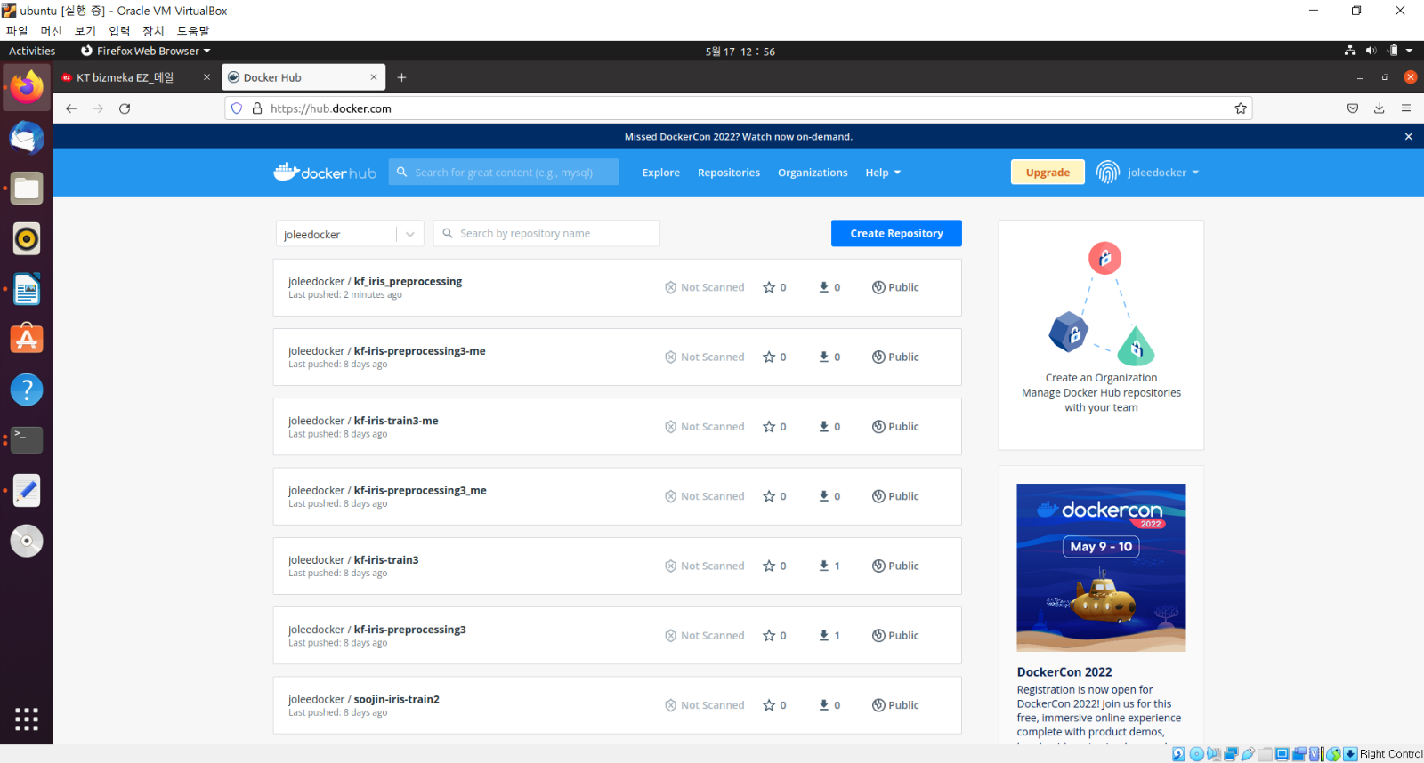

**(mlpipeline) traindb@traindb-VirtualBox:~/kubeflow_example-master/iris$** **cd 2_model_training/**

(**mlpipeline) traindb@traindb-VirtualBox:~/kubeflow_example-master/iris/2_model_training$** **ls**

|  |
| --- |
| Dockerfile requirements.txt training_model.py |

* **Dockfile**

|  |
| --- |
| #FROM frolvlad/alpine-python-machinelearning  FROM python:3  ENV PYTHONUNBUFFERED 1  RUN mkdir /code  WORKDIR /code  COPY . /code/  RUN pip install --upgrade pip  #RUN adduser -D myuser  #USER myuser  #WORKDIR /home/myuser  #COPY --chown=myuser:myuser requirements.txt requirements.txt  #RUN pip install --user -r requirements.txt  #ENV PATH="/home/user/.local/bin:${PATH}"  #COPY --chown=myuser:myuser . .  RUN pip install --upgrade wheel  RUN pip install --upgrade setuptools  #RUN pip install gensim  #RUN pip uninstall -y numpy  RUN pip install -r requirements.txt  ENTRYPOINT ["python", "training_model.py"] |

* **requirements.txt**

|  |
| --- |
| attrs==21.2.0  cachetools==4.2.4  certifi==2021.10.8  charset-normalizer==2.0.7  click==8.0.3  cloudpickle==2.0.0  Deprecated==1.2.13  docstring-parser==0.12  fire==0.4.0  google-api-core==1.31.3  google-api-python-client==1.12.8  google-auth==1.35.0  google-auth-httplib2==0.1.0  google-cloud-core==2.1.0  google-cloud-storage==1.42.3  google-crc32c==1.3.0  google-resumable-media==2.1.0  googleapis-common-protos==1.53.0  httplib2==0.20.2  idna==3.3  importlib-metadata==4.8.1  joblib==1.1.0  jsonschema==3.2.0  kfp==1.8.9  kfp-pipeline-spec==0.1.13  kfp-server-api==1.7.1  kubernetes==18.20.0  numpy==1.21.4  oauthlib==3.1.1  packaging==21.2  protobuf==3.17.3  pyasn1==0.4.8  pyasn1-modules==0.2.8  pydantic==1.8.2  pyparsing==2.4.7  pyrsistent==0.18.0  python-dateutil==2.8.2  pytz==2021.3  PyYAML==5.4.1  requests==2.26.0  requests-oauthlib==1.3.0  requests-toolbelt==0.9.1  rsa==4.7.2  six==1.16.0  strip-hints==0.1.10  tabulate==0.8.9  termcolor==1.1.0  threadpoolctl==3.0.0  typer==0.4.0  typing-extensions==3.10.0.2  uritemplate==3.0.1  urllib3==1.26.7  websocket-client==1.2.1  wrapt==1.13.3  zipp==3.6.0  pandas==1.3.4  scikit-learn==1.0.1  scipy==1.7.2 |

* **training_model.py**

|  |
| --- |
| import argparse  import pandas as pd  from sklearn.linear_model import LogisticRegression  from sklearn.model_selection import train_test_split  from sklearn.preprocessing import LabelEncoder  from sklearn.metrics import accuracy_score  from io import StringIO  def load_data(data):  d = StringIO(data)  iris = pd.read_csv(d, sep=',')  print(iris.shape)  return iris  def get_train_test_data(iris):  encode = LabelEncoder()  iris.Species = encode.fit_transform(iris.Species)  train , test = train_test_split(iris, test_size=0.2, random_state=0)  print('shape of training data : ', train.shape)  print('shape of testing data', test.shape)  X_train = train.drop(columns=['Species'], axis=1)  y_train = train['Species']  X_test = test.drop(columns=['Species'], axis=1)  y_test = test['Species']  return X_train, X_test, y_train, y_test  if __name__ == "__main__":    argument_parser = argparse.ArgumentParser()  argument_parser.add_argument(  '--data',  type=str,  help="Input data csv"  )  args = argument_parser.parse_args()  iris = args.data  iris = load_data(iris)  X_train, X_test, y_train, y_test = get_train_test_data(iris)  model = LogisticRegression()  model.fit(X_train, y_train)  predict = model.predict(X_test)  print('\nAccuracy Score on test data : ')  print(accuracy_score(y_test, predict)) |

**(mlpipeline) traindb@traindb-VirtualBox:~/kubeflow_example-master/iris/2_model_training$** **sudo docker build -t kf_iris_train .**

|  |
| --- |
| Sending build context to Docker daemon 12.29kB  Step 1/10 : FROM python:3  ---> bda19bf988a7  Step 2/10 : ENV PYTHONUNBUFFERED 1  ---> Using cache  ---> 8c89871342ac  Step 3/10 : RUN mkdir /code  ---> Using cache  ---> ba704a8b6508  Step 4/10 : WORKDIR /code  ---> Using cache  ---> 3d15bd03bd10  Step 5/10 : COPY . /code/  ---> 89d1148d07ed  Step 6/10 : RUN pip install --upgrade pip  ---> Running in 5b4c98e9900c  Requirement already satisfied: pip in /usr/local/lib/python3.10/site-packages (22.0.4)  Collecting pip  Downloading pip-22.1-py3-none-any.whl (2.1 MB)  ━━━━━━━━━━━━━━━━━━━━━━━━━━━━━━━━━━━━━━━━ 2.1/2.1 MB 10.7 MB/s eta 0:00:00  Installing collected packages: pip  Attempting uninstall: pip  Found existing installation: pip 22.0.4  Uninstalling pip-22.0.4:  Successfully uninstalled pip-22.0.4  Successfully installed pip-22.1  WARNING: Running pip as the 'root' user can result in broken permissions and conflicting behaviour with the system package manager. It is recommended to use a virtual environment instead: https://pip.pypa.io/warnings/venv  Removing intermediate container 5b4c98e9900c  ---> 0e1dc98e0e10  Step 7/10 : RUN pip install --upgrade wheel  ---> Running in 718aebd8000a  Requirement already satisfied: wheel in /usr/local/lib/python3.10/site-packages (0.37.1)  WARNING: Running pip as the 'root' user can result in broken permissions and conflicting behaviour with the system package manager. It is recommended to use a virtual environment instead: https://pip.pypa.io/warnings/venv  Removing intermediate container 718aebd8000a  ---> 3952b30559bd  Step 8/10 : RUN pip install --upgrade setuptools  ---> Running in a394da27b45d  Requirement already satisfied: setuptools in /usr/local/lib/python3.10/site-packages (58.1.0)  Collecting setuptools  Downloading setuptools-62.3.0-py3-none-any.whl (1.2 MB)  ━━━━━━━━━━━━━━━━━━━━━━━━━━━━━━━━━━━━━━━━ 1.2/1.2 MB 9.2 MB/s eta 0:00:00  Installing collected packages: setuptools  Attempting uninstall: setuptools  Found existing installation: setuptools 58.1.0  Uninstalling setuptools-58.1.0:  Successfully uninstalled setuptools-58.1.0  Successfully installed setuptools-62.3.0  WARNING: Running pip as the 'root' user can result in broken permissions and conflicting behaviour with the system package manager. It is recommended to use a virtual environment instead: https://pip.pypa.io/warnings/venv  Removing intermediate container a394da27b45d  ---> 1c5e4aa89abd  Step 9/10 : RUN pip install -r requirements.txt  ---> Running in 52907c187e31  Collecting attrs==21.2.0  Downloading attrs-21.2.0-py2.py3-none-any.whl (53 kB)  ━━━━━━━━━━━━━━━━━━━━━━━━━━━━━━━━━━━━━━━━ 53.7/53.7 kB 6.0 MB/s eta 0:00:00  Collecting cachetools==4.2.4  Downloading cachetools-4.2.4-py3-none-any.whl (10 kB)  Collecting certifi==2021.10.8  Downloading certifi-2021.10.8-py2.py3-none-any.whl (149 kB)  ━━━━━━━━━━━━━━━━━━━━━━━━━━━━━━━━━━━━━━━ 149.2/149.2 kB 9.8 MB/s eta 0:00:00  Collecting charset-normalizer==2.0.7  Downloading charset_normalizer-2.0.7-py3-none-any.whl (38 kB)  Collecting click==8.0.3  Downloading click-8.0.3-py3-none-any.whl (97 kB)  ━━━━━━━━━━━━━━━━━━━━━━━━━━━━━━━━━━━━━━━━ 97.5/97.5 kB 3.5 MB/s eta 0:00:00  Collecting cloudpickle==2.0.0  Downloading cloudpickle-2.0.0-py3-none-any.whl (25 kB)  Collecting Deprecated==1.2.13  Downloading Deprecated-1.2.13-py2.py3-none-any.whl (9.6 kB)  Collecting docstring-parser==0.12  Downloading docstring_parser-0.12.tar.gz (23 kB)  Installing build dependencies: started  Installing build dependencies: finished with status 'done'  Getting requirements to build wheel: started  Getting requirements to build wheel: finished with status 'done'  Preparing metadata (pyproject.toml): started  Preparing metadata (pyproject.toml): finished with status 'done'  Collecting fire==0.4.0  Downloading fire-0.4.0.tar.gz (87 kB)  ━━━━━━━━━━━━━━━━━━━━━━━━━━━━━━━━━━━━━━━━ 87.7/87.7 kB 7.5 MB/s eta 0:00:00  Preparing metadata (setup.py): started  Preparing metadata (setup.py): finished with status 'done'  Collecting google-api-core==1.31.3  Downloading google_api_core-1.31.3-py2.py3-none-any.whl (93 kB)  ━━━━━━━━━━━━━━━━━━━━━━━━━━━━━━━━━━━━━━━━ 93.3/93.3 kB 11.2 MB/s eta 0:00:00  Collecting google-api-python-client==1.12.8  Downloading google_api_python_client-1.12.8-py2.py3-none-any.whl (61 kB)  ━━━━━━━━━━━━━━━━━━━━━━━━━━━━━━━━━━━━━━━━ 61.5/61.5 kB 8.9 MB/s eta 0:00:00  Collecting google-auth==1.35.0  Downloading google_auth-1.35.0-py2.py3-none-any.whl (152 kB)  ━━━━━━━━━━━━━━━━━━━━━━━━━━━━━━━━━━━━━━ 152.9/152.9 kB 10.7 MB/s eta 0:00:00  Collecting google-auth-httplib2==0.1.0  Downloading google_auth_httplib2-0.1.0-py2.py3-none-any.whl (9.3 kB)  Collecting google-cloud-core==2.1.0  Downloading google_cloud_core-2.1.0-py2.py3-none-any.whl (27 kB)  Collecting google-cloud-storage==1.42.3  Downloading google_cloud_storage-1.42.3-py2.py3-none-any.whl (105 kB)  ━━━━━━━━━━━━━━━━━━━━━━━━━━━━━━━━━━━━━━ 106.0/106.0 kB 10.5 MB/s eta 0:00:00  Collecting google-crc32c==1.3.0  Downloading google_crc32c-1.3.0-cp310-cp310-manylinux_2_12_x86_64.manylinux2010_x86_64.whl (37 kB)  Collecting google-resumable-media==2.1.0  Downloading google_resumable_media-2.1.0-py2.py3-none-any.whl (75 kB)  ━━━━━━━━━━━━━━━━━━━━━━━━━━━━━━━━━━━━━━━━ 75.6/75.6 kB 10.6 MB/s eta 0:00:00  Collecting googleapis-common-protos==1.53.0  Downloading googleapis_common_protos-1.53.0-py2.py3-none-any.whl (198 kB)  ━━━━━━━━━━━━━━━━━━━━━━━━━━━━━━━━━━━━━━ 198.2/198.2 kB 10.2 MB/s eta 0:00:00  Collecting httplib2==0.20.2  Downloading httplib2-0.20.2-py3-none-any.whl (96 kB)  ━━━━━━━━━━━━━━━━━━━━━━━━━━━━━━━━━━━━━━━━ 96.7/96.7 kB 8.5 MB/s eta 0:00:00  Collecting idna==3.3  Downloading idna-3.3-py3-none-any.whl (61 kB)  ━━━━━━━━━━━━━━━━━━━━━━━━━━━━━━━━━━━━━━━━ 61.2/61.2 kB 12.2 MB/s eta 0:00:00  Collecting importlib-metadata==4.8.1  Downloading importlib_metadata-4.8.1-py3-none-any.whl (17 kB)  Collecting joblib==1.1.0  Downloading joblib-1.1.0-py2.py3-none-any.whl (306 kB)  ━━━━━━━━━━━━━━━━━━━━━━━━━━━━━━━━━━━━━━━ 307.0/307.0 kB 6.2 MB/s eta 0:00:00  Collecting jsonschema==3.2.0  Downloading jsonschema-3.2.0-py2.py3-none-any.whl (56 kB)  ━━━━━━━━━━━━━━━━━━━━━━━━━━━━━━━━━━━━━━━━ 56.3/56.3 kB 4.2 MB/s eta 0:00:00  Collecting kfp==1.8.9  Downloading kfp-1.8.9.tar.gz (296 kB)  ━━━━━━━━━━━━━━━━━━━━━━━━━━━━━━━━━━━━━━━ 296.3/296.3 kB 9.0 MB/s eta 0:00:00  Preparing metadata (setup.py): started  Preparing metadata (setup.py): finished with status 'done'  Collecting kfp-pipeline-spec==0.1.13  Downloading kfp_pipeline_spec-0.1.13-py3-none-any.whl (18 kB)  Collecting kfp-server-api==1.7.1  Downloading kfp-server-api-1.7.1.tar.gz (52 kB)  ━━━━━━━━━━━━━━━━━━━━━━━━━━━━━━━━━━━━━━━━ 52.8/52.8 kB 4.7 MB/s eta 0:00:00  Preparing metadata (setup.py): started  Preparing metadata (setup.py): finished with status 'done'  Collecting kubernetes==18.20.0  Downloading kubernetes-18.20.0-py2.py3-none-any.whl (1.6 MB)  ━━━━━━━━━━━━━━━━━━━━━━━━━━━━━━━━━━━━━━━━ 1.6/1.6 MB 6.7 MB/s eta 0:00:00  Collecting numpy==1.21.4  Downloading numpy-1.21.4-cp310-cp310-manylinux_2_17_x86_64.manylinux2014_x86_64.whl (15.9 MB)  ━━━━━━━━━━━━━━━━━━━━━━━━━━━━━━━━━━━━━━━━ 15.9/15.9 MB 11.4 MB/s eta 0:00:00  Collecting oauthlib==3.1.1  Downloading oauthlib-3.1.1-py2.py3-none-any.whl (146 kB)  ━━━━━━━━━━━━━━━━━━━━━━━━━━━━━━━━━━━━━━━ 146.2/146.2 kB 9.6 MB/s eta 0:00:00  Collecting packaging==21.2  Downloading packaging-21.2-py3-none-any.whl (40 kB)  ━━━━━━━━━━━━━━━━━━━━━━━━━━━━━━━━━━━━━━━━ 40.7/40.7 kB 4.6 MB/s eta 0:00:00  Collecting protobuf==3.17.3  Downloading protobuf-3.17.3-py2.py3-none-any.whl (173 kB)  ━━━━━━━━━━━━━━━━━━━━━━━━━━━━━━━━━━━━━━━ 173.9/173.9 kB 8.6 MB/s eta 0:00:00  Collecting pyasn1==0.4.8  Downloading pyasn1-0.4.8-py2.py3-none-any.whl (77 kB)  ━━━━━━━━━━━━━━━━━━━━━━━━━━━━━━━━━━━━━━━━ 77.1/77.1 kB 8.8 MB/s eta 0:00:00  Collecting pyasn1-modules==0.2.8  Downloading pyasn1_modules-0.2.8-py2.py3-none-any.whl (155 kB)  ━━━━━━━━━━━━━━━━━━━━━━━━━━━━━━━━━━━━━━ 155.3/155.3 kB 10.1 MB/s eta 0:00:00  Collecting pydantic==1.8.2  Downloading pydantic-1.8.2-py3-none-any.whl (126 kB)  ━━━━━━━━━━━━━━━━━━━━━━━━━━━━━━━━━━━━━━ 126.0/126.0 kB 10.0 MB/s eta 0:00:00  Collecting pyparsing==2.4.7  Downloading pyparsing-2.4.7-py2.py3-none-any.whl (67 kB)  ━━━━━━━━━━━━━━━━━━━━━━━━━━━━━━━━━━━━━━━━ 67.8/67.8 kB 9.0 MB/s eta 0:00:00  Collecting pyrsistent==0.18.0  Downloading pyrsistent-0.18.0.tar.gz (104 kB)  ━━━━━━━━━━━━━━━━━━━━━━━━━━━━━━━━━━━━━━ 104.2/104.2 kB 16.0 MB/s eta 0:00:00  Installing build dependencies: started  Installing build dependencies: finished with status 'done'  Getting requirements to build wheel: started  Getting requirements to build wheel: finished with status 'done'  Preparing metadata (pyproject.toml): started  Preparing metadata (pyproject.toml): finished with status 'done'  Collecting python-dateutil==2.8.2  Downloading python_dateutil-2.8.2-py2.py3-none-any.whl (247 kB)  ━━━━━━━━━━━━━━━━━━━━━━━━━━━━━━━━━━━━━━━ 247.7/247.7 kB 7.0 MB/s eta 0:00:00  Collecting pytz==2021.3  Downloading pytz-2021.3-py2.py3-none-any.whl (503 kB)  ━━━━━━━━━━━━━━━━━━━━━━━━━━━━━━━━━━━━━━━ 503.5/503.5 kB 7.3 MB/s eta 0:00:00  Collecting PyYAML==5.4.1  Downloading PyYAML-5.4.1.tar.gz (175 kB)  ━━━━━━━━━━━━━━━━━━━━━━━━━━━━━━━━━━━━━━━ 175.1/175.1 kB 6.1 MB/s eta 0:00:00  Installing build dependencies: started  Installing build dependencies: finished with status 'done'  Getting requirements to build wheel: started  Getting requirements to build wheel: finished with status 'done'  Preparing metadata (pyproject.toml): started  Preparing metadata (pyproject.toml): finished with status 'done'  Collecting requests==2.26.0  Downloading requests-2.26.0-py2.py3-none-any.whl (62 kB)  ━━━━━━━━━━━━━━━━━━━━━━━━━━━━━━━━━━━━━━━━ 62.3/62.3 kB 6.3 MB/s eta 0:00:00  Collecting requests-oauthlib==1.3.0  Downloading requests_oauthlib-1.3.0-py2.py3-none-any.whl (23 kB)  Collecting requests-toolbelt==0.9.1  Downloading requests_toolbelt-0.9.1-py2.py3-none-any.whl (54 kB)  ━━━━━━━━━━━━━━━━━━━━━━━━━━━━━━━━━━━━━━━━ 54.3/54.3 kB 7.1 MB/s eta 0:00:00  Collecting rsa==4.7.2  Downloading rsa-4.7.2-py3-none-any.whl (34 kB)  Collecting six==1.16.0  Downloading six-1.16.0-py2.py3-none-any.whl (11 kB)  Collecting strip-hints==0.1.10  Downloading strip-hints-0.1.10.tar.gz (29 kB)  Preparing metadata (setup.py): started  Preparing metadata (setup.py): finished with status 'done'  Collecting tabulate==0.8.9  Downloading tabulate-0.8.9-py3-none-any.whl (25 kB)  Collecting termcolor==1.1.0  Downloading termcolor-1.1.0.tar.gz (3.9 kB)  Preparing metadata (setup.py): started  Preparing metadata (setup.py): finished with status 'done'  Collecting threadpoolctl==3.0.0  Downloading threadpoolctl-3.0.0-py3-none-any.whl (14 kB)  Collecting typer==0.4.0  Downloading typer-0.4.0-py3-none-any.whl (27 kB)  Collecting typing-extensions==3.10.0.2  Downloading typing_extensions-3.10.0.2-py3-none-any.whl (26 kB)  Collecting uritemplate==3.0.1  Downloading uritemplate-3.0.1-py2.py3-none-any.whl (15 kB)  Collecting urllib3==1.26.7  Downloading urllib3-1.26.7-py2.py3-none-any.whl (138 kB)  ━━━━━━━━━━━━━━━━━━━━━━━━━━━━━━━━━━━━━━ 138.8/138.8 kB 11.2 MB/s eta 0:00:00  Collecting websocket-client==1.2.1  Downloading websocket_client-1.2.1-py2.py3-none-any.whl (52 kB)  ━━━━━━━━━━━━━━━━━━━━━━━━━━━━━━━━━━━━━━━━ 52.8/52.8 kB 9.9 MB/s eta 0:00:00  Collecting wrapt==1.13.3  Downloading wrapt-1.13.3-cp310-cp310-manylinux_2_5_x86_64.manylinux1_x86_64.manylinux_2_12_x86_64.manylinux2010_x86_64.whl (81 kB)  ━━━━━━━━━━━━━━━━━━━━━━━━━━━━━━━━━━━━━━━━ 81.5/81.5 kB 8.8 MB/s eta 0:00:00  Collecting zipp==3.6.0  Downloading zipp-3.6.0-py3-none-any.whl (5.3 kB)  Collecting pandas==1.3.4  Downloading pandas-1.3.4-cp310-cp310-manylinux_2_17_x86_64.manylinux2014_x86_64.whl (11.5 MB)  ━━━━━━━━━━━━━━━━━━━━━━━━━━━━━━━━━━━━━━━━ 11.5/11.5 MB 11.2 MB/s eta 0:00:00  Collecting scikit-learn==1.0.1  Downloading scikit-learn-1.0.1.tar.gz (6.6 MB)  ━━━━━━━━━━━━━━━━━━━━━━━━━━━━━━━━━━━━━━━━ 6.6/6.6 MB 11.5 MB/s eta 0:00:00  Installing build dependencies: started  Installing build dependencies: finished with status 'done'  Getting requirements to build wheel: started  Getting requirements to build wheel: finished with status 'done'  Preparing metadata (pyproject.toml): started  Preparing metadata (pyproject.toml): finished with status 'done'  Collecting scipy==1.7.2  Downloading scipy-1.7.2-cp310-cp310-manylinux_2_17_x86_64.manylinux2014_x86_64.whl (39.9 MB)  ━━━━━━━━━━━━━━━━━━━━━━━━━━━━━━━━━━━━━━━━ 39.9/39.9 MB 9.4 MB/s eta 0:00:00  Requirement already satisfied: setuptools>=40.3.0 in /usr/local/lib/python3.10/site-packages (from google-api-core==1.31.3->-r requirements.txt (line 10)) (62.3.0)  Collecting absl-py<=0.11,>=0.9  Downloading absl_py-0.11.0-py3-none-any.whl (127 kB)  ━━━━━━━━━━━━━━━━━━━━━━━━━━━━━━━━━━━━━━━ 127.8/127.8 kB 9.9 MB/s eta 0:00:00  Requirement already satisfied: wheel in /usr/local/lib/python3.10/site-packages (from strip-hints==0.1.10->-r requirements.txt (line 45)) (0.37.1)  Building wheels for collected packages: docstring-parser, fire, kfp, kfp-server-api, pyrsistent, PyYAML, strip-hints, termcolor, scikit-learn  Building wheel for docstring-parser (pyproject.toml): started  Building wheel for docstring-parser (pyproject.toml): finished with status 'done'  Created wheel for docstring-parser: filename=docstring_parser-0.12-py3-none-any.whl size=31750 sha256=ff9ebb6466f58c827c39cdb0960714e9a7d65461b4cff11f862a3c6d0d904873  Stored in directory: /root/.cache/pip/wheels/15/79/47/3e7b25bb22e824142721caa80d20bf025ce9f8e1ccce51f58d  Building wheel for fire (setup.py): started  Building wheel for fire (setup.py): finished with status 'done'  Created wheel for fire: filename=fire-0.4.0-py2.py3-none-any.whl size=115926 sha256=40b5288d3293cbe1a4f75b5cec4e1195b8c38241a91572881c2caca638e7a340  Stored in directory: /root/.cache/pip/wheels/26/9a/dd/2818b1b023daf077ec3e625c47ae446aca587a5abe48e05212  Building wheel for kfp (setup.py): started  Building wheel for kfp (setup.py): finished with status 'done'  Created wheel for kfp: filename=kfp-1.8.9-py3-none-any.whl size=409625 sha256=a6d36c3e4f61b0eadad8cc075be5d4ba670dccfd105d23b5a6bb973fee219272  Stored in directory: /root/.cache/pip/wheels/f2/c8/fe/b8938f9b2f303ae2fa418cfd64ff50841551d26b9a99fac115  Building wheel for kfp-server-api (setup.py): started  Building wheel for kfp-server-api (setup.py): finished with status 'done'  Created wheel for kfp-server-api: filename=kfp_server_api-1.7.1-py3-none-any.whl size=92607 sha256=9ae776593820218e88f99a318f6810d87e569136606bd275cbfdc8810d55fb06  Stored in directory: /root/.cache/pip/wheels/77/eb/09/fe6b25c980db6511fe1bc9015a082672c01f477ac7152d0fe6  Building wheel for pyrsistent (pyproject.toml): started  Building wheel for pyrsistent (pyproject.toml): finished with status 'done'  Created wheel for pyrsistent: filename=pyrsistent-0.18.0-cp310-cp310-linux_x86_64.whl size=115437 sha256=ba3e33a65ecc7ae9c41ceb836de64184258ca99e4d137cebe7e4bcf39296f71a  Stored in directory: /root/.cache/pip/wheels/bf/ee/17/b548a960bb9e20daf7987f316c326e8a368603809ace3b2374  Building wheel for PyYAML (pyproject.toml): started  Building wheel for PyYAML (pyproject.toml): finished with status 'done'  Created wheel for PyYAML: filename=PyYAML-5.4.1-cp310-cp310-linux_x86_64.whl size=562044 sha256=2526b712b22a2d6f4127ad85aa9499b8bf95f133e46de44fa71aa2a393e0ac0c  Stored in directory: /root/.cache/pip/wheels/c7/0d/22/696ee92245ad710f506eee79bb05c740d8abccd3ecdb778683  Building wheel for strip-hints (setup.py): started  Building wheel for strip-hints (setup.py): finished with status 'done'  Created wheel for strip-hints: filename=strip_hints-0.1.10-py2.py3-none-any.whl size=22284 sha256=956a6e3a01797fb5ad11aeeb9c4d628763b4ce3c6eba3ac9ee5990c2179da0c6  Stored in directory: /root/.cache/pip/wheels/19/fd/dc/1192a4b454695fa9f0c95b17597a44b200d9fcf0eeb771d104  Building wheel for termcolor (setup.py): started  Building wheel for termcolor (setup.py): finished with status 'done'  Created wheel for termcolor: filename=termcolor-1.1.0-py3-none-any.whl size=4832 sha256=6d0d3636dc79153aee1e7ff1a7108b59d386e285f81825c9d5d55c5d21e64ee3  Stored in directory: /root/.cache/pip/wheels/a1/49/46/1b13a65d8da11238af9616b00fdde6d45b0f95d9291bac8452  Building wheel for scikit-learn (pyproject.toml): started  Building wheel for scikit-learn (pyproject.toml): still running...  Building wheel for scikit-learn (pyproject.toml): still running...  Building wheel for scikit-learn (pyproject.toml): still running...  Building wheel for scikit-learn (pyproject.toml): finished with status 'done'  Created wheel for scikit-learn: filename=scikit_learn-1.0.1-cp310-cp310-linux_x86_64.whl size=26454604 sha256=d16a23a53b092dafd32a3d0fa436bcf0ae05dd0ea0e8c02dc2f493ddb1deaaa6  Stored in directory: /root/.cache/pip/wheels/b9/52/71/bb62d82a2b50c3c07fc7595c9cecbc696734d889da56cf0de6  Successfully built docstring-parser fire kfp kfp-server-api pyrsistent PyYAML strip-hints termcolor scikit-learn  Installing collected packages: typing-extensions, termcolor, tabulate, pytz, pyasn1, certifi, zipp, wrapt, websocket-client, urllib3, uritemplate, threadpoolctl, strip-hints, six, rsa, PyYAML, pyrsistent, pyparsing, pydantic, pyasn1-modules, oauthlib, numpy, joblib, idna, google-crc32c, docstring-parser, cloudpickle, click, charset-normalizer, cachetools, attrs, typer, scipy, requests, python-dateutil, protobuf, packaging, jsonschema, importlib-metadata, httplib2, google-resumable-media, google-auth, fire, Deprecated, absl-py, scikit-learn, requests-toolbelt, requests-oauthlib, pandas, kfp-server-api, kfp-pipeline-spec, googleapis-common-protos, google-auth-httplib2, kubernetes, google-api-core, google-cloud-core, google-api-python-client, google-cloud-storage, kfp  Successfully installed Deprecated-1.2.13 PyYAML-5.4.1 absl-py-0.11.0 attrs-21.2.0 cachetools-4.2.4 certifi-2021.10.8 charset-normalizer-2.0.7 click-8.0.3 cloudpickle-2.0.0 docstring-parser-0.12 fire-0.4.0 google-api-core-1.31.3 google-api-python-client-1.12.8 google-auth-1.35.0 google-auth-httplib2-0.1.0 google-cloud-core-2.1.0 google-cloud-storage-1.42.3 google-crc32c-1.3.0 google-resumable-media-2.1.0 googleapis-common-protos-1.53.0 httplib2-0.20.2 idna-3.3 importlib-metadata-4.8.1 joblib-1.1.0 jsonschema-3.2.0 kfp-1.8.9 kfp-pipeline-spec-0.1.13 kfp-server-api-1.7.1 kubernetes-18.20.0 numpy-1.21.4 oauthlib-3.1.1 packaging-21.2 pandas-1.3.4 protobuf-3.17.3 pyasn1-0.4.8 pyasn1-modules-0.2.8 pydantic-1.8.2 pyparsing-2.4.7 pyrsistent-0.18.0 python-dateutil-2.8.2 pytz-2021.3 requests-2.26.0 requests-oauthlib-1.3.0 requests-toolbelt-0.9.1 rsa-4.7.2 scikit-learn-1.0.1 scipy-1.7.2 six-1.16.0 strip-hints-0.1.10 tabulate-0.8.9 termcolor-1.1.0 threadpoolctl-3.0.0 typer-0.4.0 typing-extensions-3.10.0.2 uritemplate-3.0.1 urllib3-1.26.7 websocket-client-1.2.1 wrapt-1.13.3 zipp-3.6.0  WARNING: Running pip as the 'root' user can result in broken permissions and conflicting behaviour with the system package manager. It is recommended to use a virtual environment instead: https://pip.pypa.io/warnings/venv  Removing intermediate container 52907c187e31  ---> a29e47c1d623  Step 10/10 : ENTRYPOINT ["python", "training_model.py"]  ---> Running in 460c99113cf9  Removing intermediate container 460c99113cf9  ---> 92467a64c301  Successfully built 92467a64c301  Successfully tagged kf_iris_train:latest |

**(mlpipeline) traindb@traindb-VirtualBox:~/kubeflow_example-master/iris/2_model_training$** **sudo docker images**

|  |
| --- |
| REPOSITORY TAG IMAGE ID CREATED SIZE  kf_iris_train latest 92467a64c301 About a minute ago 1.52GB  kf_iris_preprocessing latest 1962173c4ec9 14 minutes ago 1.24GB  joleedocker/kf_iris_preprocessing 0.5 1962173c4ec9 14 minutes ago 1.24GB  python 3 bda19bf988a7 5 days ago 919MB |

**(mlpipeline) traindb@traindb-VirtualBox:~/kubeflow_example-master/iris/2_model_training$** **sudo docker tag kf_iris_train:latest joleedocker/kf_iris_train:0.5**

**(mlpipeline) traindb@traindb-VirtualBox:~/kubeflow_example-master/iris/2_model_training$** **sudo docker images**

|  |
| --- |
| REPOSITORY TAG IMAGE ID CREATED SIZE  joleedocker/kf_iris_train 0.5 92467a64c301 2 minutes ago 1.52GB  kf_iris_train latest 92467a64c301 2 minutes ago 1.52GB  joleedocker/kf_iris_preprocessing 0.5 1962173c4ec9 14 minutes ago 1.24GB  kf_iris_preprocessing latest 1962173c4ec9 14 minutes ago 1.24GB  python 3 bda19bf988a7 5 days ago 919MB |

**(mlpipeline) traindb@traindb-VirtualBox:~/kubeflow_example-master/iris/2_model_training$** **sudo docker push joleedocker/kf_iris_train:0.5**

|  |
| --- |
| The push refers to repository [docker.io/joleedocker/kf_iris_train]  05754e285f43: Pushed  223af3d83d4e: Pushed  ef86f338bfec: Pushed  ffe1bd67acf0: Pushed  c276efacdb40: Pushed  2433fc18a726: Mounted from joleedocker/kf_iris_preprocessing  d63526a5d12e: Mounted from joleedocker/kf_iris_preprocessing  d35a703f2b0a: Mounted from joleedocker/kf_iris_preprocessing  db7f8cc44a42: Mounted from joleedocker/kf_iris_preprocessing  b889a93a79dd: Mounted from joleedocker/kf_iris_preprocessing  9d4550089a93: Mounted from joleedocker/kf_iris_preprocessing  a7934564e6b9: Mounted from joleedocker/kf_iris_preprocessing  1b7cceb6a07c: Mounted from joleedocker/kf_iris_preprocessing  b274e8788e0c: Mounted from joleedocker/kf_iris_preprocessing  78658088978a: Mounted from joleedocker/kf_iris_preprocessing  0.5: digest: sha256:c58bab4389a4a145adb84187d7d068f0f5f1cf1691339513cabe26753c75ab7b size: 3478 |

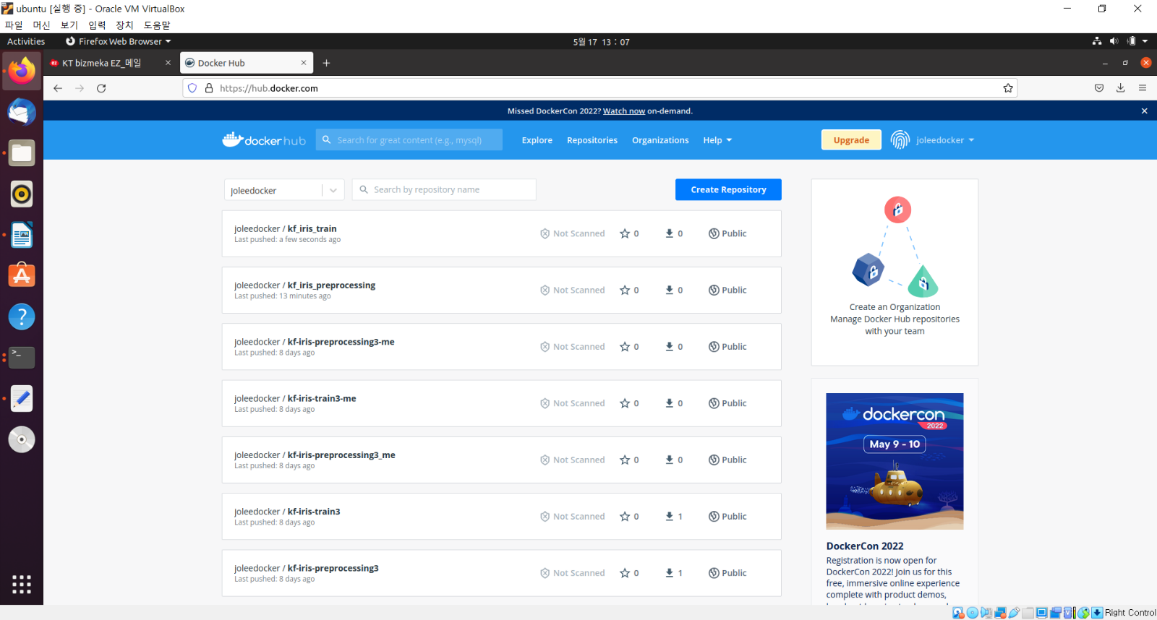

**(mlpipeline) traindb@traindb-VirtualBox:~/kubeflow_example-master/iris/2_model_training$** **cd ..**

**(mlpipeline) traindb@traindb-VirtualBox:~/kubeflow_example-master/iris$** **ls**

|  |
| --- |
| 1_data_load 2_model_training pipeline.py __pycache__ |

* **pipeline.py**

|  |
| --- |
| import kfp  import kfp.components as comp  from kfp import dsl  @dsl.pipeline(  name='kf-iris',  description='kubeflow iris test'  )  def kf_pipeline():  add_p = dsl.ContainerOp(  name="load iris data pipeline",  #image="lsjsj92/soojin-iris-preprocessing:0.6",  image="joleedocker/kf-iris-preprocessing3:0.5",  arguments=[  '--data_path', './Iris.csv'  ],  file_outputs={'iris' : '/iris.csv'}  )  ml = dsl.ContainerOp(  name="training pipeline",  image="joleedocker/kf-iris-train3:0.5",  arguments=[  '--data', add_p.outputs['iris']  ]  )  ml.after(add_p)    if __name__ == "__main__":  import kfp.compiler as compiler  compiler.Compiler().compile(kf_pipeline, __file__ + ".tar.gz") |

**(mlpipeline) traindb@traindb-VirtualBox:~/kubeflow_example-master/iris$** **dsl-compile --py pipeline.py --output kf_iris_pipeline_0_5.tar.gz**

|  |
| --- |
| /home/traindb/miniconda3/envs/mlpipeline/lib/python3.6/site-packages/kfp/dsl/_container_op.py:1264: FutureWarning: Please create reusable components instead of constructing ContainerOp instances directly. Reusable components are shareable, portable and have compatibility and support guarantees. Please see the documentation: https://www.kubeflow.org/docs/pipelines/sdk/component-development/#writing-your-component-definition-file The components can be created manually (or, in case of python, using kfp.components.create_component_from_func or func_to_container_op) and then loaded using kfp.components.load_component_from_file, load_component_from_uri or load_component_from_text: https://kubeflow-pipelines.readthedocs.io/en/stable/source/kfp.components.html#kfp.components.load_component_from_file  category=FutureWarning, |

**(mlpipeline) traindb@traindb-VirtualBox:~/kubeflow_example-master/iris$** **ls**

|  |
| --- |
| 1_data_load 2_model_training kf_iris_pipeline_0_5.tar.gz pipeline.py __pycache__ |

# **11. Deploying pipeline**

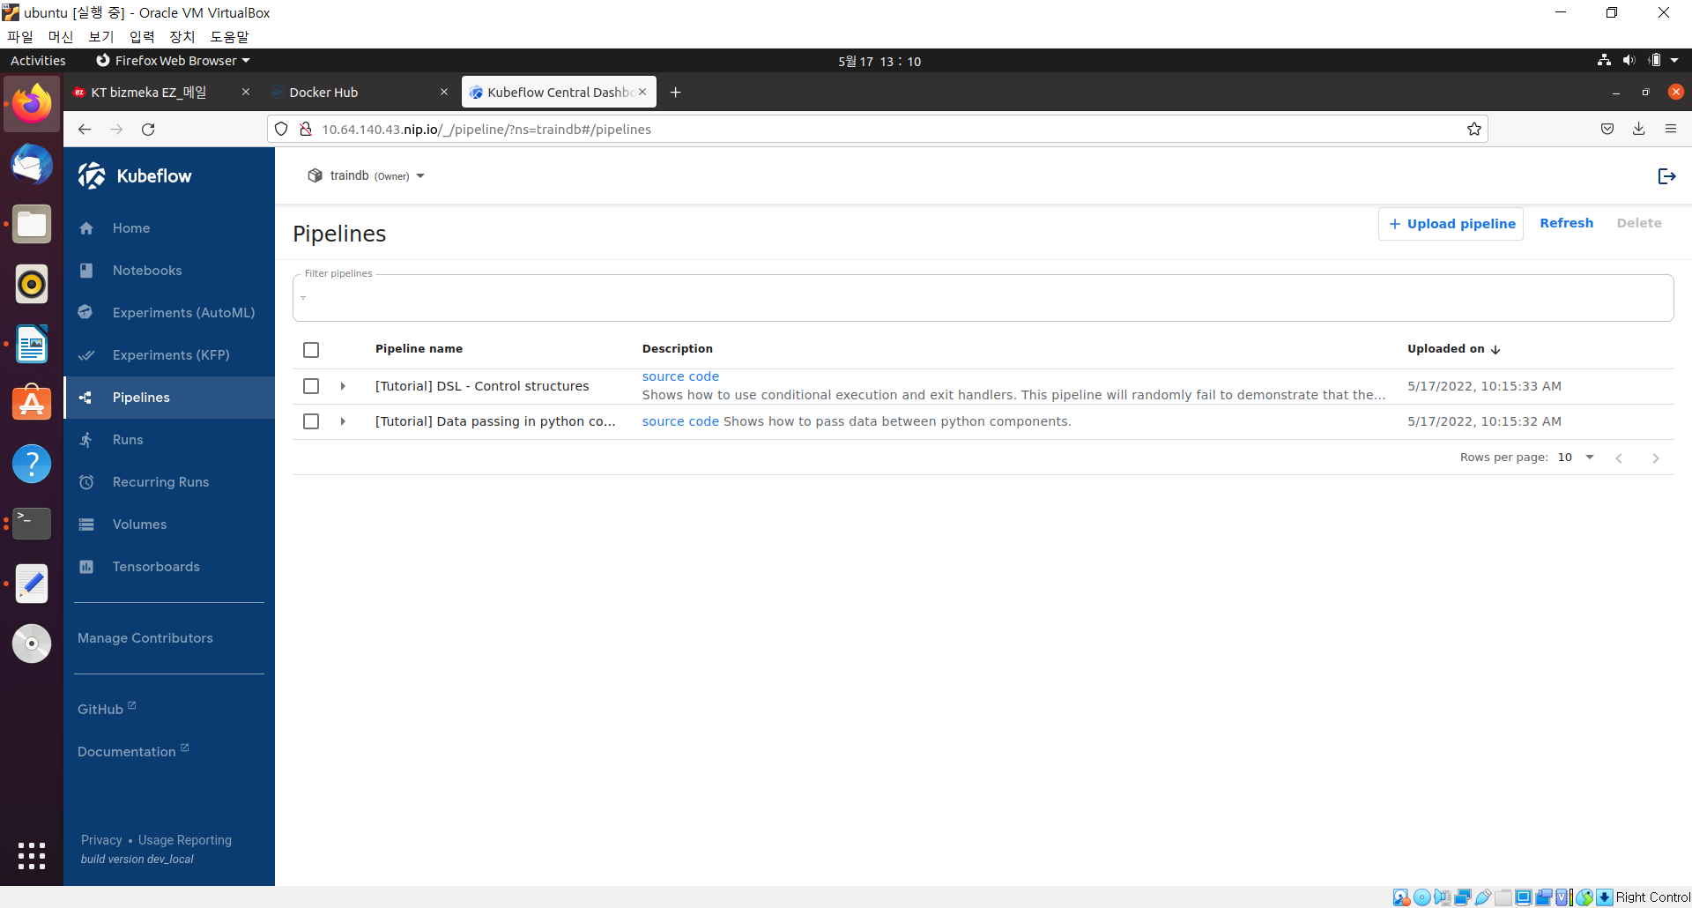

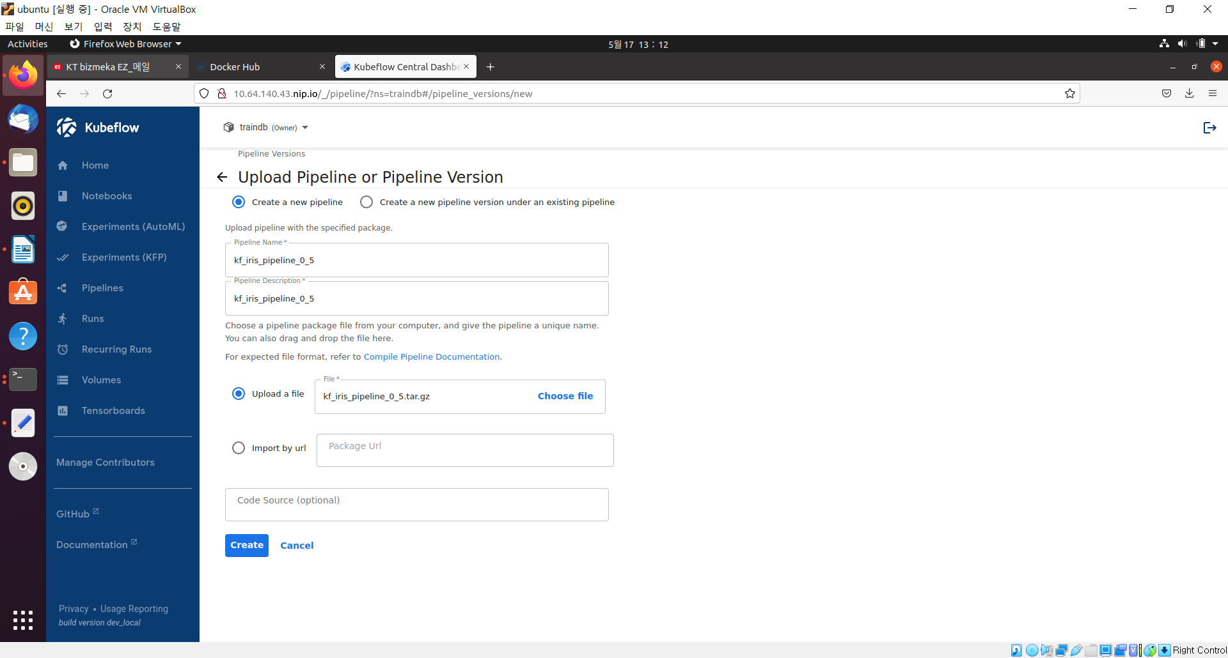

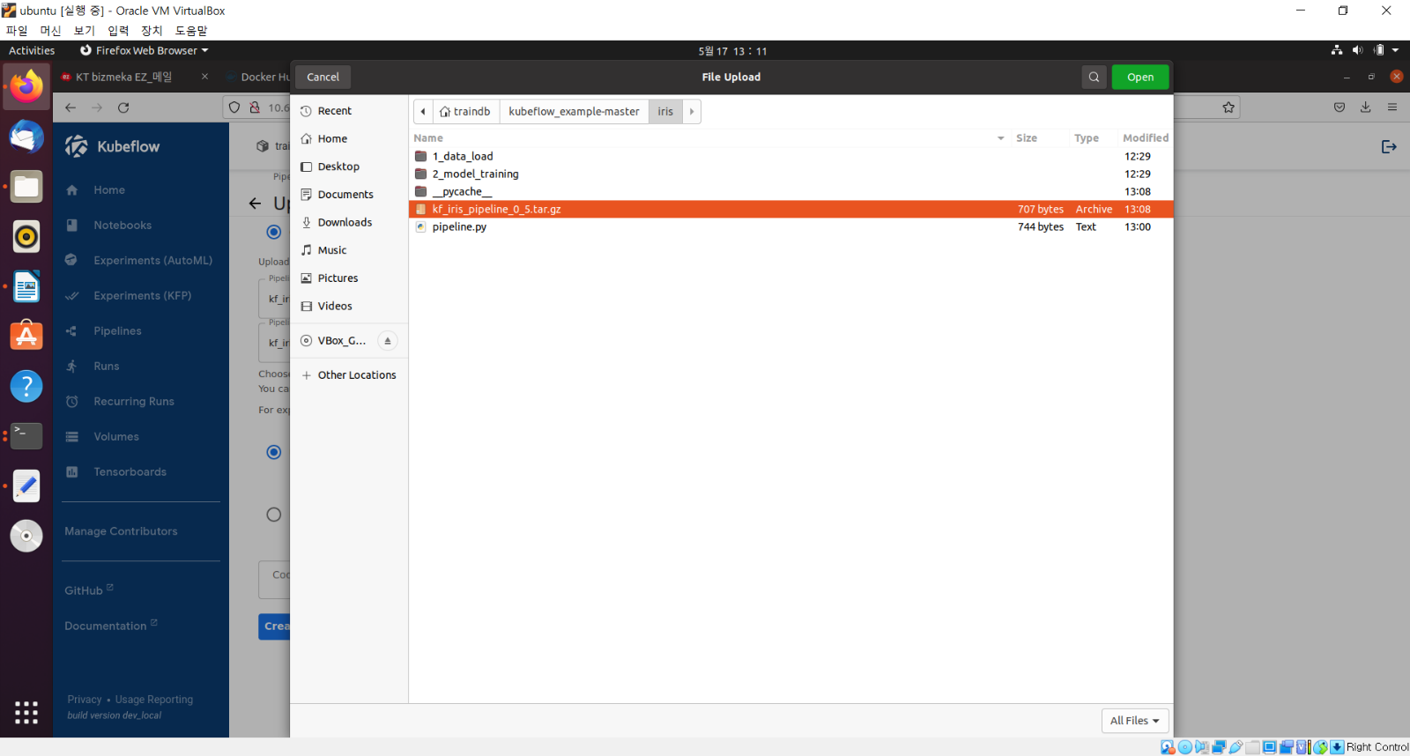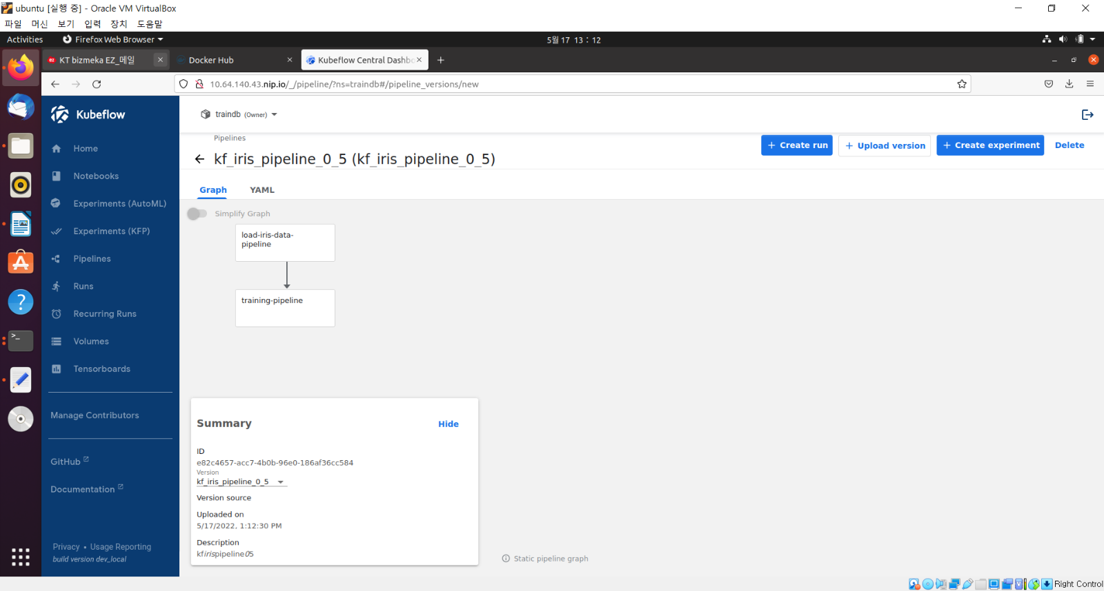

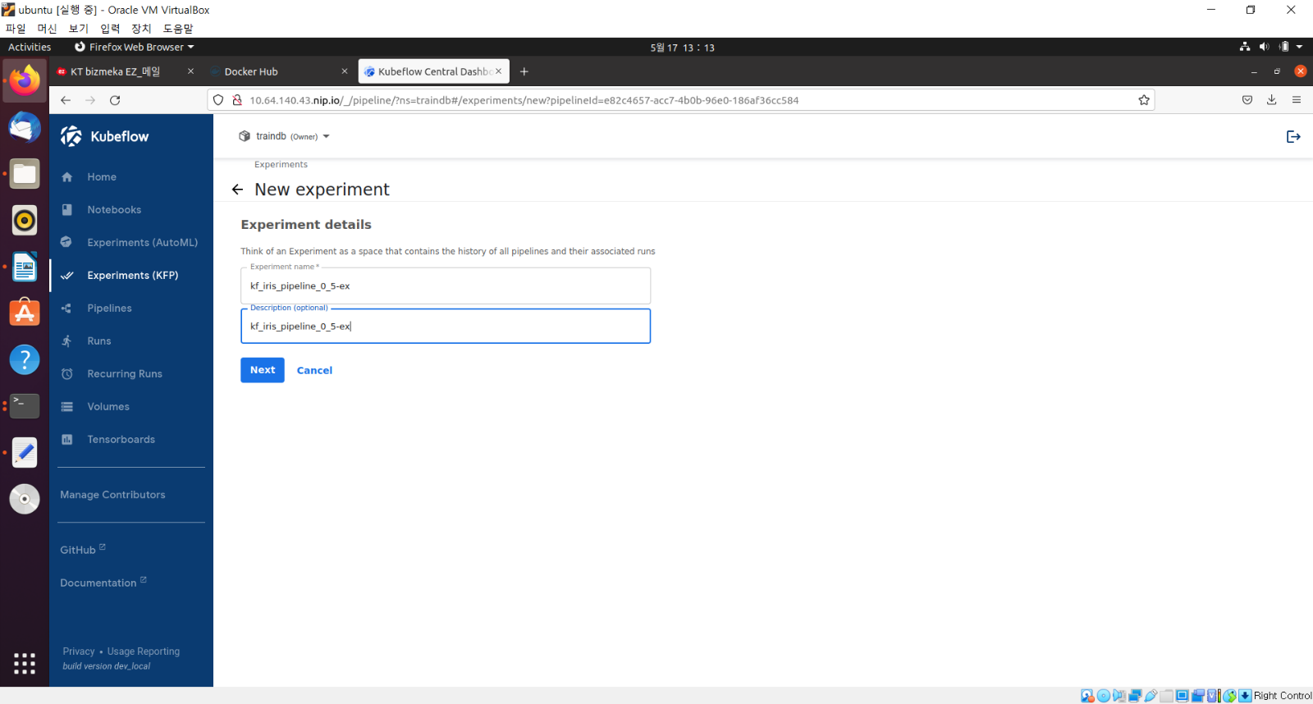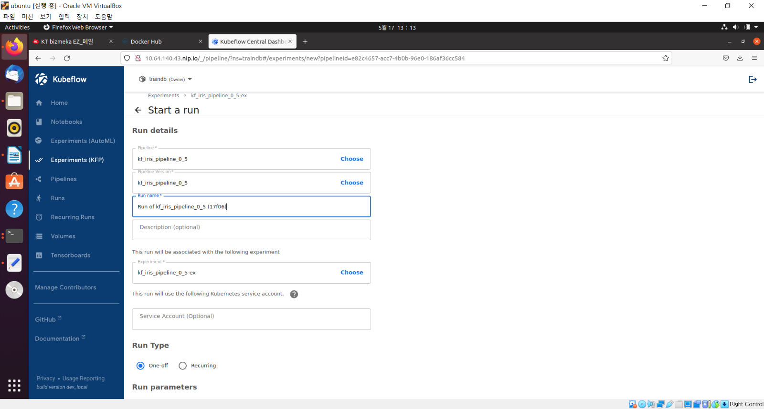

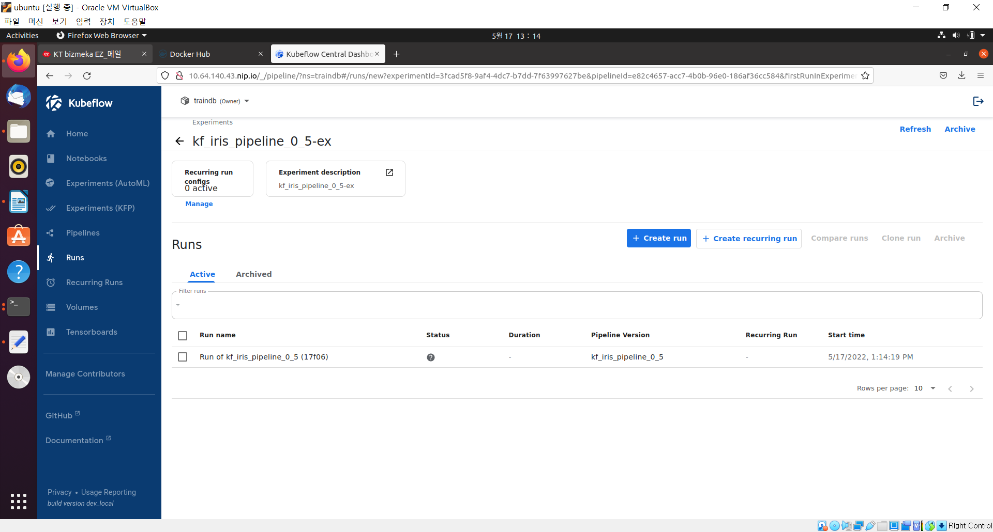

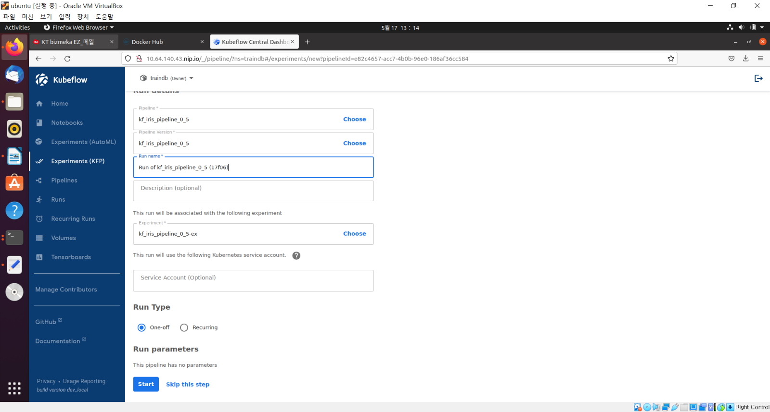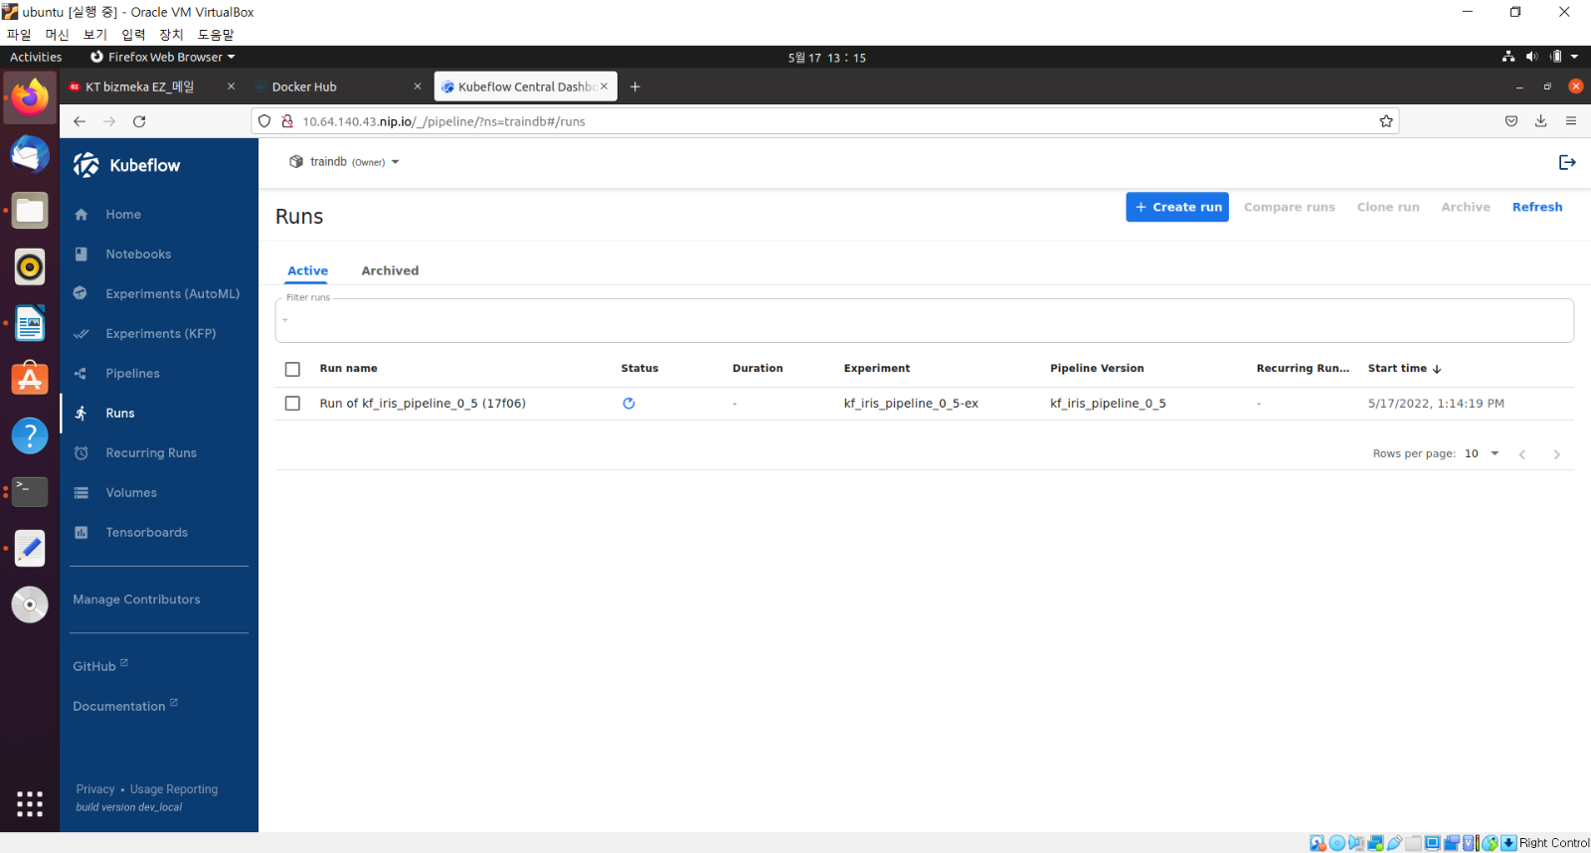

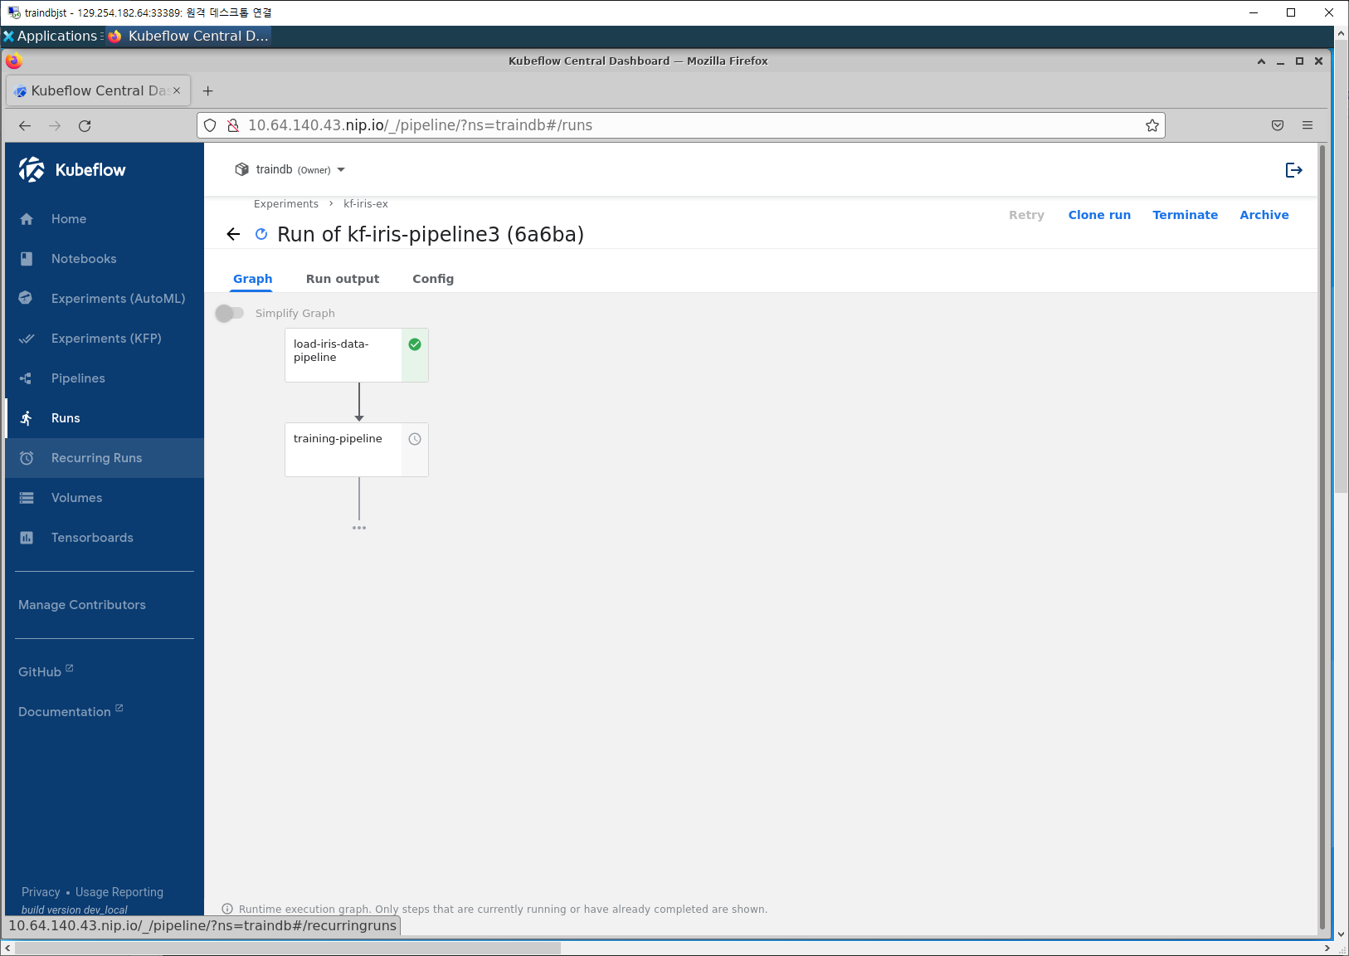

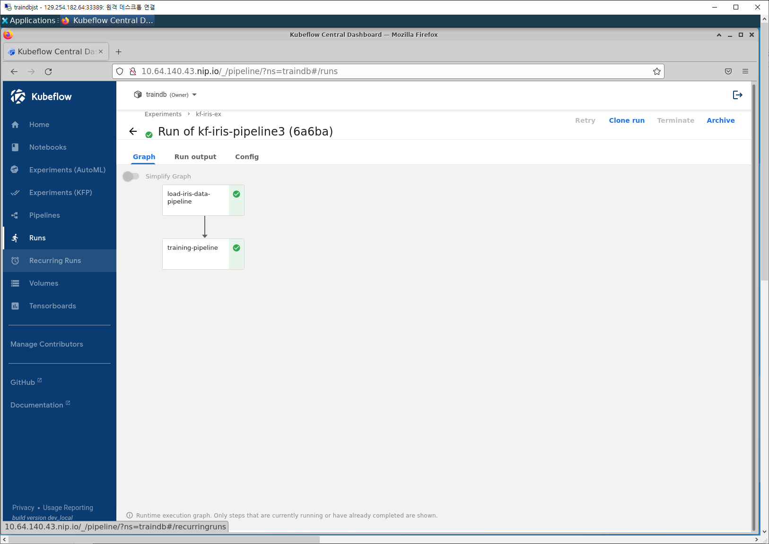

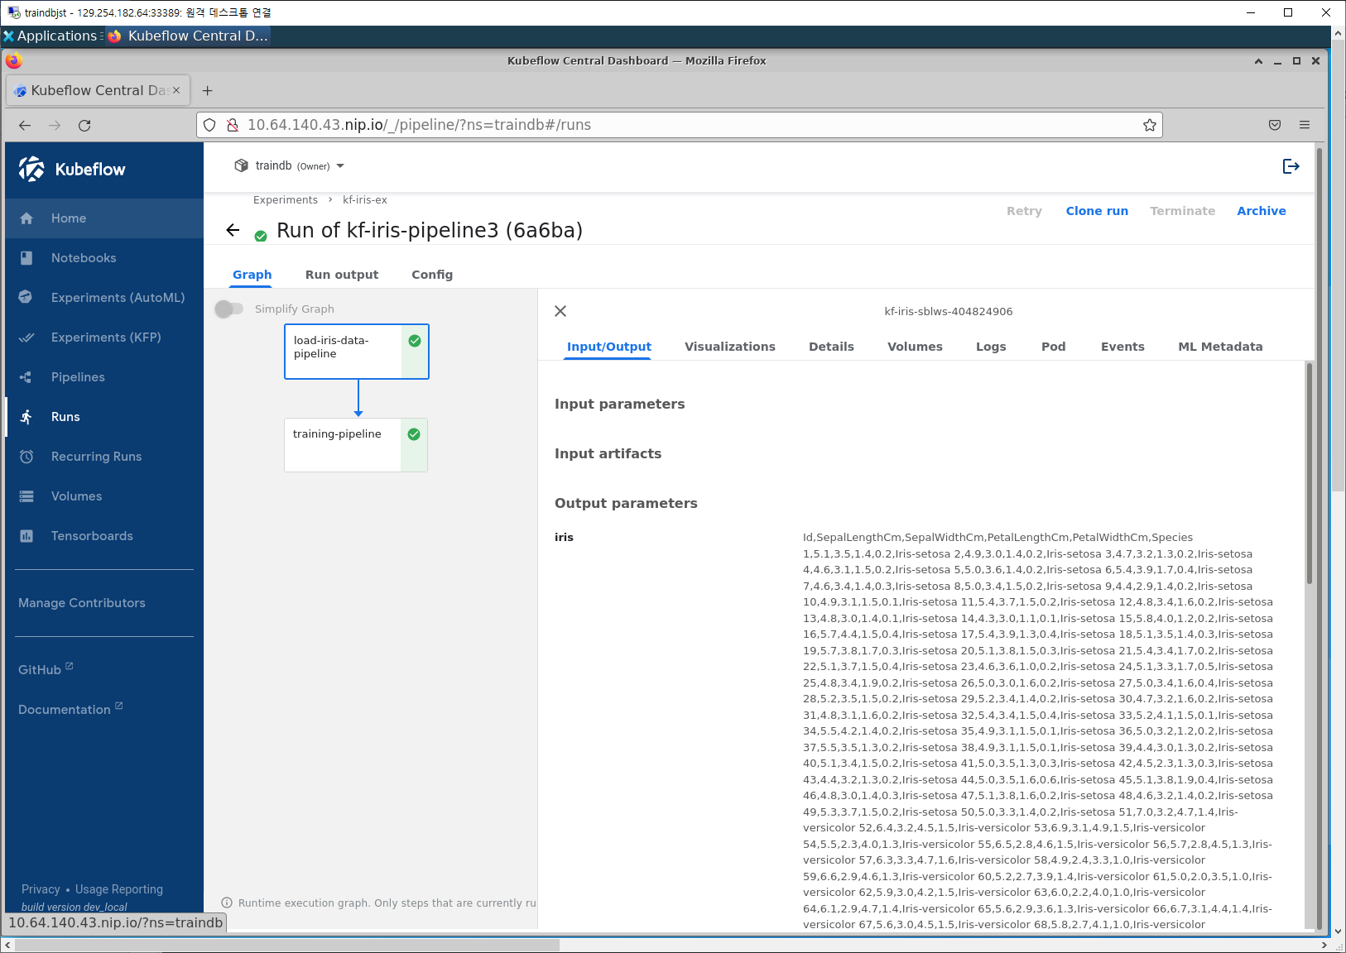

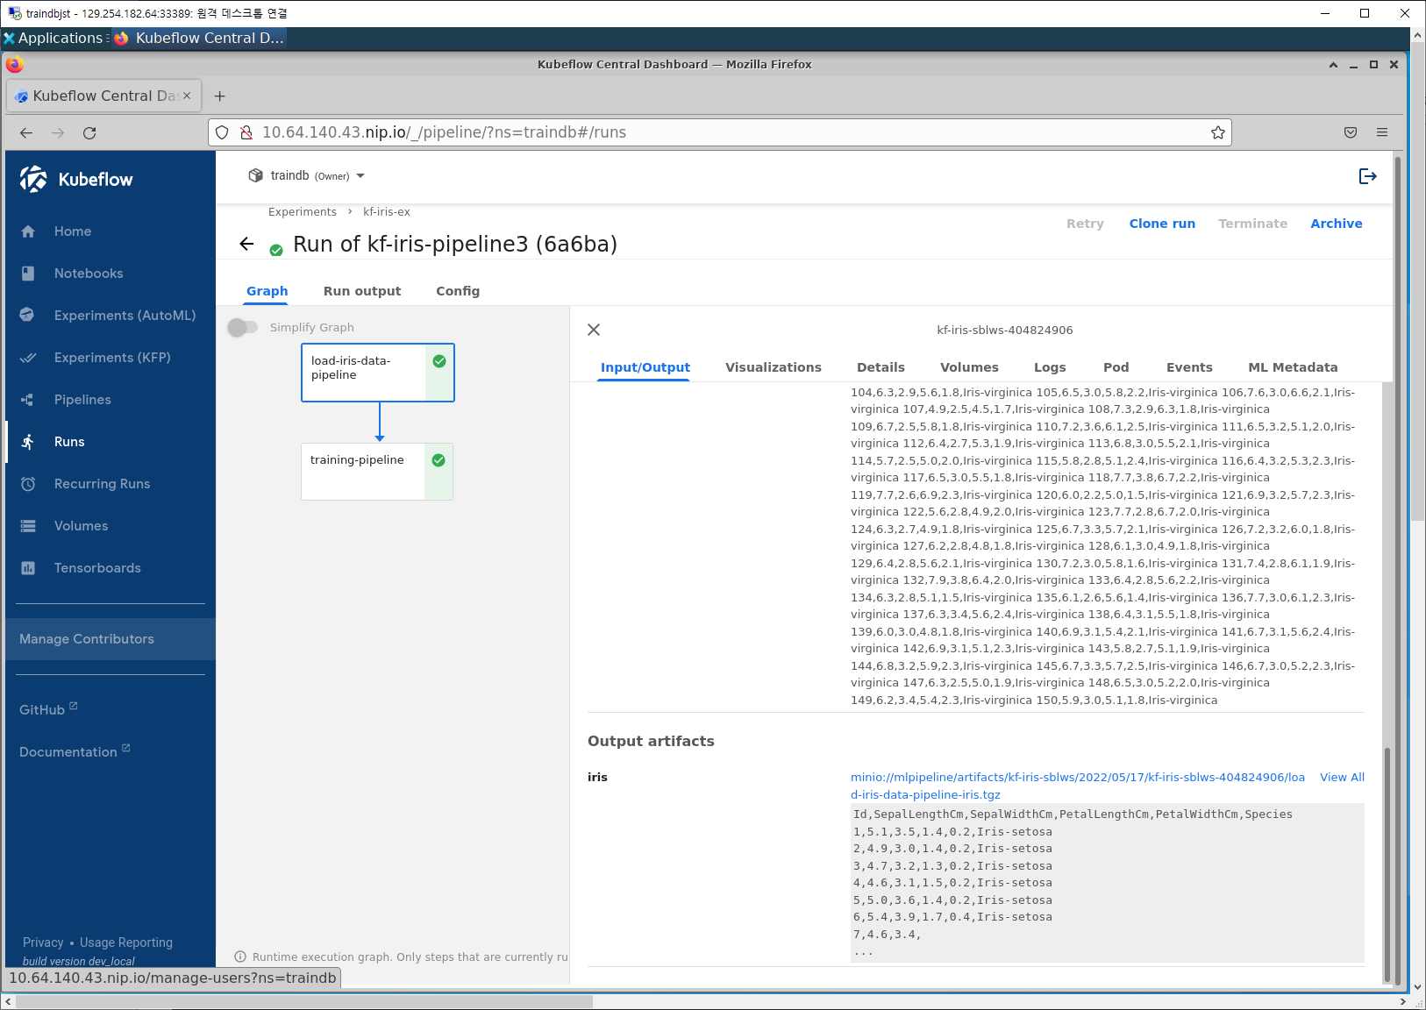

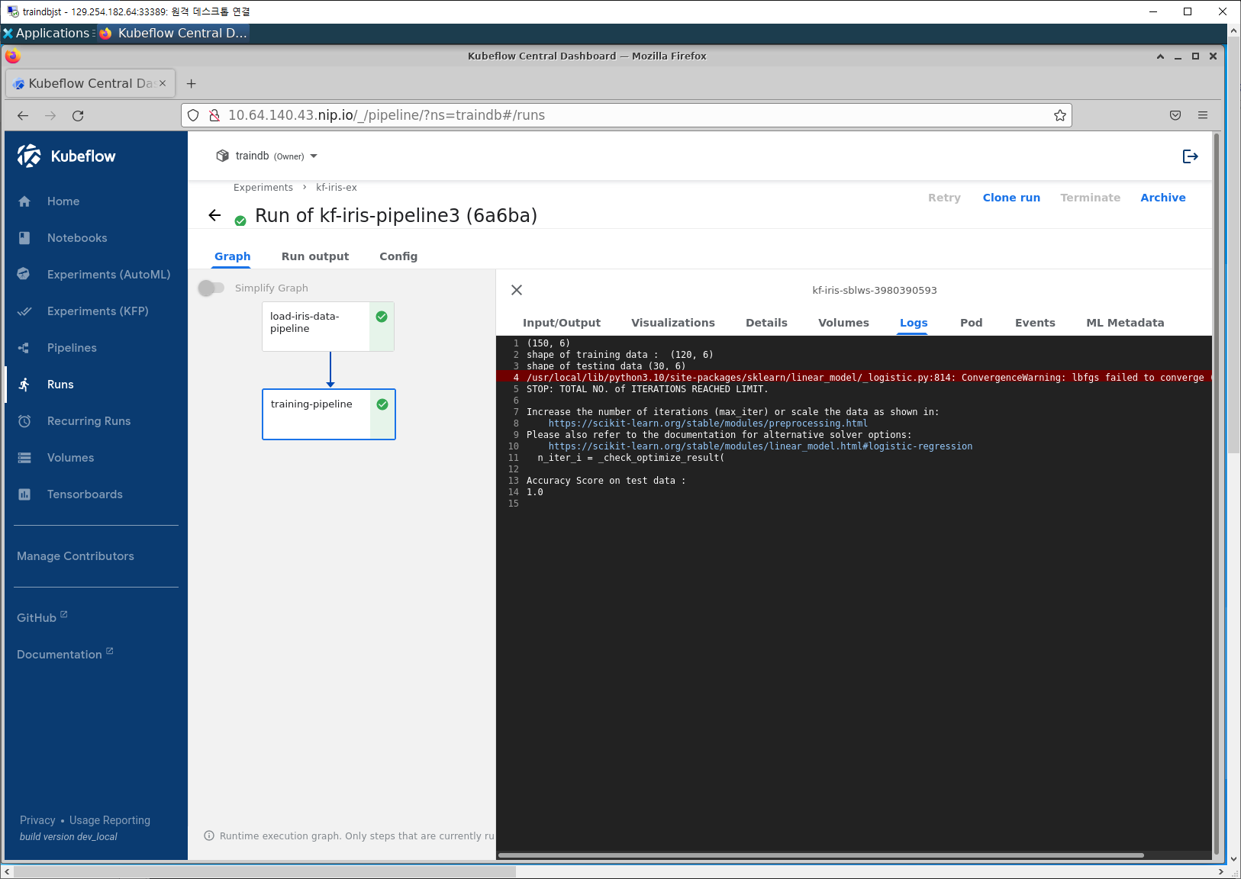

**12. Model Serving**

**13. Experiment(AutoML) - Katib**

**14. Jupyter Notebook Server**

**15. ---**